SMT FPGA

Version 1.0

이 문서는 사전에 공지나 예고 없이 변경될 수 있습니다.

REVISION HISTORY
Version | Detail | Name | Date
1.0 | First Version | SHMT SoC Team | 2007-3-1

Technical documents

Copyright © 2006 Shmt Limited. All rights reserved.

Confidentiality Status
This document is NOT OPEN ACCESS. The distribution is restricted to certified company.
This document is CONFIDENTIAL.

Feedback on this document
If you have any comments on this document, please contact your channel to our company.

Shmt Web address
http://www.shmt.com

Table of contents

1. Introduction 12
1.1. Overview 12
1.2. Features 12
2. ARM926EJ-S 14
2.1. Overview 14
2.1.1. Feature 14
2.1.2. Block diagram 14
2.1.3. Processor operating state 15
2.2. Switching operating state 16
2.3. Registers 16
2.3.1. ARM state에서의 register 16
2.3.2. Thumb state에서의 register 18
2.3.3. Status register 18
2.4. Exceptions 20
2.4.1. Exception vectors 20
2.4.2. Exception priorities 20
2.4.3. Entering an ARM exception 21
2.4.4. Leaving an ARM exception 21
2.4.5. Reset 21
2.4.6. Fast interrupt request 21
2.4.7. Interrupt request 21
2.4.8. Aborts 22
3. Programmer’s model 24
3.1. Overview 24
3.2. Memory Map 24
3.2.1. Overview 24
3.2.2. Memory Map 24
3.3. Peripherals 27
3.3.1. Peripheral Memory Map 27
3.4. Boot sequence 29
3.4.1. Direct boot mode 29
4. System control 30
4.1. Overview 30
4.2. Registers 30
4.2.1. Information Register 30
4.2.2. Resource Share Register 31
4.2.3. System Configuration Register 32
5. Static Memory Controller 33
5.1. Overview 33
5.1.1. Feature 33
5.1.2. Block Diagram 33
5.2. Signal Description 33
5.3. Address Map 34
5.4. Timing 34
5.5. Interface 35
5.5.1. Interface Example 35
5.6. Register Description 37
5.6.1. Registers 37
5.6.2. SMC_BANKx Register 37
6. DDR-RAM Scheduler 39
6.1. Overview 39
6.1.1. Feature 39
6.1.2. Block Diagram 40
6.2. Operation 40
6.2.1. AXI BUS Interface Block 40
6.2.2. DDR SDRAM Controller Block 42
6.2.3. DDR SDRAM Controller Timing Description 44
6.3. Register Description 46
6.3.1. DDR SDRAM Registers 46
6.3.2. DDR SDRAM TIMING Control Register 46
6.3.3. DDR SDRAM Control Register 46
6.3.4. DDR SDRAM Power Control Register 47
6.3.5. DDR SDRAM Refresh Control Register 47
6.3.6. DDR SDRAM Configuration Register 48
7. Vectored interrupt controller 49
7.1. Overview 49
7.1.1. General features 49
7.2. Registers 49
7.2.1. INTERRUPT CONTROL REGISTER(INTCON) 51
7.2.2. INTERRUPT PENDING REGISTER(INTPND) 51
7.2.3. INTERRUPT MODE REGISTER(INTMOD) 52
7.2.4. INTERRUPT MASK REGISTER(INTMSK) 52
7.2.5. Trigger Level Control Register(LEVEL) 53
7.2.6. IRQ/FIQ Priority of Slave Registers(PSLV) 54
7.2.7. IRQ/FIQ Priority of Master Register(PMST) 54
7.2.8. Current IRQ/FIQ Priorities of Slave Register (I_CSLV/F_CSLV) 55
7.2.9. Current IRQ/FIQ Priority of the Master Register 56
7.2.10. nIRQ/nFIQ Interrupt Service Pending Register (I_ISPR/F_ISPR) 56
7.2.11. IRQ/FIQ Interrupt Service Pending Clear Register (I_ISPC/F_ISPC). 56
7.2.12. Polarity register(POLARITY) 56
7.2.13. Vector Address Register(I_VECADDR/F_VECADDR) 57
7.3. Description 58
7.3.1. Channels 58
8. Enhanced-DMA 59
8.1. Overview 59
8.1.1. Features 59
8.1.2. Block diagram 59
8.2. DMA Channel 61
8.2.1. Channel Arbitration 62
8.3. Channel Operation 62
8.3.1. Basic Operation 62
8.3.2. Descriptor Loading 63
8.3.3. Interrupt 64
8.3.4. Trailing Bytes 65
8.3.5. Memory-to-Memory Transfer 65
8.4. Software Model 65
8.4.1. Enabling DMA Channel 65
8.4.2. Enabling DMA Channel(No Descriptor Mode) 66
8.4.3. Enabling DMA Channel(Using Descriptor) 66
8.4.4. 10.4.4 Disabling DMA Channel 66
8.4.5. Restriction on Register Access 66
8.5. Register Description 67
8.5.1. Registers 67
8.5.2. Source Address Register 68
8.5.3. Destination Address Register 68
8.5.4. Control Register 69
8.5.5. Descriptor Register 70
8.5.6. Status Register 71
9. TIMER 73
9.1. Overview 73
9.1.1. Features 73
9.1.2. Block diagram 73
9.2. Operation 74
9.2.1. Interval Mode 74
9.2.2. Match&Overflow Mode 74
9.3. Register Description 74
9.3.1. Registers 74
9.3.2. Timer Data Register (T0_TDAT/T1_TDAT/T2_TDAT/T3_TDAT) 75
9.3.3. Timer Prescaler Register (T0_PRES/T1_PRES/T2_PRES/T3_PRES) 75
9.3.4. Timer Control Register (T0_CTRL/T1_CTRL/T2_CTRL/T3_CTRL) 76
9.3.5. Timer Counter Register (T0_CNT/T1_CNT/T2_CNT/T3_CNT) 76
10. WDT 78
10.1. Overview 78
10.1.1. Feature 78
10.1.2. Block Diagram 79
10.2. Operation 79
10.2.1. Clock Prescaler Block 80
10.2.2. Interrupt Generation Block 80
10.2.3. Reset Output Generation 80
10.3. Register Description 81
10.3.1. WDT Registers 81
10.3.2. WDT Control Register 82
10.3.3. WDT Prescale Register 82
10.3.4. WDT Load Register 82
10.3.5. WDT Count Register 83
10.3.6. WDT Interrupt Status Register 83
11. I2S 84
11.1. Overview 84
11.1.1. Features 84
11.1.2. Block diagram 84
11.2. Signals 85
11.3. Operation 85
11.3.1. Digital Oscillator 85
11.3.2. Master/Slave Configuration 87
11.3.3. Transmit 동작 : Audio Play 88
11.3.4. Receive 동작 : Audio Record 90
11.3.5. Interrupt 92
11.3.6. Left-justified Mode/I2S Mode Selection 92
11.3.7. WordLength와 FIFO data 93
11.4. Register Description 94
11.4.1. Registers 94
11.4.2. I2S_CLKCTRL Register 95
11.4.3. I2S_CTRL Register 96
11.4.4. I2S_STATUS Register 97
11.4.5. I2S_DATA Register 98
12. I2C Master 100
12.1. Overview 100
12.1.1. Feature 100
12.1.2. Block Diagram 100
12.2. Operation 100
12.2.1. Overview 100
12.3. Signal Description 101
12.3.1. APB Signal (생략) 101
12.3.2. I2C Module Signal 101
12.4. Register Description 101
12.4.1. Registers 101
12.4.2. I2CCON (I2C Control) Register 101
12.4.3. I2CSTA (I2C Status) Register 102
12.4.4. I2CDAT (I2C Data) Register 102
12.5. Operation Sequence 103
13. UART 106
13.1. Overview 106
13.2. Register 106
13.2.1. Master Command Register 107
13.2.2. Status Register 108
13.2.3. Buadrate Gen Register 110
13.2.4. TxFIFO Write Register 110
13.2.5. RxFIFO Read Register 110
13.2.6. Receive time out count register 111
13.3. Description 111
13.3.1. Baudrate clock generation 111
13.3.2. Low Pass Filter 112
13.3.3. Water Level 112
13.3.4. Receive Time out interrupt 113
13.3.5. Loop back mode 114
14. GPIO 115
14.1. Overview 115
14.1.1. Features 115
14.2. Operation 115
14.2.1. GPIO Operation 115
14.2.2. Interrupt Operation 116
14.3. Register Description 117
14.3.1. Registers 117
14.3.2. GPIO Output Enable Register (GPIO0_OE /GPIO1_OE) 118
14.3.3. GPIO Input Register (GPIO0_IN/GPIO1_IN) 118
14.3.4. GPIO Output Register (GPIO0_OUT/GPIO1_OUT) 119
14.3.5. GPIO Interrupt Status Register (GPIO0_INTSTAT/GPIO1_INTSTAT) 119
14.3.6. GPIO Interrupt Enable Register (GPIO0_INTEN/GPIO1_INTEN) 120
14.3.7. GPIO Interrupt Level/Edge Selection Register (GPIO0_INTLEVEL/GPIO1_INTLEVEL) 121
14.3.8. GPIO Interrupt Polarity Register (GPIO0_INTPOL/GPIO1_INTPOL) 121
14.3.9. GPIO Interrupt Both Edge Register (GPIO0_INTBEDGE/GPIO1_INTBEDGE) 122
15. NAND Flash Memory Controller 123
15.1. Overview 123
15.1.1. Feature 123
15.1.2. Block Diagram 123
15.2. Signal Description 124
15.3. Timing 124
15.4. Interface 125
15.5. Register Description 126
15.5.1. Registers 126
15.5.2. Operation Register(NFOER) 127
15.5.3. Data Register (NFDATA) 129
15.5.4. Configuration Register(NFCONF) 129
15.5.5. Control Register(NFCTRL) 130
15.5.6. Status Register(NFSTAT) 131
15.5.7. Ecc Register 133
15.6. Programming Guide 139
15.6.1. NFOPER레지스터의 1st word 139
15.6.2. Command 전송 139
15.6.3. DATA read/write 140
15.6.4. DMA를 이용한 Data read/write 140

Table of Figure

Figure 1-1 FPGA Platform Block diagram 12
Figure 2-1 ARM926EJ-S Block Diagram 15
Figure 2-2 ARM state에서의 register 16
Figure 2-3 Thumb state에서의 register 18
Figure 2-4 Status register 18
Figure 3-1 FPGA Platform Memory Map 24
Figure 3-2 FPGA Platform Peripheral Memory MAP 27
Figure 5-1 Timing 34
Figure 5-2 Interface 8bit memory 35
Figure 5-3 Interface 8bit memory x2 35
Figure 5-4 Interface 8bit memory x4 36
Figure 5-5 Interface 16bit memory 36
Figure 5-6 Interface (byte enable이 있는)16bit memory 36
Figure 5-7 Interface (byte enable이 있는)16bit memoryx2 37
Figure 5-8 SMC_BANKx Register 37
Figure 7-1 Block diagram 49
Figure 8-1 DMA Controller Block Diagram 60
Figure 8-2 4 Channel DMA Controller의 내부구조 60
Figure 8-3 DMA Operation State Machine 62
Figure 8-4 Source Address Register 68
Figure 8-5 Destination Address Register 68
Figure 8-6 Control Register 69
Figure 8-7 Descriptor Register 70
Figure 8-8 Status Register 71
Figure 9-1 Block Diagram 73
Figure 9-2 Timer Data Register 75
Figure 9-3 Timer Prescaler Register 75
Figure 9-4 Timer Control Register 76
Figure 9-5 Timer Counter Register 77
Figure 10-1 Watch Dog Block Diagram 79
Figure 10-2WDT Control Register Bits 82
Figure 10-3 WDT Prescale Register Bits 82
Figure 10-4 WDT Load Register Bits 83
Figure 10-5 WDT Count Register Bits 83
Figure 10-6 WDT Interrupt Status Register Bits 83
Figure 11-1 I2S Controller Block Diagram 85
Figure 11-2 Left(MSB)-justified Mode and I2S compatible Mode 93
Figure 11-3 8 bit/sample data format 93
Figure 11-4 16 bit/sample data format 94
Figure 11-5 24 bit/sample data format 94
Figure 11-6 32 bit/sample data format 94
Figure 11-7 I2S_CLKCTRL Register 95
Figure 11-8 I2S_CTRL Register 96
Figure 11-9 I2S_STATUS Register 97
Figure 11-10 I2S_DATA Register 98
Figure 12-1 I2C Block Diagram 100
Figure 12-3 I2CCON Register Bits 101
Figure 12-4 I2CSTA Register Bits 102
Figure 12-5 I2CDAT Register Bits 103
Figure 13-1 Block diagram 106
Figure 13-2 master command register 107
Figure 13-3 Status register bit filed 108
Figure 13-4 Status register bit filed 110
Figure 13-5 Status register bit filed 110
Figure 13-6 Status register bit filed 110
Figure 13-7 Status register bit filed 111
Figure 13-8 Low pass filter in Rx Data 112
Figure 13-9 Status Water Level 112
Figure 13-10 Water Level Control logic 113
Figure 13-11 UART Loopback logic 114
Figure 14-1 GPIO Operation Block Diagram 115
Figure 14-2 Interrupt Operation Block Diagram 116
Figure 14-3 GPIO Output Enable Register 118
Figure 14-4 GPIO Input Register 118
Figure 14-5 GPIO Output Register 119
Figure 14-6 GPIO Interrupt Status Register 119
Figure 14-7 GPIO Interrupt Enable Register 120
Figure 14-8 GPIO Interrupt Level/Edge Selection Register 121
Figure 14-9 GPIO Interrupt Polarity Register 121
Figure 15-1 NAND Flash Controller Block Diagram 123
Figure 15-2 Address to data load time/WE high to busy Timing 124
Figure 15-3 ALE,CLE Timing 125
Figure 15-4 RE,WE Timing 125
Figure 15-5 Interface exampe 125
Figure 15-6 1st Operation Register bit 127
Figure 15-7 2nd Operation Register bit 128
Figure 15-8 3rd Operation Register bit 128
Figure 15-9 Data Register bit(Word Access) 129
Figure 15-10 Data Register bit(Half Word Access) 129
Figure 15-11 Data Register bit(Byte Access) 129
Figure 15-12 Configuration Register bit 129
Figure 15-13 Control Register bit 130
Figure 15-14 Status Register bit 131
Figure 15-15 Interface별 Ecc Sector 134
Figure 15-16 ECC Sector Register bit 134
Figure 15-17 Spare area 135
Figure 15-18 Spare ECC Sector Register bit 135
Figure 15-19 MECC Error Register bit 136
Figure 15-20 SECCERR Register bit 137

Tables

Table 2-1 Status register의 bit 구성 19
Table 2-2 SPR mode bit별 mode설정 20
Table 2-3 Vector base address 20
Table 2-4 Exception vector addresses 20
Table 5-1 ESMC Signal 33
Table 5-2 Address Map 34
Table 5-3 Registers 37
Table 5-4 SMC_BANKx Register (Offset : 0000 0000h~0000 000ch) 37
Table 6-1 DDR SDRAM Registers(Base Address : 1FFF 0000h) 46
Table 6-2 DDR SDRAM Timing Control Register Description(Offset : 0000 0000h) 46
Table 6-3 DDR SDRAM Control Register Description(Offset : 0000 0004h) 46
Table 6-4 DDR SDRAM Power Control Register Description(Offset : 0000 0008h) 47
Table 6-5 DDR SDRAM Refresh Control Register Description(Offset : 0000 000Ch) 48
Table 6-6DDR SDRAM Configuration Register Description(Offset : 0000 0010h) 48
Table 8-1 DMA Channel Allocation 61
Table 8-2 Descriptor 63
Table 8-3 Registers 67
Table 8-4 Source Address Register Description 68
Table 8-5 Control Register Description 69
Table 8-6 Descriptor Register Description 70
Table 8-7 Status Register Description 71
Table 9-1 Registers 74
Table 9-2 Timer Data Register Description 75
Table 9-3 Timer Prescaler Register Description 76
Table 9-4 Timer Control Register Description 76
Table 9-5 Timer Counter Register Description 77
Table 10-1 WDT Registers(Base Address : 1FFF 0000h) 81
Table 10-2 WDT Control Register Description(Offset : 0000 0000h) 82
Table 10-3 WDT Prescale Register Description(Offset : 0000 0004h) 82
Table 10-4 WDT Load Register Description(Offset : 0000 0008h) 83
Table 10-5 WDT Count Register Description(Offset : 0000 000Ch) 83
Table 10-6 WDT Interrupt Status Register Description(Offset : 0000 0010h) 83
Table 11-1 External Signals 85
Table 11-2 Registers 95
Table 11-3 I2S_CLKCTRL Register Description(Offset : 0000h) 95
Table 11-4 I2S_CTRL Register Description(Offset : 0004h) 96
Table 11-5 I2S_STATUS Register Description(Offset : 0008h) 97
Table 11-6 I2S_DATA Register Description(Offset : 000Ch) 99
Table 12-1 I2C Module Signal 101
Table 12-2 Registers (Base Address : ???? ????h) 101
Table 12-3 I2CCON Register Description (Offset : 0000 0000h) 101
Table 12-4 I2CSTA Register Description (Offset : 0000 0004h) 102
Table 12-5 I2CDAT Register Description (Offset : 0000 0008h) 103
Table 14-1 Registers 117
Table 14-2 GPIO Output Enable Register Description 118
Table 14-3 GPIO Input Register Description 119
Table 14-4 GPIO Output Register Description 119
Table 14-5 GPIO Interrupt Status Register Description 120
Table 14-6 GPIO Interrupt Enable Register Description 120
Table 14-7 GPIO Interrupt Level/Edge Selection Register 121
Table 14-8 GPIO Interrupt Polarity Register Description 121
Table 14-9 GPIO Interrupt Both Edge Register 122
Table 14-10 GPIO Interrupt Both Edge Register Description 122
Table 15-1 NAND Flash Signal 124
Table 15-2 Registers 126
Table 15-3 1st Operation Register Description(Offset : 0000 0000h) 127
Table 15-4 2nd Operation Register Description(Offset : 0000 0000h) 128
Table 15-5 3rd Operation Register Description(Offset : 0000 0000h) 128
Table 15-6 Configuration Register Description(Offset : 0000 0008h) 129
Table 15-7 Control Register Description(Offset : 0000 000ch) 130
Table 15-8 Status Register Description(Offset : 0000 0010h) 131
Table 15-9 Main Ecc(0000 0014h~0000 0050h) 133
Table 15-10 Spare Ecc(0000 0054h~0000 00070h) 133
Table 15-11 MECC Error Register Description(Offset : 0000 0074h) 136
Table 15-12 SECCERR Register Description(Offset : 0000 0078h) 137

Introduction

  - Overview

ARM926을 내장하고 있으므로 다양한 어플리케이션에 효율적으로 대응을 할 수 있도록 구성되어 있다. 또한 JTAG 인터페이스를 사용하여 디버깅 을 용이하도록 구성되어 있다.

Figure 1-1 FPGA Platform Block diagram

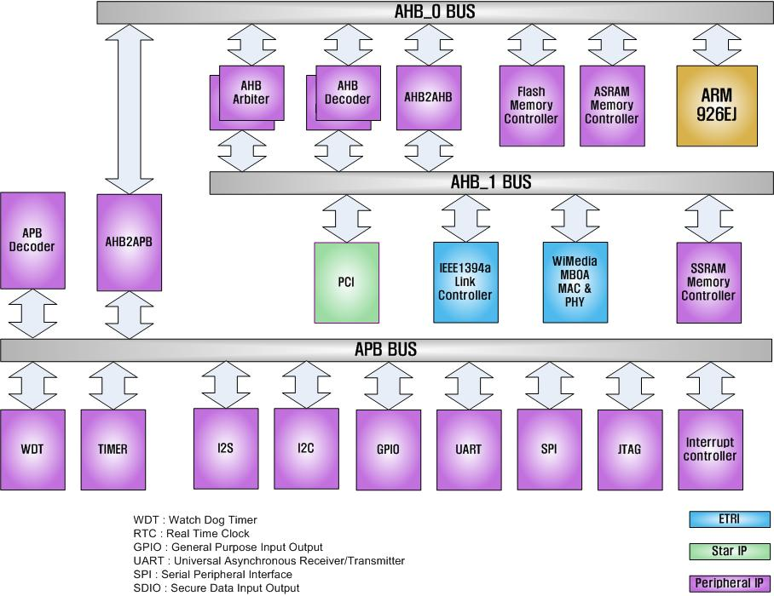

  - Features

- ARM 926 내장
  - Normal operation mode : 100 Mhz
  - 2x operation mode : 200MHz

- UART 2 Channel
- UART 8 depth FIFO 내장한 버전 2 ch

- DDR Controller
- 128/256/512 Mbit

- I2C
- Variable clock rate : 400kHz max.

- I2S
• Configurable Master/Slave.
• ADC(receive) & DAC(transmit) IF for audio Codec.
• IF mode : Standard I2S, MSB(=Left) justified mode(configurable).
• 8/16/24/32bit Word lengths.
• 16k/32k/44.1k/48kHz Sampling Frequency.
• Each 16 word FIFO entries for Transmit & Receive.

- Timer
- Enhaned-DMA

- SPI
• SPI clock speed up to 12MHz.
• Ch-1 :
- 160Byte/10mS @128k Sampling.
- Support DMA.
• Ch-2 :
- Data Length(max) : 64bit(8byte).
- No needs DMA.

- UART
- Special UART (2ch)
- Baudrate : 115200 max
- Tx 32bytes & Rx 32bytes FIFOs.
- 31.25k baudrate support for MIDI.
- Standard UART (2ch)
- Baudrate : 115200 max
- Tx 8bytes & Rx 8bytes FIFOs.

- NAND Flash memory controller
- 32M ~ 2G Byte.
- 512/256 byte, 1-bit ECC.
- Command FIFO/Data FIFO.
- Support small/large block.
- Support SLC/MLC.

- Extra Asynchronous Chip select signal for reservation : 4 (8/16bit).
- Async IF – ex) ROM/Nor-flash/SRAM IF.
- Wait configurable.
- Upto 128M Byte.

ARM926EJ-S

  - Overview

    - Feature

- Base Core : ARM9EJ-S
  - ARM architecture 5TEJ
- Little/Big endian
- Seven operation mode
  - User mode
  - Fast interrupt mode
  - Interrupt mode
  - Supervisor mode
  - Abort mode
  - System mode
  - Undefined mode
- 37 registers
  - 31 general purpose 32bit registers
  - 6 32bit status register
- Cache Size
  - I-Cache : 4way, 8Kbyte
  - D-Cache : 4way, 8Kbyte
- MMU
- AMBA AHB interface
- Three Processor operating state
  - ARM state
  - Thumb state
  - Jazelle state
- Supported Instructions
  - 32bit ARM instruction
  - 16bit Thumb instruction
  - Java byte codes
- System control coprocessor(CP15)
  - With ID code register
  - With Cache and MMU control register

    - Block diagram

Figure 2-2 ARM926EJ-S Block Diagram
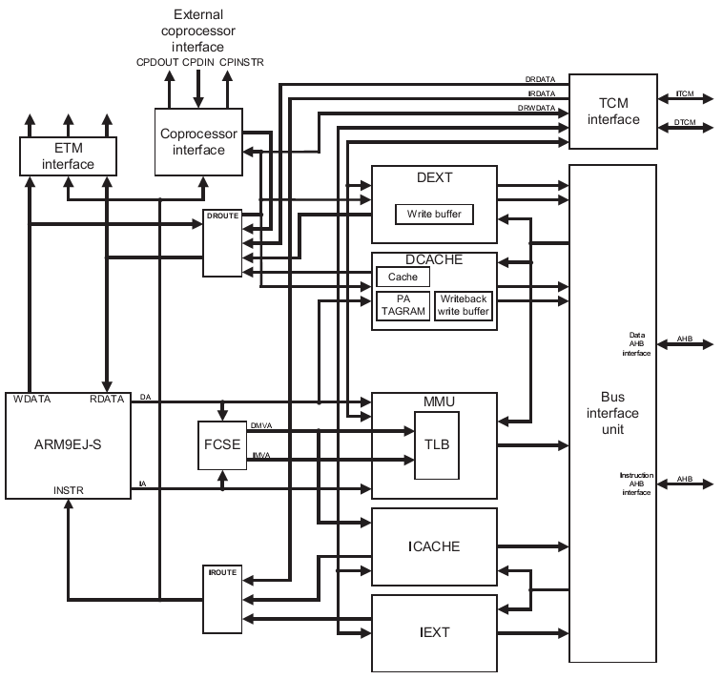

ARM9EJ-S processor core와 I/D cache, MMU, memory interface, coprocessor interface로 구성된다.
Debug를 위해서 ETM(Embedded Trace Macrocell) interface를 갖고 있다.

    - Processor operating state

ARM9EJ-S는 다음과 같이 세 가지의 operating state를 지원한다.
- ARM state : 32bit, word aligned instruction을 수행
- Thumb state : 16bit, half word aligned instruction을 수행
- Jazelle state : variable length, byte aligned instruction을 수행

  - Switching operating state

- ARM ↔ Thumb : BX, BLX 명령을 이용.
- ARM ↔ Jazelle : BXJ 명령을 이용

Exception이 발생하면 ARM state에서 service routine을 수행하고 원래 state로 전환한다.

  - Registers

ARM926EJ-S는 총 37개의 32bit register를 내장하고 있다.
Register들은 다음과 같이 두 가지로 구분할 수 있다.
- 31개의 general purpose register
- 6개의 status register
Register들은 processor operating state에 따라 access할 수 있는 register가 다르게 구성된다.

    - ARM state에서의 register

ARM state 에서는 모든 register를 각 mode에 따라 사용할 수 있다.

Figure 2-3 ARM state에서의 register
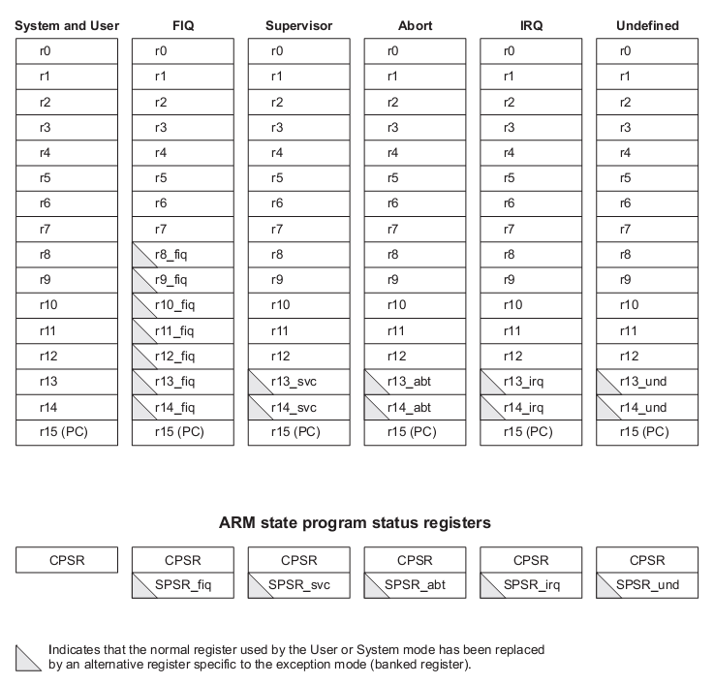

General registers

ARM state에서는 general register중 2개를 특수한 용도로 사용한다.
R15는 program counter로 사용되고, R14는 link register로 사용된다.
R13은 일반적으로 stack pointer로 사용된다.
R13, R14, R15를 제외한 나머지 register는 용도가 규정되어 있지 않다.
Stack pointer와 link register는 mode에 따라 별개의 register를 사용할 수 있도록 여분의 register가 존재한다.
FIQ mode에서는 좀더 빠른 interrupt 처리를 위해서 별도의 R8 ~ R12를 사용하도록 한다.

Status register

ARM9EJ-S는 mode전환시 사용하던 status register의 내용을 backup할 수 있도록 mode별로 별도의 SPSR을 가지고 있다.

    - Thumb state에서의 register

Figure 2-4 Thumb state에서의 register
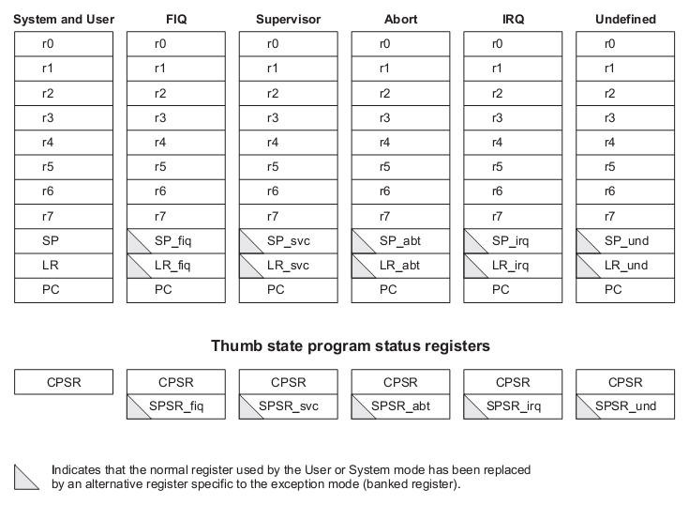

General registers

R0 ~ R7까지 총 8개의 general purpose register를 사용할 수 있다.
이 register들은 특별히 용도를 한정하지 않는다.
이 register는 ARM state에서 R0 ~ R7에 대응된다.

Special registers

총 4가지의 special purpose register가 있다.
- Program counter : ARM state의 R15에 대응.
- Link register : ARM state의 R14에 대응.
- Stack pointer : ARM state의 R13에 대응.
- Status register : 현재 mode의 status register와 각 mode에서 backup하는 SPSR로 구성.

    - Status register

Figure 2-5 Status register
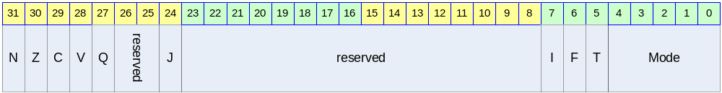

Table 2-1 Status register의 bit 구성
Bits | Name | R/W | Description | Init. value
[31] | N | RW | Negative/Less than | 0b
[30] | Z | RW | Zero | 0b
[29] | C | RW | Carry/Borrow/Extend | 0b
[28] | V | RW | Overflow | 0b
[27] | Q | RW | Sticky overflow | 0b
[25:26] |  |  | reserved
[24] | J | R | Jazelle state bit | 0b
[8:23] |  |  | reserved
[7] | I | RW | IRQ disable | 1b
[6] | F | RW | FIQ disable | 1b
[5] | T | RW | Thumb state bit | 0b
[4:0] | Mode | RW | Mode bits | 00000b

Condition code flags

N, Z, C, V bits.
가장 최근의 연산 결과를 반영한다.
Thumb state에서는 branch 명령만 참조한다.

Q flag

다음과 같은 certain multiply나 fractional arithmetic 명령어에서 사용된다.
- QADD
- QDADD
- QSUB
- QDSUB
- SMLAxy
- SMLAWy

J flag

Processor operating state가 Jazelle state임을 나타냄.

- J = 0 : ARM or Thumb state
- J = 1 : Jazelle state

CPSR의 J flag는 MSR로 변경할 수 없다.

Interrupt disable flags

IRQ와 FIQ를 en/disable한다.
- I = 1 : IRQ를 disable한다.
- F = 1 : FIQ를 disable한다.

T flag

Processor operating state를 Thumb state로 변경한다.

- T = 1 : Processor를 Thumb state로 동작시킨다.
- T = 0 : Processor를 ARM state나 Jazelle state로 동작시킨다.

CPSR의 T flag는 MSR 명령으로 변경해서는 안 된다. 만일 MSR 명령어로 변경하게 되면, processor는 예측할 수 없는 동작을 하게 된다.

Mode bits

Processor의 mode를 결정한다.

Table 2-2 SPR mode bit별 mode설정
M[4:0] | Mode
10000b | User
10001b | FIQ
10010b | IRQ
10011b | Supervisor
10111b | Abort
11011b | Undefined
11111b | System

  - Exceptions

    - Exception vectors

Exception vector의 base address는 CFGHIVECS signal에 의해서 다음과 같이 결정된다.

Table 2-3 Vector base address
Value of CFGHIVECS | Vector base address
0b | 0000 0000h
1b | FFFF 0000h

Table 2-4 Exception vector addresses
Exception | Offset | Mode on entry | I bit on entry | F bit on entry
Reset | 00h | Supervisor | Disabled | Disabled
Undefined instruction | 04h | Undefined | Disabled | Unchanged
Software interrupt | 08h | Supervisor | Disabled | Unchanged
Abort(prefetch) | 0Ch | Abort | Disabled | Unchanged
Abort(data) | 10h | Abort | Disabled | Unchanged
Reserved | 14h | Reserved | - | -
IRQ | 18h | IRQ | Disabled | Unchanged
FIQ | 1Ch | FIQ | Disabled | Disabled

    - Exception priorities

동시에 다수의 exception이 발생할 경우 다음과 같은 우선 순위에 따라 exception을 처리한다.
- Reset(highest priority)
- Data Abort
- FIQ
- IRQ
- Prefetch Abort
- BKPT, Undefined instruction, and SWI(lowest priority)

    - Entering an ARM exception

다음과 과정을 거쳐 exception service routine으로 진입한다.
- Next instruction의 주소를 LR에 저장한다.
- CPSR를 해당 mode의 SPSR로 복사.
- CPSR mode bit을 해당 mode로 설정.
- PC를 exception vector의 주소로 설정하여 다음 명령어를 fetch.

Thumb state나 Jazelle state에서 exception이 발생하면 자동으로 ARM state로 전환되어 exception vector address를 PC로 load한다.

    - Leaving an ARM exception

다음과 과정을 거쳐 exception service를 종료한다.
- LR을 PC로 복사한다.
- S bit이 1이고, rd=r15이면, SPSR을 CPSR에 복사한다. 그리고 interrupt disable flag를 clear한다.

    - Reset

nRESET 핀이 low로 driving 될 경우, processor는 reset 상태에 들어가게 된다.
Reset 상태에서 nRESET 핀이 high로 driving 되면 다음과 같은 동작을 수행하게 된다.
- CPSR의 mode bits을 supervisor mode(10011b)로 설정한다. I와 F flag를 set하여 interrupt를 disable한다. T와 J bit을 clear하여 ARM state로 설정한다.
- PC를 reset vector address로 설정한다.
- ARM state에서 명령어를 수행한다.

Reset후 PC와 CPSR을 제외한 다른 register는 undefined value를 갖는다.

    - Fast interrupt request

FIQ를 위해서 8개의 전용 register를 내장하여 interrupt 응답시간을 줄인다.
Privileged mode에서 F flag를 set하여 FIQ를 disable시킬 수 있다.
FIQ가 발생하면, IRQ와 FIQ 모두 disable된다.
Fast interrupt handler에서 본래 프로그램으로 되돌아 가려면 다음 명령을 수행하면 된다.

SUBS PC, R14_fiq, #4

    - Interrupt request

IRQ는 FIQ보다 우선순위가 낮다.
Privileged mode에서 I flag를 set하여 IRQ를 disable시킬 수 있다.
IRQ가 발생하면, IRQ는 disable된다.
Interrupt handler에서 본래 프로그램으로 되돌아 가려면 다음 명령을 수행하면 된다.

SUBS PC, R14_irq, #4

    - Aborts

Abort exception은 memory operation은 완료되지 못 할 경우 발생한다.
Abort는 다음과 같이 두 가지 경우에 발생하게 된다.
- Prefetch Abort
- Data Abort

Abort exception이 발생하면 IRQ는 diable된다.

Prefetch Abort

Instruction fetch의 마지막에 IABORT signal을 검사하여, prefetched instruction에 invalid라고 marking한 뒤, invalid instruction이 execution stage에 도착했을 때 exception에 진입한다.
만일 branch등에 의해서 invalid instruction이 수행되지 않는다면, exception은 발생하지 않는다.
Prefetch Abort exception에서 본래 프로그램으로 되돌아 가려면 다음 명령을 수행하면 된다.

SUBS PC, R14_abt, #4
위 명령어는 PC와 CPSR을 복원시킨다.

Data Abort

Data abort는 data access cycle의 마지막에 체크되며, read와 write 모두에서 발생할 수 있다.
ARM9EJ-S는 base restored Data Abort model을 사용하는데 이것은 ARM7TDMI-S의 base updated Data Abort model과는 다르다.
base restored Data Abort model은 memory access 명령을 수행하는 중 Data Abort가 발생했을 때, processor 하드웨어가 base register를 명령어가 실행되기 전의 값으로 복원시킨다. 따라서 Data Abort exception handler가 base register를 이전 값으로 복원시킬 필요가 없어지게 되어 handler를 간단하게 구성할 수 있게 된다.
Abort exception은 demand-paged virtual memory system을 사용할 수 있도록 해준다.

Access하는 address의 data가 유효하지 않다면, MMU는 Abort를 발생시킨다. 그러면 Abort exception handler는 abort의 원인을 분석하고, data를 유효하게 한 뒤, processor는 중단된 명령어를 재 시도한다.

Data Abort exception에서 본래 프로그램으로 되돌아 가려면 다음 명령을 수행하면 된다.

SUBS PC, R14_abt, #8
위 명령어는 PC와 CPSR을 복원시킨다.

Software interrupt instruction

SWI(Software interrupt instruction)은 supervisor mode로 진입하여 supervisor function의 수행을 요구하는데 사용된다.
SWI handler는 opcode를 이용하여 SWI function 번호를 구한다.
SWI가 발생하면, IRQ는 disable된다.

SWI는 다음 명령을 수행하여 SWI의 다음 명령어 주소로 되돌아 갈 수 있다.

MOVS PC, R14_svc
위 명령은 PC와 CPSR을 복원시킨다.

Undefined instruction

ARM의 명령어를 확장하는데 이 exception을 사용할 수 있다. 이 exception이 발생하면 IRQ는 disable된다.
다음 명령을 수행하여 emulated instruction의 다음 명령어로 되돌아 갈 수 있다.

MOVS PC, R14_und
위 명령은 CPSR도 복원시킨다.

Breakpoint instruction(BKPT)

Breakpoint instruction은 Prefetch Abort를 발생시킨다. 만일 branch등에 의해서 breakpoint instruction이 수행되지 않는다면 Prefetch Abort는 발생하지 않는다.

Breakpoint에 대한 처리가 끝나면 다음 명령을 수행하여 break point의 명령을 수행하게 된다.

SUBS PC, R14_abt, #4
위 명령어는 PC와 CPSR을 복원시킨다.

Programmer’s model

  - Overview

  - Memory Map

    - Overview

Internal SRAM 128Kbytes는 마찬가지로 필요에 의해서 부팅시에는 내부 메모리에 보이고 부팅이 종료된 뒤에는 필요에 따라서 외부 메모리로 보여야한다.

    - Memory Map

Figure 3-6 FPGA Platform Memory Map

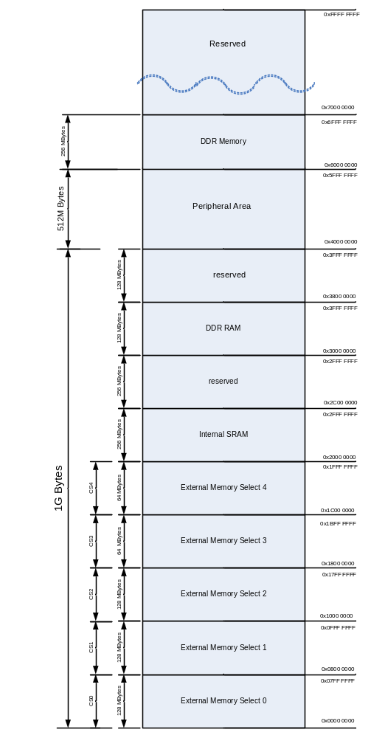

각각의 Memory bank는 ARM926EJS의 MMU 설정에 의해서 Cacheable 혹은 non cacheable 영역으로 설정될 수 있다.

  - Peripherals

    - Peripheral Memory Map

Figure 3-7 FPGA Platform Peripheral Memory MAP

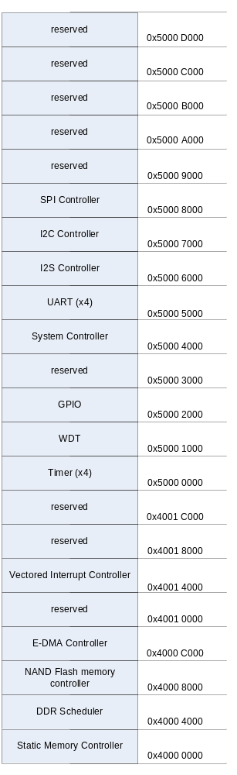

  - Boot sequence

    - Direct boot mode

External ROM에서 직접 부팅한다. 이 모드로 부팅하기 위해서 외부 Boot mode[1:0] pin을 “00”으로 설정한 후 Reset 신호를 준다.

External ROM이 어드레스 0x0000 0000으로 매핑이 되어 진행된다.

절차는 다음과 같다.

- Boot mode pin [1:0] 설정
- Reset
- External ROM에서 부팅

System control

  - Overview
시스템의 제어 및 관련 정보를 설정하거나 얻을 수 있는 레지스터의 모음
전원 관리등을 수행한다.

- Support Slow Mode.
- Operate by External Clock divided or not
- Support CPU Idle Mode.
- Disconnect Only CPU Clock
- Wake Up From Any Interrupt
- Support Power Down Mode.
  - Disconnect All Clock
  - Wake Up From External Interrupt

  - Registers

    - Information Register

Offset : 0x0000 0000
Bits | Name | R/W | Description | Init. value
31:14 | Reserved | R | Reserved | 0000 0000h
13 | RSTWDT | R | Reset by watchdog  1 : Reseted by watch dog  0 : Reseted by external H/W
12:11 | EXTBWIDTH | R | External Memory Width  00 : 8 Bit  01 : 16 Bit  1x : Reserved  외부 버스의 크기의 설정을 받아 들인다.  핀 할당은 하나가 되어 있으나 내부에는 향후 32비트 버스를 대비해서 1비트를 그냥 ‘0’으로 고정되어 있다
10 | UBOOTSZE | R | Uart download data bit size  0 : 16 K Bytes  1 : 32 K Bytes
9:8 | Boot Mode | R | Boot mode  11 : Reserved  10 : UART boot mode  01 : NAND flash memory boot mode  00 : Direct boot mode  Boot mode에 따른 설정 값이다.  외부 핀 2개를 할당하여 Reset시에 설정된 상태를 파악한 후 이 값이 그대로 읽혀진다
7:4 | MAJOR | R | Major Number  버전 번호를 가지고 있다.  첫번째 버전은 0x01이 된다. | 0x01
3:0 | MINOR | R | Minor version number  0x0 : Non MCP Version  0x1 : MCP Version  MCP 여부를 검사한다. | 0x00

Resource Share Register

Offset : 0x0000 0004

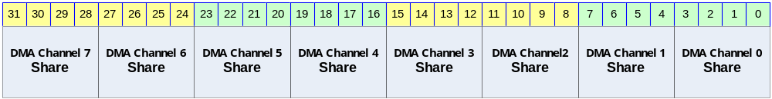

Bits | Name | R/W | Description | Init. value
[31:28] | DMA Channel 7  Share | R/W | DMA Channel 7 Input selection | 0x0
[27:24] | DMA Channel 6  Share | R/W | DMA Channel 6 Input selection | 0x0
[23:20] | DMA Channel 5  Share | R/W | DMA Channel 5 Input selection | 0x0
[19:16] | DMA Channel 4  Share | R/W | DMA Channel 4 Input selection | 0x0
[15:12] | DMA Channel 3  Share | R/W | DMA Channel 3 Input selection | 0x0
[11:8] | DMA Channel 2  Share | R/W | DMA Channel 2 Input selection | 0x0
[7:4] | DMA Channel 1  Share | R/W | DMA Channel 1 Input selection | 0x0
[3:0] | DMA Channel 0  Share | R/W | DMA Channel 0 Input selection | 0x0

각 채널의 입력 값은 아래와 같이 설정된다.

Value | Selected Input
0 | Nand flash memory DMA Request
1 | resurved
2 | resurved
3 | I2S Tx DMA Req
4 | I2S Rx DMA Req
5 | SPI 0 Tx DMA Request
6 | SPI 0 Rx DMA Request
7 | UART Channel 0 Tx Dma Request
8 | UART Channel 0 Rx Dma Request
9 | UART Channel 1 Tx Dma Request
10 | UART Channel 1 Rx Dma Request

    - System Configuration Register

Offset : 0x0000 0008

Bits | Name | R/W | Description | Init. value
31 | SRST | R/W | Software Reset  0 : No Effect  1 : Warm reset  1을 기록할 경우 S/W에 의한 리셋이 발생한다.  레지스터의 값이나 다른 값은 변동이 없이 CPU Core의 리셋이 걸리게 된다.  해당 비트가 ‘1’인 경우 나머지 비트들은 영향 받지 않는다. | 0000 0000h
30 | ARMOPCLK | R/W | ARM926EJS Operation clock  0 : 1x Clock  1 : 2x Clock  PLL이 설정된 후 ARM026EJS가 동작하는 주파수를 결정한다. 2x Clock 동작 모드로 동작하는 경우는 Bus의 동작 주파수에 2배의 속도로 동작하는 모드이다. 1x Clock 모드는 Bus의 동작 주파수와 같은 주파수로 동작한다. 2x Clock 모드인 경우 전력 소모가 1x Clock 모드보다 전력 소모가 높다.
29:2 | Reserved |  | Reserved
1 | Reserved | R/W | Must be 0. | 0
0 | Reserved | R/W | Must be 1. | 1

Static Memory Controller

Overview

Feature

- AXI Slave Interface.
- Support 5-BANK
- Programmable access cycle
- Programmable device bus Width(8/16/32)
- Programmable address shift(1bit/2bit)

Block Diagram

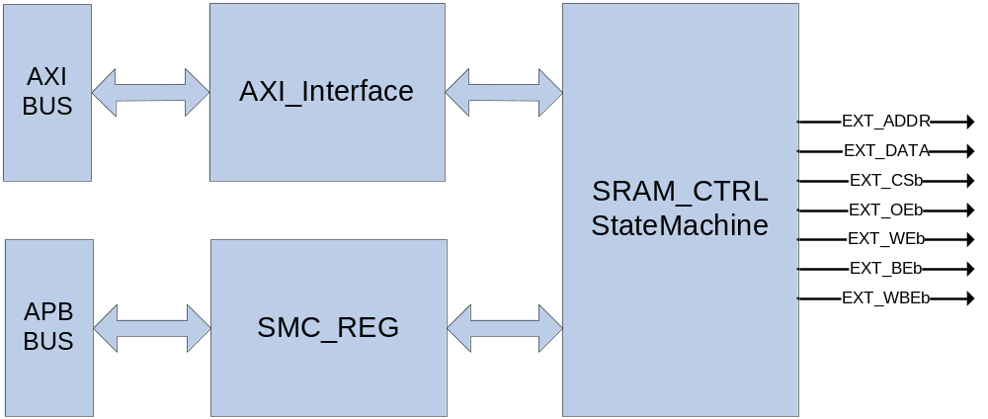

Signal Description

Table 5-5 ESMC Signal
Signal Name | Direction | Description | Init. value
EXT_ADDR[26:0] | Output | Address signal
EXT_DATA[31:0] | InOut | 32bit Data Input/Output signal
EXT_CSb[4:0] | Output | Chip select (active low)
EXT_OEb | Output | Output Enable signal(active low)
EXT_Web | Output | Write Enable signal(active low)
EXT_BEb[3:0] | Output | Byte Enable signal(active low)
EXT_WBEb[3:0] | Output | Write byte enable signal(active low)

EXT_BEb[0]은 EXT_DATA[7:0],EXT_BEb[1]은 EXT_DATA[15:8],EXT_BEb[2]는 EXT_DATA[23:16],
EXT_BEb[4]는 EXT_DATA[31:24]을 Enable/Disable한다.

EXT_BEb는 ChipSelect 신호(EXT_CSb)와 같은 timing을 가지고 EXT_WBEb는 WriteEanble 신호 (EXT_WEb)와 같은 timing을 가진다.

Address Map

Table 5-6 Address Map
Name | Start Address | End Address
External SRAM(CS0:128M)  WaveROM과 공유 | 0x0000 0000 | 0x07FF FFFF
External SRAM(CS1:128M) | 0x0800 0000 | 0x0FFF FFFF
External SRAM(CS2:128M) | 0x1000 0000 | 0x17FF FFFF
External SRAM(CS3:64M) | 0x1800 0000 | 0x1BFF FFFF
External SRAM(CS4:64M) | 0x1C00 0000 | 0x1FFF FFFF

Timing
Figure 5-8 Timing
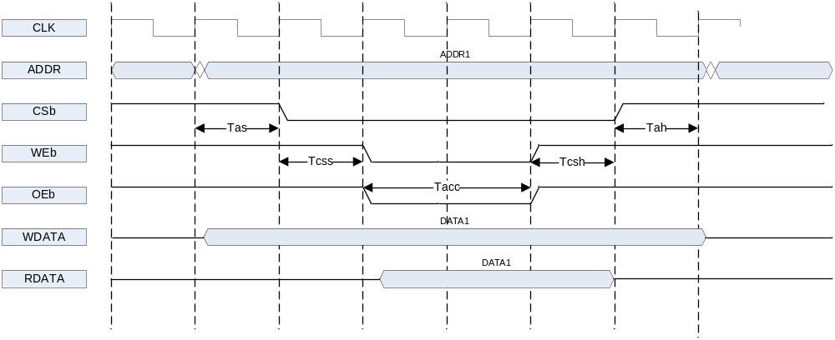

Timing diagram에 있는 time 정보에 대한 약자는 다음과 같다.

Tas : address setup time
Tcss : chip select setup time
Tacc : access time
Tcsh : chip select hold time
Tah : addrese hold time

기본적으로 address 출력이 제일 먼저 이루어 진다. Address setup time이 지난 다음에 CSb가 low가 되고 그 다음 Chip select setup time이 지나면 Output Enable 혹은 Write Enable신호가 low가 된다.
Access time이 지나면 RDATA를 latch하게 되고 그 다음 chip select hold time, address hold time이 지나면 모든 access가 끝나게 된다.

Tas, Tcss, Tacc, Tcsh, Tah를 system clock(정확하게는 AXI interface clock) cycle수로 정할 수 있는 register가 각 bank 별로 존재한다.

Interface

32bit SRAM의 경우 EXT_DATA의 32bit을 모두 사용하면 되고, 16bit SRAM의 경우 EXT_DATA[15:0]만, 8 bit SRAM의 경우 EXT_DATA[7:0]만 연결하여 사용한다.
EXT_ADDR은 0번 bit부터 연결한 후에 각 bank별 Address shift register를 조정하여도 되고 아니면 SRAM의 bit width에 맞추어 하위 1bit 혹은 2bit를 빼고 연결해도 된다.
EXT_CSb와 EXT_OEb, EXT_WEb는 SRAM의 각 pin에 연결하면 되고, SRAM이 byte enable
signal을 가지고 있으면 EXT_BEb에 연결한다.
여기서 주의할 사항이 하나 있는데, 외부의 device가 ByteEnable pin이 없는 device라면 Write Enable pin에 EXT_WEb를 연결하지 말고 EXT_WBEb를 연결해야 한다. 보통의 8bit SRAM도 byte enable pin이 없으므로 동일하다. AXI Write data channel에서 WSTRB가 모두 0으로 된 signal이 들어올 수 있는데 그런 경우에는 EXT_WEb는 low로 떨어지는데 EXT_WBEb는 high로 유지가 되기 때문이다.

Interface Example

EXT_ADDR[26:0]은 메모리 크기에 따라 붙여준다 아래 그림에서는 A[15:0]인 메모리를 예로 들었다.

Figure 5-9 Interface 8bit memory
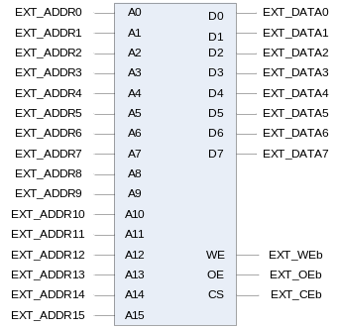
Figure 5-10 Interface 8bit memory x2
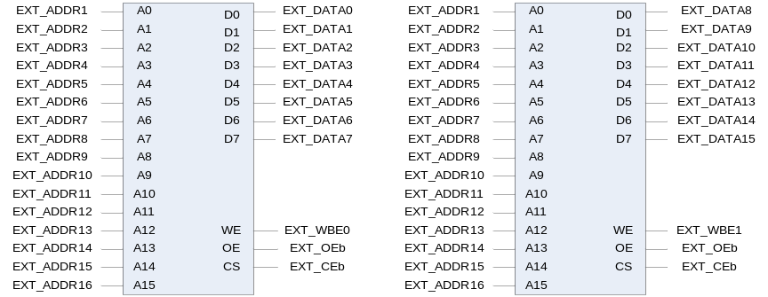
Figure 5-11 Interface 8bit memory x4
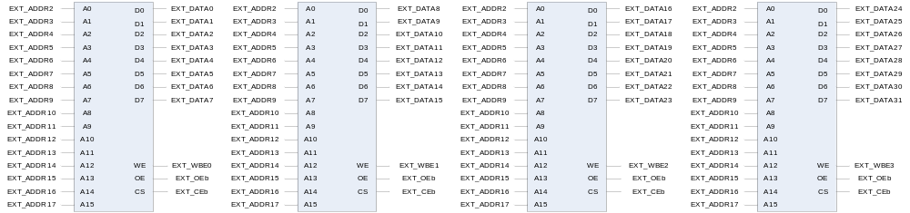

Figure 5-12 Interface 16bit memory
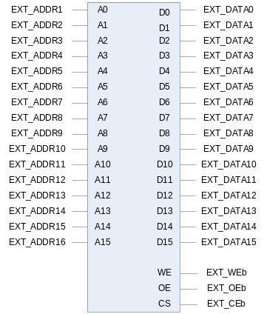

Figure 5-13 Interface (byte enable이 있는)16bit memory
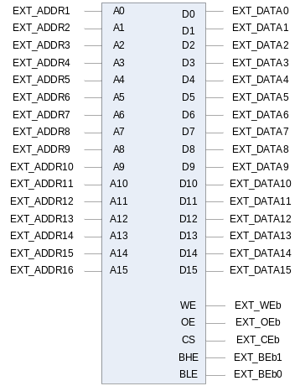
Figure 5-14 Interface (byte enable이 있는)16bit memoryx2
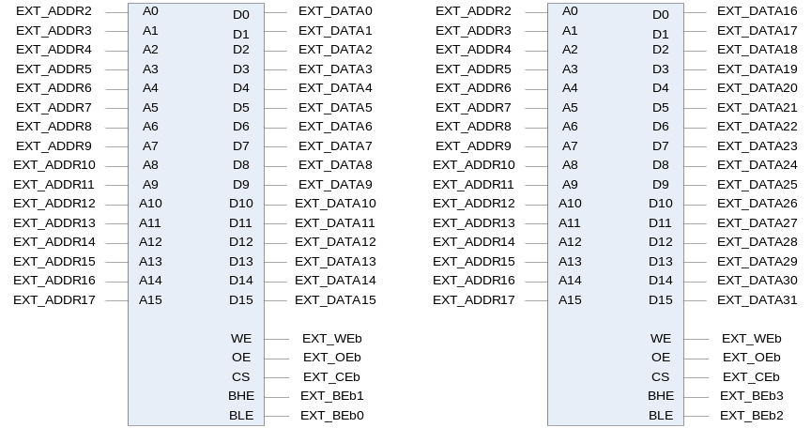

Register Description

Registers

External Sram Controller는 총 4개의 BANK를 가지고 있으며 각 BANK별로 Timing과 Bus Width, Address Shift여부를 셋팅 할수 있다.

Table 5-7 Registers
Offset | Name | R/W | Description | Init. value
0000h | SMC_BANK0 | R/W | BANK0 Control
0004h | SMC_BANK1 | R/W | BANK1Control
0008h | SMC_BANK2 | R/W | BANK2Control
000Ch | SMC_BANK3 | R/W | BANK3Control
0010h | SMC_BANK4 | R/W | BANK4Control

SMC_BANKx Register

각각의 BANK Register는 아래와 같은 구성을 가진다.

Figure 5-15 SMC_BANKx Register
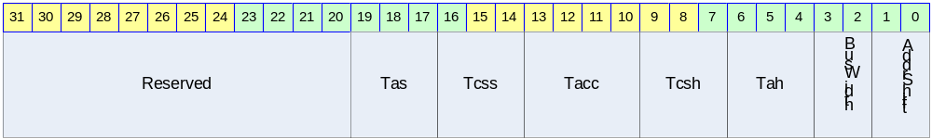

Table 5-8 SMC_BANKx Register (Offset : 0000 0000h~0000 000ch)
Bits | Name | R/W | Description | Init. value
[19:17] | Tacs | R/W | Address set-up time before csb  000 = 0clock 001 = 1clock  010 = 2clock 011 = 3clock  100 = 4clock 101 = 5clock  110 = 6clock 111 = 7clock
[16:14] | Tcos | R/W | Chip selection set-up time before oeb, web  000 = 0clock 001 = 1clock  010 = 2clock 011 = 3clock  100 = 4clock 101 = 5clock  110 = 6clock 111 = 7clock
[13:10] | Tacc | R/W | Access cycle  0000=1clock 0001=2clock  0010=3clock 0011=4clock  0100=5clock 0101=6clock  0110=7clock 0111=8clock  1000=9clock 1001=10clock  1010=11clock 1011=12clock  1100=13clock 1101=14clock  1110=15clock 1111=16clock
[9:7] | Tcoh | R/W | Chip selection hold time after oeb, web  000 = 0clock 001 = 1clock  010 = 2clock 011 = 3clock  100 = 4clock 101 = 5clock  110 = 6clock 111 = 7clock
[6:4] | Tcah | R/W | Address hold time after csb  000 = 0clock 001 = 1clock  010 = 2clock 011 = 3clock  100 = 4clock 101 = 5clock  110 = 6clock 111 = 7clock
[3 : 2] | BusWidth | R/W | SRAM Bus Width  00=8bit 01=16bit 10=32 bit 11= reserved
[1 : 0] | AddrShift | R/W | Address shift by right  00=0bit 01=1bit 10=2bit 11= reserved

DDR-RAM Scheduler

Overview

Feature

- Support Maximum 16 Wrap/Increment Burst.
- Support Up to 4 Physical Memory Banks
- Up to 4 Simultaneous Open Banks
- Self-Refresh, DDR SDRAM Power Save Feature
- Programmable Timing latencies and refresh rates.
- Support Up to 128MBytes DDR SDRAM.
- Support 16 Bit DDR SDRAM Interface.
- Configurable Data FIFO Depth.
- Maximum 80% Data Bandwidth
  - Maximum 425MBytes/Sec, if Full Bandwidth is 532MBytes/Sec at 133MHz Memory Clock and 32Bit Memory Width
  - Condition is Consecutive Incremental Read Burst 8
  - If Random Read or Write Applied then Data Bandwidth is Maximum 60%

Block Diagram

Figure 6-1 AXI Interface DDR SDRAM Controller Top Block Diagram
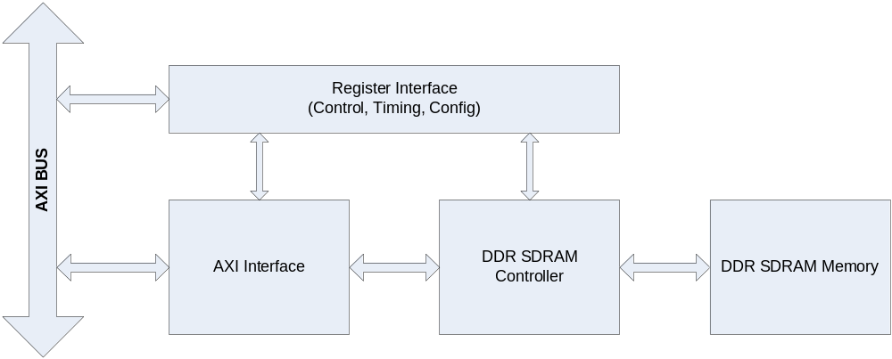

Operation

AXI Interface DDR SDRAM Controller는 3개의 Block으로 나눌 수 있다.
DDR SDRAM의 Configuration, Timing 및 Control에 필요한 Register 인터페이스 블록과 AXI BUS 인터페이스 블록 및 실제 Memory의 Timing에 맞게 Read나 Write할 Data, Address 및 Command를 생성하는 블록이다.

AXI BUS Interface Block

AMBA3 AXI BUS는 Write Command Channel, Write Data Channel, Write Response Channel, Read Command Channel, Read Data Channel 등의 5 채널로 나눌 수 있다.
DDR SDRAM 메모리는 Read나 Write를 동시에 처리할 수 없으므로 이 블록에서 Read와 Write에 대한 Command를 Arbitration 해야 한다.

Write Control FSM
Memory Controller에 보낼 Write Command와 Address, Data 및 부가 정보를 Control하는 메인 Finite State Machine이다.

Read Control FSM
Memory Controller에 보낼 Read Command와 Address 및 부가 정보를 Control하는 메인 Finite State Machine이다.

Address/Control Mux
Read/Write 각 FSM에 의해 생성된 Command, Address 및 부가 정보를 Multiplexing하여 DDR SDRAM Memory Controller에 전달하는 역할을 한다.

Write Data Control
Write Control FSM과 DDR SDRAM Memory Controller에서 생성된 Memory Write Data Valid에 의해 Write Buffer의 Data Management를 담당한다.

Write Buffer

FIFO 구조이고 Configuration 가능하다.

Read Data Control
DDR SDRAM Memory Controller에서 생성된 Memory Read Data Valid에 의해 Read Buffer의 Data Management를 담당한다.

Read Buffer

FIFO 구조이고 Configuration 가능하다.

Wrap, Increment Miss Calculation
DDR SDRAM의 Wrap Burst Mode를 사용하므로 Data의 Increment Burst에서 Data의 Miss의 처리를 담당한다. 즉, DDR SDRAM의 Wrap Burst Boundary를 넘으면, Burst를 Split 시켜준다.

다음 그림은 AXI BUS Interface Block을 나타낸다. AXI Write Channel과 Read Channel을 Arbitration하여 메모리에 전달할 Address와 Control 및 부가정보를 만들고, Data는 FIFO에 저장하여 처리하여 AXI BUS의 Wrap Burst 처리가 가능하며, FIFO Depth를 늘릴 수 있어Latency가 긴 DDR SDRAM 메모리의 효율을 높일 수 있다.

Figure 6-2 DDR SDRAM AXI BUS Interface Block Diagram
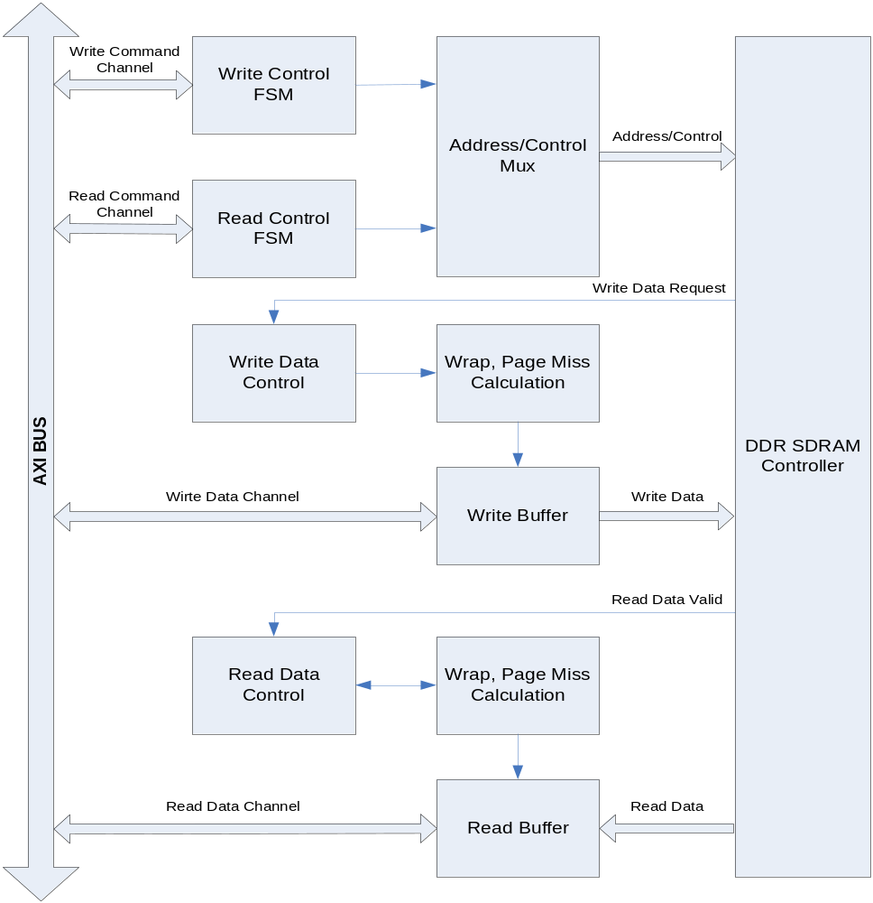

DDR SDRAM Controller Block

Initialize & Refresh & Power Down FSM
DDR SDRAM의 초기화에 필요한 Timing을 생성하고, Refresh Count에 의해 Auto Refresh Command Timing을 만들며, Power Down을 위한 Self Refresh Mode 진입에 필요한 Timing을 만드는 역할을 한다.

Master FSM
DDR SDRAM Controller의 Main State Machine으로써 DDR SDRAM 동작의 Timing을 제어한다.

Bank/Time FSM
DDR SDRAM의 Timing에 맞게 각 Bank의 Row를 Open하는 역할과 Data Read/Write Timing을 생성한다.

RAS Machine
AXI BUS Interface에서 보내온 Row Address를 FSM에서 생성한 적절한 Timing에 내 놓는다.

Cas Machine
AXI BUS Interface에서 보내온 Column Address를 FSM에서 생성한 적절한 Timing에 내 놓는다.

Write Data
AXI BUS Interface에서 보내온 Data를 FSM에서 생성한 적절한 Timing에 내 놓는다.

Read Data
DDR SDRAM Memory에서 보내온 Data를 FSM에서 생성한 적절한 Timing에 AXI BUS Interface에 보낸다.

DDR SDRAM Controller는 다음 그림과 같이 Initialize & Refresh & Power Down FSM, Master FSM, Bank/Time FSM, RAS Machine, Cas Machine, Address/Control Mux. 및 Read/Write Data 부분으로 나눌 수 있다.

Figure 6-3 DDR SDRAM Controller Block Diagram

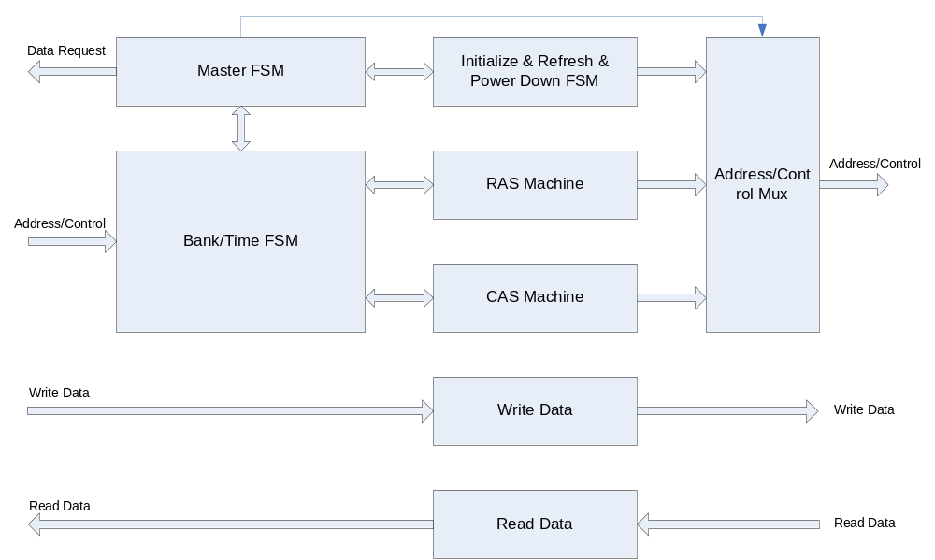

DDR SDRAM Controller Timing Description

그림에서 Row/Bank Open은 생략되어 있고, RAS Buffer가 채워져 있으면 꺼내서 미리 Row와 Bank를 열어 놓는 구조이므로 일단 열린 Row/Bank(Same Row at Different Bank나 Different Row at Same Bank)에서 연속적으로 Read/Write가 가능하다. Row/Bank를 Open하는 시간과 FIFO 상황과 Auto Refresh Time을 고려하면, 80% 이상의 Memory BandWidth가 가능하다.
DDR SDRAM은 Burst 8 Mode와 Read/Write Without Auto Precharge Mode를 사용한다.

다음에서 n=7, 즉 DDR SDRAM의 Burst 8을 사용할 경우의 예제이다.

Read to Read
Same Row at Different Bank or Different Row at Same Bank
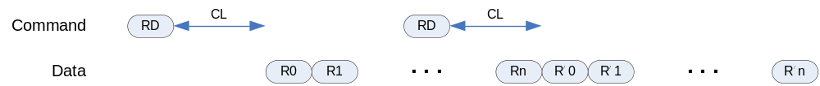

Same Row at Same Bank Read → PreCharge
Ras/Cas Queue Empty Read → PreCharge All Bank
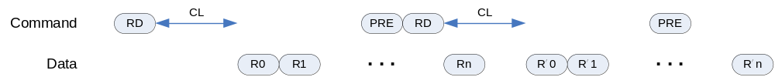

Read to Write
Same Row at Different Bank or Different Row at Same Bank
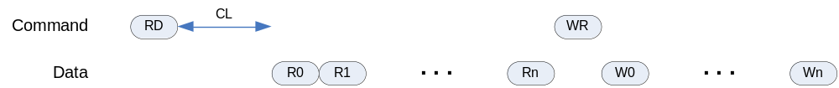
Same Row at Same Bank Read → PreCharge
Ras/Cas Queue Empty Read → PreCharge All Bank

Write to Write
Same Row at Different Bank or Different Row at Same Bank

Same Row at Same Bank Write → PreCharge All Bank after tWR
Ras/Cas Queue Empty Write → PreCharge All Bank after tWR
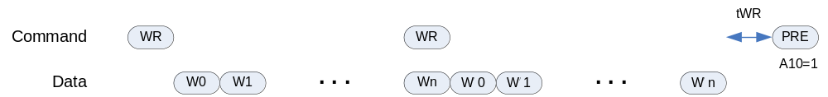

Write to Read
Same Row at Different Bank or Different Row at Same Bank
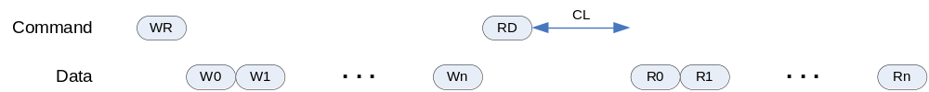

Same Row at Same Bank Write → PreCharge All Bank after tWR
Ras/Cas Queue Empty Write → PreCharge All Bank after tWR
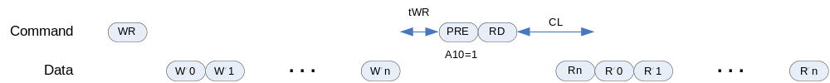

Register Description

DDR SDRAM Registers

Table 6-9 DDR SDRAM Registers(Base Address : 1FFF 0000h)
Offset | Name | R/W | Description | Init. value
0000h | DDRTCON | RW | DDR SDRAM Timing Control Register | 0000 B91Ah
0004h | DDRCON | RW | DDR SDRAM Control Register | 0000 0000h
0008h | DDRPCON | RW | DDR SDRAM Power Control Register | 0000 FFFFh
000Ch | DDRREF | RW | DDR SDRAM Refresh Control Register | 0000 0410h
0010h | DDRCFG | RW | DDR SDRAM Configuration Register | 0000 0000h

DDR SDRAM TIMING Control Register

Figure 6-4 DDR SDRAM Timing Control Register Bits
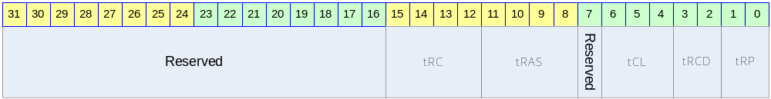

Table 6-10 DDR SDRAM Timing Control Register Description(Offset : 0000 0000h)
Bits | Name | R/W | Description | Init. value
[31:16] |  |  | Reserved | 0
[15:12] | tRC | RW | Row Cycel Time | Bh
[11:8] | tRAS | RW | Minimum Row Active Time | 8h
 |  |  | Reserved | 0
[6:4] | tCL | RW | Cas Latency For Read Data  1 : CL2  2 : CL2.5 | 1h
[3:2] | tRCD | RW | Ras to Cas Delay | 2h
[1:0] | tRP | RW | Precharge Time | 2h

DDR SDRAM Control Register

Figure 6-5 DDR SDRAM Control Register Bits
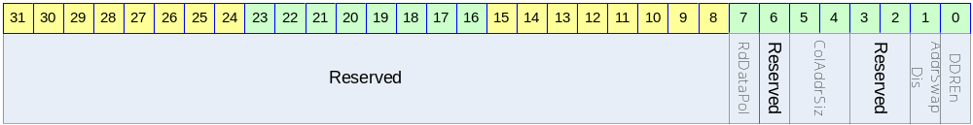

Table 6-11 DDR SDRAM Control Register Description(Offset : 0000 0004h)
Bits | Name | R/W | Description | Init. value
[31:8] |  |  | Reserved | 0
[7] | RdDataPol | RW | Read Data Latch Polarity  0 : Latch at Rising Edge  0 : Latch at Falling Edge | 0
[6] |  | RW | Reserved | 0
[5:4] | ColAddrSiz | RW | Column Address Size  0 : 8 Bit, 16MB  1 : 9 Bit, 32MB  2 : 10 Bit, 64MB  3 : 11 Bit, 128MB | 0
[3:2] |  |  | Reserved | 0
[1] | AddrSwapDis | RW | Address Swap Disable  0 : Swap : RA-BA-CA  1 : Normal : BA-RA-CA | 0
[0] | DDREn | RW | DDR SDRAM Enable  0 : Disable  1 : Enable | 0

DDR SDRAM Power Control Register

Figure 6-6 DDR SDRAM Power Control Register Bits
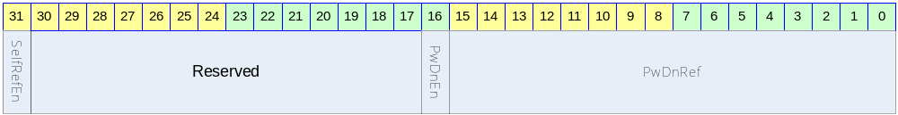

Table 6-12 DDR SDRAM Power Control Register Description(Offset : 0000 0008h)
Bits | Name | R/W | Description | Init. value
[31] | SelfRefEn | RW | DDR SDRAM Self Refresh Enable  0 : Disable  1 : Enable | 0
[30:17] |  |  | Reserved | 0
[16] | PwDnEn | RW | Auto Power Down Enable  0 : Disable  1 : Enable | 0
[15:0] | PwDnRef | RW | Auto Power Down Count  PwDnEn이 Enable 되었고, Master에서 메모리 요구가 없을 때부터 설정된 값만큼 Down Counting이 시작 되며, 이 Zero 가 되면 자동으로 DDR의 Power Down Mode로 진입한다. | ffffh

DDR SDRAM Refresh Control Register

Figure 6-7 DDR SDRAM Refresh Control Register Bits
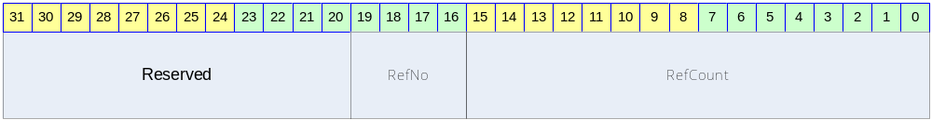

Table 6-13 DDR SDRAM Refresh Control Register Description(Offset : 0000 000Ch)
Bits | Name | R/W | Description | Init. value
[30:20] |  | RW | Reserved | 0
[19:16] | RefNo | RW | Refresh Number  Refresh cycle 마다 수행되는 Refresh 개수 | 0
[15:0] | RefCount | RW | Refresh Count  7.8usec Refresh time  RefNo가 7일 경우에는 2080h 값을 넣어 준다.  즉, 2080 cycle마다 8번의 Refresh를 한꺼번에 한다는 의미이다. | 0410h

DDR SDRAM Configuration Register

Figure 6-8 DDR SDRAM Configuration Register Bits
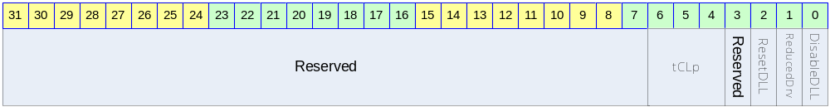

Table 6-14DDR SDRAM Configuration Register Description(Offset : 0000 0010h)
Bits | Name | R/W | Description | Init. value
[30:7] |  | RW | Reserved | 0
[6:4] | tCLp | W | 2 : DDR SDRAM CL2 설정  6 : DDR SDRAM CL2.5 설정 | 2
[3] |  |  | Reserved
[2] | ResetDLL | W | DDR SDRAM DLL Reset Enable | 1
[1] | ReducedDrv | W | DDR SDRAM Reduced Drive Mode Enable | 0
[0] | DisableDLL | W | DDR SDRAM DLL Disable | 0

Vectored interrupt controller

  - Overview

Support 8 external interrupt source
Priority programmable

    - General features
- Support 32-interrupt sources
- All interrupt sources are mask able
- Support a fixed and round robin priority mode
- Programmable vectored interrupt
- Programmable polarity
- Programmable level- and edge-triggered mode

Figure 7-16 Block diagram

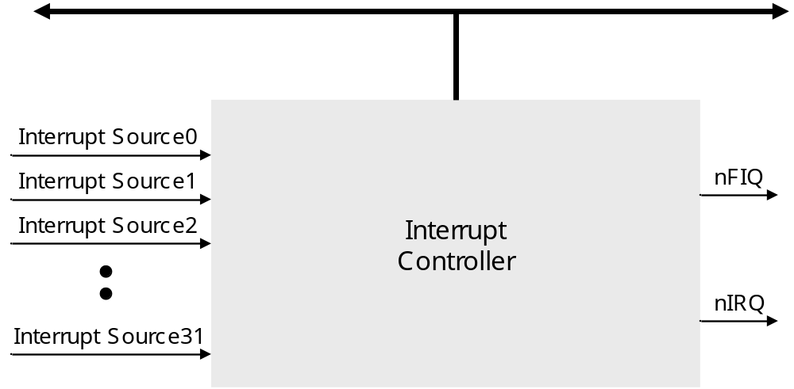

  - Registers

Register | Addr | R/W | Description | Reset Value
INTCON | 0x00 | R/W | Interrupt control Register | 0xB
INTPND | 0x04 | R/W | Indicates the interrupt request status of each source.  0 = The interrupt has not been required  1 = The interrupt source has asserted the interrupt request | 0x00000000
INTMOD | 0x08 | R/W | Interrupt mode Register  0 = nIRQ mode, 1 = nFIQ mode | 0x00000000
INTMSK | 0x0C | R/W | Determines which interrupt source is masked.  The masked interrupt source will not be serviced.  0 = Interrupt service is available  1 = Interrupt service is masked | 0xFFFFFFFF
LEVEL | 0x10 | R/W | 0 = Edge-triggered interrupt  1 = Level-triggered interrupt | 0x00000000
I_PSLV0 | 0x14 | R/W | nIRQ priority of slave register 0 | 0xFAC688
I_PSLV1 | 0x18 | R/W | nIRQ priority of slave register 1 | 0xFAC688
I_PSLV2 | 0x1C | R/W | nIRQ priority of slave register 2 | 0xFAC688
I_PSLV3 | 0x20 | R/W | nIRQ priority of slave register 3 | 0xFAC688
I_PMST | 0x24 | R/W | nIRQ priority of master register | 0x1FE4
I_CSLV0 | 0x28 | R | Current nIRQ priority of slave register 0 | 0xFAC688
I_CSLV1 | 0x2C | R | Current nIRQ priority of slave register 1 | 0xFAC688
I_CSLV2 | 0x30 | R | Current nIRQ priority of slave register 2 | 0xFAC688
I_CSLV3 | 0x34 | R | Current nIRQ priority of slave register 3 | 0xFAC688
I_CMST | 0x38 | R | Current nIRQ priority of master register | 0x1FE4
I_ISPR | 0x3C | R | nIRQ interrupt service pending register(Only one service bit set) | 0x00000000
I_ISPC | 0x40 | W | nIRQ interrupt service clear register (whatever to be set, it will be cleared with INTPND automatically) | Undefined
F_PSLV0 | 0x44 | R/W | nFIQ priority of slave register 0 | 0xFAC688
F_PSLV1 | 0x48 | R/W | nFIQ priority of slave register 1 | 0xFAC688
F_PSLV2 | 0x4C | R/W | nFIQ priority of slave register 2 | 0xFAC688
F_PSLV3 | 0x50 | R/W | nFIQ priority of slave register 3 | 0xFAC688
F_PMST | 0x54 | R/W | nIRQ priority of master register | 0x1FE4
F_CSLV0 | 0x58 | R | Current nFIQ priority of slave register 0 | 0xFAC688
F_CSLV1 | 0x5C | R | Current nFIQ priority of slave register 1 | 0xFAC688
F_CSLV2 | 0x60 | R | Current nFIQ priority of slave register 2 | 0xFAC688
F_CSLV3 | 0x64 | R | Current nFIQ priority of slave register 3 | 0xFAC688
F_CMST | 0x68 | R | Current nFIQ priority of master register | 0x1FE4
F_ISPR | 0x6C | R | nFIQ interrupt service pending register | 0x00000000
F_ISPC | 0x70 | W | nFIQ interrupt service clear register | Undefined
POLARITY | 0x74 | R/W | It determines whether the interrupt signals are active low or not.  0 = Active High  1 = Active Low | 0x00000000
I_VECADDR | 0x78 | R | It is useful for the system software to reduce the interrupt service time. The encoded address can be used as a offset address for the nIRQ interrupt directly without searching the interrupt pending register.  It is used as an offset value for the interrupt vector table entry. | 0x00
F_VECADDR | 0x7C | R | It is useful for the system software to reduce the interrupt service time. The encoded address can be used as a offset address for the nFIQ interrupt directly without searching the interrupt pending register.  It is used as an offset value for the interrupt vector table entry. | 0x00

    - INTERRUPT CONTROL REGISTER(INTCON)

INTCON | Bit | R/W | Description | Reset Value
Reserved | [31:4] |  | Reserved
GIE | [3] | R/W | Global interrupt enable(GIE)비트가 ‘1’이.면 모든 인터럽트가 Disable이 된다  0 = Global interrupt enable  1 = Global interrupt disable | 1
VECTORED | [2] | R/W | Vectored interrupt enable  0 = Non-vectored interrupt  1 = Vectored interrupt | 0
nENBIRQ | [1] | R/W | This bit determines enable/disable for nIRQ  0 = nIRQ interrupt enable  1 = nIRQ interrupt disable | 1
nENBFIQ | [0] | R/W | This bit determines enable/disable for nFIQ  0 = nFIQ interrupt enable  1 = nFIQ interrupt disable | 1

    - INTERRUPT PENDING REGISTER(INTPND)

INTPND | Bit | R/W | Description | Reset Value
SOURCE_31 | [31] | R | 0 = Not requested, 1 = Requested | 0
SOURCE_30 | [30] | R | 0 = Not requested, 1 = Requested | 0
SOURCE_29 | [29] | R | 0 = Not requested, 1 = Requested | 0
SOURCE_28 | [28] | R | 0 = Not requested, 1 = Requested | 0
SOURCE_27 | [27] | R | 0 = Not requested, 1 = Requested | 0
SOURCE_26 | [26] | R | 0 = Not requested, 1 = Requested | 0
SOURCE_25 | [25] | R | 0 = Not requested, 1 = Requested | 0
SOURCE_24 | [24] | R | 0 = Not requested, 1 = Requested | 0
SOURCE_23 | [23] | R | 0 = Not requested, 1 = Requested | 0
SOURCE_22 | [22] | R | 0 = Not requested, 1 = Requested | 0
SOURCE_21 | [21] | R | 0 = Not requested, 1 = Requested | 0
SOURCE_20 | [20] | R | 0 = Not requested, 1 = Requested | 0
SOURCE_19 | [19] | R | 0 = Not requested, 1 = Requested | 0
SOURCE_18 | [18] | R | 0 = Not requested, 1 = Requested | 0
SOURCE_17 | [17] | R | 0 = Not requested, 1 = Requested | 0
SOURCE_16 | [16] | R | 0 = Not requested, 1 = Requested | 0
SOURCE_15 | [15] | R | 0 = Not requested, 1 = Requested | 0
SOURCE_14 | [14] | R | 0 = Not requested, 1 = Requested | 0
SOURCE_13 | [13] | R | 0 = Not requested, 1 = Requested | 0
SOURCE_12 | [12] | R | 0 = Not requested, 1 = Requested | 0
SOURCE_11 | [11] | R | 0 = Not requested, 1 = Requested | 0
SOURCE_10 | [10] | R | 0 = Not requested, 1 = Requested | 0
SOURCE_9 | [9] | R | 0 = Not requested, 1 = Requested | 0
SOURCE_8 | [8] | R | 0 = Not requested, 1 = Requested | 0
SOURCE_7 | [7] | R | 0 = Not requested, 1 = Requested | 0
SOURCE_6 | [6] | R | 0 = Not requested, 1 = Requested | 0
SOURCE_5 | [5] | R | 0 = Not requested, 1 = Requested | 0
SOURCE_4 | [4] | R | 0 = Not requested, 1 = Requested | 0
SOURCE_3 | [3] | R | 0 = Not requested, 1 = Requested | 0
SOURCE_2 | [2] | R | 0 = Not requested, 1 = Requested | 0
SOURCE_1 | [1] | R | 0 = Not requested, 1 = Requested | 0
SOURCE_0 | [0] | R | 0 = Not requested, 1 = Requested | 0

    - INTERRUPT MODE REGISTER(INTMOD)

INTMOD레지스터의 각각의 비트는 해당되는 인터럽트 소스를 의미한다. 각 비트가 ‘1’로 설정이 되면, 해당 인터럽트는 nFIQ(fast interrupt)모드로 서비스가 된다. ‘0’으로 설정된 경우 Normal Interrupt 모드로서 nIRQ모드로 서비스가 된다.

INTMOD | Bit | R/W | Description | Reset Value
SOURCE_31 | [31] | R/W | 0 = IRQ mode, 1 = FIQ mode | 0
SOURCE_30 | [30] | R/W | 0 = IRQ mode, 1 = FIQ mode | 0
SOURCE_29 | [29] | R/W | 0 = IRQ mode, 1 = FIQ mode | 0
SOURCE_28 | [28] | R/W | 0 = IRQ mode, 1 = FIQ mode | 0
SOURCE_27 | [27] | R/W | 0 = IRQ mode, 1 = FIQ mode | 0
SOURCE_26 | [26] | R/W | 0 = IRQ mode, 1 = FIQ mode | 0
SOURCE_25 | [25] | R/W | 0 = IRQ mode, 1 = FIQ mode | 0
SOURCE_24 | [24] | R/W | 0 = IRQ mode, 1 = FIQ mode | 0
SOURCE_23 | [23] | R/W | 0 = IRQ mode, 1 = FIQ mode | 0
SOURCE_22 | [22] | R/W | 0 = IRQ mode, 1 = FIQ mode | 0
SOURCE_21 | [21] | R/W | 0 = IRQ mode, 1 = FIQ mode | 0
SOURCE_20 | [20] | R/W | 0 = IRQ mode, 1 = FIQ mode | 0
SOURCE_19 | [19] | R/W | 0 = IRQ mode, 1 = FIQ mode | 0
SOURCE_18 | [18] | R/W | 0 = IRQ mode, 1 = FIQ mode | 0
SOURCE_17 | [17] | R/W | 0 = IRQ mode, 1 = FIQ mode | 0
SOURCE_16 | [16] | R/W | 0 = IRQ mode, 1 = FIQ mode | 0
SOURCE_15 | [15] | R/W | 0 = IRQ mode, 1 = FIQ mode | 0
SOURCE_14 | [14] | R/W | 0 = IRQ mode, 1 = FIQ mode | 0
SOURCE_13 | [13] | R/W | 0 = IRQ mode, 1 = FIQ mode | 0
SOURCE_12 | [12] | R/W | 0 = IRQ mode, 1 = FIQ mode | 0
SOURCE_11 | [11] | R/W | 0 = IRQ mode, 1 = FIQ mode | 0
SOURCE_10 | [10] | R/W | 0 = IRQ mode, 1 = FIQ mode | 0
SOURCE_9 | [9] | R/W | 0 = IRQ mode, 1 = FIQ mode | 0
SOURCE_8 | [8] | R/W | 0 = IRQ mode, 1 = FIQ mode | 0
SOURCE_7 | [7] | R/W | 0 = IRQ mode, 1 = FIQ mode | 0
SOURCE_6 | [6] | R/W | 0 = IRQ mode, 1 = FIQ mode | 0
SOURCE_5 | [5] | R/W | 0 = IRQ mode, 1 = FIQ mode | 0
SOURCE_4 | [4] | R/W | 0 = IRQ mode, 1 = FIQ mode | 0
SOURCE_3 | [3] | R/W | 0 = IRQ mode, 1 = FIQ mode | 0
SOURCE_2 | [2] | R/W | 0 = IRQ mode, 1 = FIQ mode | 0
SOURCE_1 | [1] | R/W | 0 = IRQ mode, 1 = FIQ mode | 0
SOURCE_0 | [0] | R/W | 0 = IRQ mode, 1 = FIQ mode | 0

    - INTERRUPT MASK REGISTER(INTMSK)
각각의 32비트의 INTMASK는 인터럽트 채널소스와 연결되어 있다. 해당 비트가 ‘1’인 경우 그리고 해당되는 인터럽트가 발생한 경우 , ‘1’로 설정되어 있지 않으면 인터럽트가 발생한다. 즉 ‘0’으로 설정되어 있으면 인터럽트가 발생하는 것이다.

인터럽트 마스크 조건에 상관이 없이 interrupt pending register(INTPND)에 등록되는 것에 주의해야 한다. 마스크된 인터럽트는 nFIQ혹은 nIRQ모두 발생하지 않으므로 결코 CPU는 해당 인터럽트가 발생하였는지 알수 없다.

INTMSK | Bit | R/W | Description | Reset Value
SOURCE_31 | [31] | R/W | 0 = Service available, 1 = Masked | 1
SOURCE_30 | [30] | R/W | 0 = Service available, 1 = Masked | 1
SOURCE_29 | [29] | R/W | 0 = Service available, 1 = Masked | 1
SOURCE_28 | [28] | R/W | 0 = Service available, 1 = Masked | 1
SOURCE_27 | [27] | R/W | 0 = Service available, 1 = Masked | 1
SOURCE_26 | [26] | R/W | 0 = Service available, 1 = Masked | 1
SOURCE_25 | [25] | R/W | 0 = Service available, 1 = Masked | 1
SOURCE_24 | [24] | R/W | 0 = Service available, 1 = Masked | 1
SOURCE_23 | [23] | R/W | 0 = Service available, 1 = Masked | 1
SOURCE_22 | [22] | R/W | 0 = Service available, 1 = Masked | 1
SOURCE_21 | [21] | R/W | 0 = Service available, 1 = Masked | 1
SOURCE_20 | [20] | R/W | 0 = Service available, 1 = Masked | 1
SOURCE_19 | [19] | R/W | 0 = Service available, 1 = Masked | 1
SOURCE_18 | [18] | R/W | 0 = Service available, 1 = Masked | 1
SOURCE_17 | [17] | R/W | 0 = Service available, 1 = Masked | 1
SOURCE_16 | [16] | R/W | 0 = Service available, 1 = Masked | 1
SOURCE_15 | [15] | R/W | 0 = Service available, 1 = Masked | 1
SOURCE_14 | [14] | R/W | 0 = Service available, 1 = Masked | 1
SOURCE_13 | [13] | R/W | 0 = Service available, 1 = Masked | 1
SOURCE_12 | [12] | R/W | 0 = Service available, 1 = Masked | 1
SOURCE_11 | [11] | R/W | 0 = Service available, 1 = Masked | 1
SOURCE_10 | [10] | R/W | 0 = Service available, 1 = Masked | 1
SOURCE_9 | [9] | R/W | 0 = Service available, 1 = Masked | 1
SOURCE_8 | [8] | R/W | 0 = Service available, 1 = Masked | 1
SOURCE_7 | [7] | R/W | 0 = Service available, 1 = Masked | 1
SOURCE_6 | [6] | R/W | 0 = Service available, 1 = Masked | 1
SOURCE_5 | [5] | R/W | 0 = Service available, 1 = Masked | 1
SOURCE_4 | [4] | R/W | 0 = Service available, 1 = Masked | 1
SOURCE_3 | [3] | R/W | 0 = Service available, 1 = Masked | 1
SOURCE_2 | [2] | R/W | 0 = Service available, 1 = Masked | 1
SOURCE_1 | [1] | R/W | 0 = Service available, 1 = Masked | 1
SOURCE_0 | [0] | R/W | 0 = Service available, 1 = Masked | 1

    - Trigger Level Control Register(LEVEL)
Trigger level 제어 레지스터는 인터럽트의 트리거 모드를 결정한다. 만약 인터럽트 요청 신호가 level trigger모드로 설정되어 있으면, 해당되는 interrupt pending register bit는 클럭의 다음 상승 엣지에서 클리어 되고 interrupt request signal은 비 활성화 상태로 들어간다. 이것은 인터럽트 컨트롤러에게 인터럽트를 disable시키기 위해서 별도의 작업이 필요하지 않다는 것을 의미한다.

인터럽트 서비스 루틴은 Peripheral들의 인터럽트 상태 레지스터를 클리어해야 한다. Edge triggered mode에서 인터럽트 pending condition 조건을 클리어 하기 위해서 S/W는 인터럽트 pending레지스터에서 읽어들인 값을 interrupt clear register에 값을 써야 한다. Edge triggered mode에서 주변기기의 interrupt status register를 access하는 것은 반드시 필요하지는 않다.

Note]
현재의 컨트롤러에서 “Edge triggered mode”가 반드시 필요하지 많은 않다. 컨트롤러가 동기화 개념에 맞추어서 설계되었기 때문이다. 그러나 “Edge triggered mode”라는 용어는 “Level triggered mode”의 차별화된 개념으로 이 문서에서 사용되었다.

REGISTER | Bit | R/W | Description | Reset Value
LEVEL | [31:0] | R/W | 0 = Edge-triggered interrupt  1 = Level-triggered interrupt | 0x00000000

    - IRQ/FIQ Priority of Slave Registers(PSLV)

인터럽트우선 순위의 생성 블럭은 5개의 블럭으로 구성되어 있다. 하나의 마스터 블럭과 4개의 슬레이브 블럭으로 구성되어 있다. 각 슬레이브 블럭은 8개의 인터럽트의 우선순위를 생성시키는 기능을 담당한다. 따라서 각 슬레이브 블럭은 소프트웨어에 의해서 우선 순위가 설정된 8개의 인터럽트 소스를 가지고 있다. 여덟개의 인터럽트 소스의 우선순위는 I_PSLV/F_PSLV레지스터에 저장된다.

Note]
해당되는 인터럽트의 소스가 사용되지 않더라도 틀린 우순 순위를 I_PSLV/F_PSLV에 값을 설정해야 한다.

Holelee’s Note] If each items in I_PSLV/F_PSLV is not configured with different priorities, VIC doesn’t operate properly. In such case I_ISPR and/or F_ISPR can have multiple active bits and I_VECADDR and/or F_VECADDR has the value 0.
REGISTER | Bit | R/W | Description | Reset Value
I_PSLV0 | [23:0] | R/W | This 24 bits determines interrupt priorities in slave 0  000 = 1st 001 = 2nd 010 = 3rd 011 = 4th  100 = 5th 101 = 6th 110 = 7th 111 = 8th | 0xFAC688
I_PSLV1 | [23:0] | R/W | This 24 bits determines interrupt priorities in slave 0  000 = 1st 001 = 2nd 010 = 3rd 011 = 4th  100 = 5th 101 = 6th 110 = 7th 111 = 8th | 0xFAC688
I_PSLV2 | [23:0] | R/W | This 24 bits determines interrupt priorities in slave 0  000 = 1st 001 = 2nd 010 = 3rd 011 = 4th  100 = 5th 101 = 6th 110 = 7th 111 = 8th | 0xFAC688
I_PSLV3 | [23:0] | R/W | This 24 bits determines interrupt priorities in slave 0  000 = 1st 001 = 2nd 010 = 3rd 011 = 4th  100 = 5th 101 = 6th 110 = 7th 111 = 8th | 0xFAC688
F_PSLV0 | [23:0] | R/W | This 24 bits determines interrupt priorities in slave 0  000 = 1st 001 = 2nd 010 = 3rd 011 = 4th  100 = 5th 101 = 6th 110 = 7th 111 = 8th | 0xFAC688
F_PSLV1 | [23:0] | R/W | This 24 bits determines interrupt priorities in slave 0  000 = 1st 001 = 2nd 010 = 3rd 011 = 4th  100 = 5th 101 = 6th 110 = 7th 111 = 8th | 0xFAC688
F_PSLV2 | [23:0] | R/W | This 24 bits determines interrupt priorities in slave 0  000 = 1st 001 = 2nd 010 = 3rd 011 = 4th  100 = 5th 101 = 6th 110 = 7th 111 = 8th | 0xFAC688
F_PSLV3 | [23:0] | R/W | This 24 bits determines interrupt priorities in slave 0  000 = 1st 001 = 2nd 010 = 3rd 011 = 4th  100 = 5th 101 = 6th 110 = 7th 111 = 8th | 0xFAC688

    - IRQ/FIQ Priority of Master Register(PMST)
마스터는 4개의 슬래이브 유닛에서 나오는 4개의 인터럽트 요청 시그널을 이용하여 인터럽트 순위를 설정할 수 있다.

Note]
해당되는 인터럽트 소스를 사용하지 않는다고 하더라도 반드시 틀린 우선 순위를 설정해야 한다.

Holelee’s Note] If each items in I_PMST/F_PMST is not configured with different priorities, VIC doesn’t operate properly. In such case I_ISPR and/or F_ISPR can have multiple active bits and I_VECADDR and/or F_VECADDR has the value 0.
I_PMST | Bit | R/W | Description | Reset Value
Undefined | [31:13] |  | Undefined
FIX_IMST | [12] | R/W | It indicates the master operating mode  0 = round-robin, 1 = fixed mode | 1
FIX_ISLV | [11:8] | R/W | It indicates the slave operating mode  0 = round-robin, 1 = fixed mode | 1111
I_PMST | [7:0] | R/W | It determines priorities among 4 slaves | 11100100

F_PMST | Bit | R/W | Description | Reset Value
Undefined | [31:13] |  | Undefined
FIX_FMST | [12] | R/W | It indicates the master operating mode  0 = round-robin, 1 = fixed mode | 1
FIX_FSLV | [11:8] | R/W | It indicates the slave operating mode  0 = round-robin, 1 = fixed mode | 1111
F_PMST | [7:0] | R/W | It determines priorities among 4 slaves | 11100100

    - Current IRQ/FIQ Priorities of Slave Register (I_CSLV/F_CSLV)

The I_CSLV/F_CSLV registers are reflecting the current priorities of the interrupts and used mainly for a debugging purpose. In a fixed mode, they have the same value as the I_PSLV/F_PSLV registers. However, these register values can be varied dynamically in the round-robin mode to indicate updated priorities.

The I_CSLV/F_CSLV registers always point to the next interrupt to be executed and remarks as a “0”. The priority difference between the current serviced interrupt the next interrupt to be executed is a index and is used to calculate the new priority order. The interrupt being bigger priority than that of the current serviced interrupt has the current priority minus priority index as a new priority. Similarly the interrupt being smaller priority than that of the current serviced interrupt has the current priority plus priority index minus one as a new priority. The following example shows how I_CSLV/F_CSLV changes.
Example]
Assume that the INTPND[1] and INTPND[5] registers are set to “1” and interrupt mode is set to nIRQ mode. The current priority of slave registers will be changed to the following sequence.

Pended interrupts | 7 | 6 | 5 | 4 | 3 | 2 | 1 | 0
Pended interrupts | 0 | 1 | 1 | 0 | 0 | 0 | 1 | 0
1) I_CSLV : FAC688 -- initial State
2) I_CSLV : 447D63 -- the results after the first priority-interrupt, INTPND[1] is serviced.
3) I_CSLV : 23EB1A -- the results after the second priority-interrupt, INTPND[5] is serviced.
3) I_CSLV : 23EB1A -- the results after the second priority-interrupt, INTPND[6] is serviced.

Note]
I_CSLV keeps the last priority order when there are no more pending interrupts.
Holelee’s Note]
I_CSLV/F_CSLV is read-only register but, if I_PSLV/F_PSLV is written, I_CSLV/F_CSLV is updated with same value.
REGISTER | Bit | R/W | Description | Reset Value
I_CSLV0 | [23:0] | R | Current priority of slave 0  000 = 1st 001 = 2nd 010 = 3rd 011 = 4th  100 = 5th 101 = 6th 110 = 7th 111 = 8th | I_PSLV0
I_CSLV1 | [23:0] | R | Current priority of slave 1  000 = 1st 001 = 2nd 010 = 3rd 011 = 4th  100 = 5th 101 = 6th 110 = 7th 111 = 8th | I_PSLV1
I_CSLV2 | [23:0] | R | Current priority of slave 2  000 = 1st 001 = 2nd 010 = 3rd 011 = 4th  100 = 5th 101 = 6th 110 = 7th 111 = 8th | I_PSLV2
I_CSLV3 | [23:0] | R | Current priority of slave 3  000 = 1st 001 = 2nd 010 = 3rd 011 = 4th  100 = 5th 101 = 6th 110 = 7th 111 = 8th | I_PSLV3
F_CSLV0 | [23:0] | R | Current priority of slave 0  000 = 1st 001 = 2nd 010 = 3rd 011 = 4th  100 = 5th 101 = 6th 110 = 7th 111 = 8th | F_PSLV0
F_CSLV1 | [23:0] | R | Current priority of slave 1  000 = 1st 001 = 2nd 010 = 3rd 011 = 4th  100 = 5th 101 = 6th 110 = 7th 111 = 8th | F_PSLV1
F_CSLV2 | [23:0] | R | Current priority of slave 2  000 = 1st 001 = 2nd 010 = 3rd 011 = 4th  100 = 5th 101 = 6th 110 = 7th 111 = 8th | F_PSLV2
F_CSLV3 | [23:0] | R | Current priority of slave 3  000 = 1st 001 = 2nd 010 = 3rd 011 = 4th  100 = 5th 101 = 6th 110 = 7th 111 = 8th | F_PSLV3

    - Current IRQ/FIQ Priority of the Master Register

I_CMST/F_CMST indicates the current priority status among the slave groups. The working mechanism is same as the IRQ/FIQ of the slave registers.
REGISTER | Bit | R/W | Description | Reset Value
I_CMST | [7:0] | R | Current IRQ priority of the slave register | I_PMST
F_CMST | [7:0] | R | Current FIQ priority of the slave register | F_PMST

    - nIRQ/nFIQ Interrupt Service Pending Register (I_ISPR/F_ISPR)
I_ISPR/F_ISPR indicates what interrupt has the highest priority. Although the several interrupts are pending in the pending register, only one interrupt will be set in the I_ISPR/F_ISPR registers. In the edge triggered mode, it is recommended for the interrupt service routine to use I_ISPR/F_ISPR registers when the interrupt pending register is cleared by the interrupt service pending clear register(I_ISPC/F_ISPC).
Note]
It has a different role between the interrupt pending register(INTPND) and the nIRQ/nFIQ interrupt service pending register(I_ISPR/F_ISPR). Regardless of the interrupt mask condition, the INTPND register is always set whenever the external devices request interrupt. But I_ISPR/F_ISPR can be set only for the interrupt with the highest priorities among them(nFIQ and/or nIRQ).

REGISTER | Bit | R/W | Description | Reset Value
I_ISPR | [31:0] | R | Interrupt Service Pending Register on IRQ | 0x00000000
F_ISPR | [31:0] | R | Interrupt Service Pending Register on FIQ | 0x00000000

    - IRQ/FIQ Interrupt Service Pending Clear Register (I_ISPC/F_ISPC).

At the end of interrupt service routine, the interrupt pending bit must be cleared. In order to clear the interrupt pending register, each value read from the I_ISPR/F_ISPR registers has to be written back to the I_ISPC/F_ISPC registers. In other words, each bit of the INTPND register can be cleared to zero by writing “1” to the corresponding bit on the I_ISPC/F_ISPC register. This feature reduces the software code size for the process to clear the INTPND register.
Note]
I_ISPC/F_ISPC register must be written only once in interrupt service routine. It is important that I_ISPC/F_ISPC registers must be only used to clear the interrupt pending register in the edge triggered mode. The interrupt pending register can be cleared automatically in the level triggered mode by removing interrupt condition in peripheral side. It means that the interrupt service routine must clear the interrupt condition in the peripheral device instead of clearing the interrupt pending register in the interrupt controller.
Holelee’s Note] Once you write the value in I_ISPR/F_ISPR into I_ISPC/F_ISPC, you cannot expect the same value(which is read before) should be in I_ISPR/F_ISPR. In such case, another arbitration result will be stored into I_ISPR/F_ISPR and I_VECADDR/F_VECADDR.
REGISTER | Bit | R/W | Description | Reset Value
I_ISPC | [31:0] | W | Interrupt Service Pending Clear Register on IRQ | Undefined
F_ISPC | [31:0] | W | Interrupt Service Pending Clear Register on FIQ | Undefined

    - Polarity register(POLARITY)
The polarity register determines the active level on the interrupt sources. It allows the hardware engineer to connect the interrupt signals between the peripherals and the interrupt controller directly without aware of its active level. The only software action to control the interrupt active level is to set the appropriate value to the interrupt polarity register just once.
Note]
The polarity register is recommended to be set when the global interrupt enable register is set to “1”. The step is important to prevent the interrupt controller from the possible mal-functioning.
Holelee’s Note]
When the global interrupt enable register is set to “1”, INTPND is cleared with all 0’s.
REGISTER | Bit | R/W | Description | Reset Value
POLARITY | [31:0] | R/W | It determines whether the interrupt signals are active low or not  0 = Active High  1 = Active Low | 0x00000000

    - Vector Address Register(I_VECADDR/F_VECADDR)

The I_VECADDDR/F_VECADDR registers have the vector offset address to return to the processor in respect to the nIRQ and/or nFIQ interrupts. The interrupt handler use I_VECADDR/F_VECADDR address to find the interrupt service routine. It allows the processor to skip the searching process required in the nonvectored mode to get the offset address whenever CPU receives the interrupt. This mechanism improves the overall system performance dramatically.
Note]
Because the I_VECADDR/F_VECADDR vector addresses are calculated as an unit of word, it can be used directly as an offset address in the 32-bit system.

IRQ or FIQ | I_VECADDR or F_VECADDR
0 | 0x00
1 | 0x04
2 | 0x08
3 | 0x0C
4 | 0x10
5 | 0x14
6 | 0x18
7 | 0x1C
8 | 0x20
9 | 0x24
10 | 0x28
11 | 0x2C
12 | 0x30
13 | 0x34
14 | 0x38
15 | 0x3C
16 | 0x40
17 | 0x44
18 | 0x48
19 | 0x4C
20 | 0x50
21 | 0x54
22 | 0x58
23 | 0x5C
24 | 0x60
25 | 0x64
26 | 0x68
27 | 0x6C
28 | 0x70
29 | 0x74
30 | 0x78
31 | 0x7C

  - Description

    - Channels

CT500은 다양한 상황에 효율 적으로 대응할 수 있도록 인터럽트 채널을 관리하고 있다.

우선 순위는 아래와 같이 할당되어 있다.

Channel | Device | Level or Edge
0 | DMA Channel 0 | Active High level
1 | DMA Channel 1 | Active High level
2 | DMA Channel 2 | Active High level
3 | DMA Channel 3 | Active High level
4 | DMA Channel 4 | Active High level
5 | DMA Channel 5 | Active High level
6 | DMA Channel 6 | Active High level
7 | DMA Channel 7 | Active High level
8 | UART Channel 0 | Active low level
9 | UART Channel 1 | Active low level
10 | reserved
11 | reserved
12 | Timer Channel 0 | Active high edge
13 | Timer Channel 1 | Active high edge
14 | Timer Channel 2 | Active high edge
15 | Timer Channel 3 | Active high edge
16 | WDT | Active high edge
17 | reserved
18 | reserved
19 | reserved
20 | I2C Controller | Active high level
21 | I2S Controller | Active high level
22 | NAND flash controller | Active high level
23 | GPIO [31:0] interrupt | Active high level
24 | GPIO [63:32] Interrupt | Active high level
25 | reserved
26 | NOT ASSIGNED
27 | NOT ASSIGNED
28 | NOT ASSIGNED
29 | NOT ASSIGNED
30 | NOT ASSIGNED
31 | reserved

위의 채널 번호가 반드시 인터럽트의 우선 순위를 의미하는 것은 아니다. 우선순위는 우선 순위 설정 레지스터에 설정함으로서 적절한 우선 순위를 배분할 수 있고 또 수정할 수 있다.

다만 8개 단위로의 우선순위는 설정되어 있다. 이는 인터럽트 컨트롤러가 8개의 인터럽트 채널을 하나의 채널로 관리하기 때문에 그러하다. 따라서 8개 단위의 우선순위가 설정을 할 수 있기 때문에 전체적으로 4 그룹으로 설정한다.

Enhanced-DMA

  - Overview

DMA(Direct Memory Access) Controller는 기본적으로 Memory와 onchip Peripheral사이의 data 전송을 관장한다. Onchip peripheral은 data를 load할 필요가 있거나 store해야할 필요가 있는 경우에 DMA Controller에 request를 생성하고 DMA Controller는 해당 request를 받으면 memory와 peripheral사이의 data 전송을 service하게 된다. 설계된 DMA Controller는 총 8개의 channel이 존재하고, 4개의 Channel을 가지는 DMA Engine이 두 개 들어 있는 구조를 가지고 있어 2개의 독립적인 data 전송이 가능하다.

    - Features

- 8 Channel Support
  - 2 x 4 Channel DMA Engine
  - 2 independent data transfer at a time
- Round-robin arbitration
- Source BUS width : BYTE/HWORD/WORD support
- Destination BUS width : BYTE/HWORD/WORD support
- Byte 단위의 transfer count
- Automatic Pack/Unpack
- Unaligned address support
  - 단, Destination address가 unaligned인 경우에는 ByteEnable신호를 받을 수 있는 Slave이어야 한다.
- Descriptor를 이용한 Linked list scatter/gather DMA support
- Memory-to-Memory copy support
- Programmable data-burst size(1/2/4/8/16/32 byte)
- Up to (64K -1) bytes of data transfer per descriptor
- Only little endian support

    - Block diagram

전체적인 하드웨어 구성은 다음 그림과 같다.

Figure 8-17 DMA Controller Block Diagram

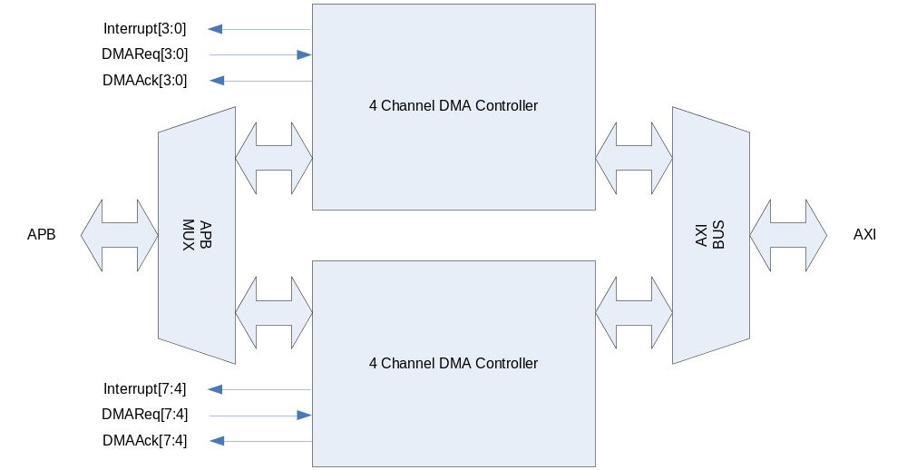
4 Channel DMA Controller가 두 개 들어 있고, 그것이 BUS MUX로 연결되어 있다. 각 Channel별로 DMA Request 신호를 받고 DMA service의 시작과 끝을 알리는 Acknowledge 신호가 peripheral로 출력된다. 각 channel의 동작의 시작과 끝 혹은 error 상황을 알려주기 위해서 8개의 interrupt line이 출력된다. 4 Channel DMA Controller의 내부 구조는 다음과 같다.

Figure 8-18 4 Channel DMA Controller의 내부구조
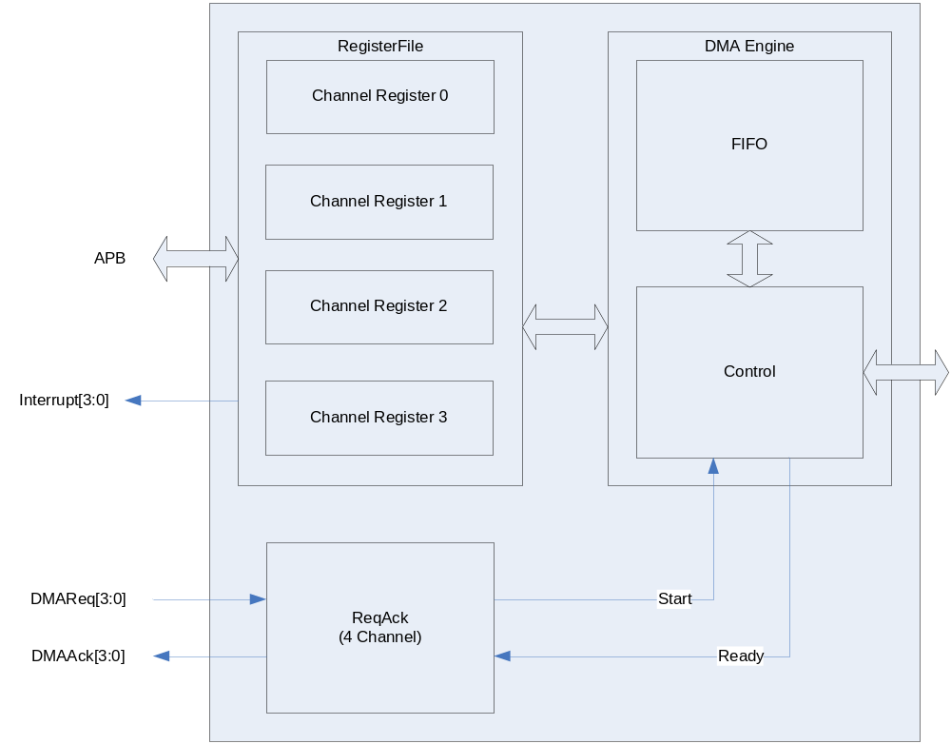

4 Channel DMA Controller는 4개의 channel마다 register set가 존재하고, DMA Request시에는 하나의 Channel register가 enable되어 DMA Engine이 동작하도록 되어있다. 각 channel별로 DMA Engine를 가지고 있는 것보다 하드웨어 복잡도가 낮아지지만 4 Channel의 DMA가 동시에 enable될 수는 없다.

  - DMA Channel

각 channel에 할당 된 onchip Peripheral은 다음과 같다.

Table 8-15 DMA Channel Allocation
Channel | Peripheral | Description
0
1
2

Channel을 Fully configuration 가능한 mux를 이용하여 설계하였습니다.
Resource Share Controller (System Controller)에서 Mux를 Programmable하도록 하였으므로 고정된 DMA Channel 할당은 하지 않습니다.

    - Channel Arbitration

하나의 DMA Engine에 물려 있는 4개의 Channel에 동시에 request가 오는 경우에는 round-robin scheme을 이용하여 arbitration 하게 된다. 즉, request에 해당 하는 service가 끝난 DMA channel이 가장 low priority를 가지게 된다.
Channel 0/1/2/3를 처리하는 DMA Engine과 Channel 4/5/6/7을 처리하는 DMA Engine 사이에는 항상 Channel 0/1/2/3의 DMA Engine이 높은 우선 순위를 가지고 BUS를 점유하게 된다. 하지만 DMA Controller가 AXI BUS의 out-of-order transfer를 지원하기 때문에 BUS 점유가 data transfer의 순서와 큰 연관 관계를 맺지 않고 효율적인 data transfer가 일어나게 된다.

  - Channel Operation

    - Basic Operation

각 Channel의 기본적인 동작은 다음과 같은 state machine으로 설명할 수 있다.

Figure 8-19 DMA Operation State Machine
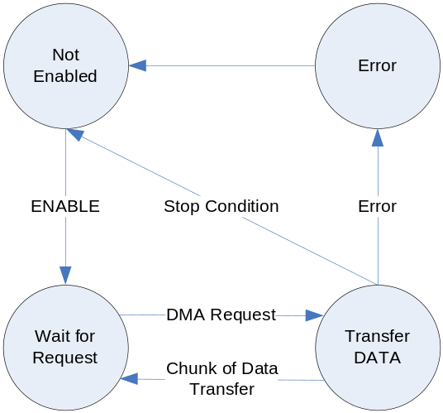

- Not Enabled State
초기 상태에서는 DMA가 Enable되지 않는다.

- Wait for Request State
DMA가 enable되면 외부의 DMA Request를 기다리게 된다.

- Transfer Data State
DMA request가 들어오면 Source Address 레지스터가 지정하고 있는 address에서 일정한 양의 data를 읽어 Destination Address 레지스터가 지정하고 있는 address에 복사를 한다. 복사후에 stop condition이 발생하면 Stop Interrupt 신호가 생성되고 Not Enabled State로 돌아가게 되고, 아니면 Wait for Request State로 돌아가게 된다. Data의 transfer는 source address에서 destination address로 일어나게 되며 한번에 전송되는 data size는 control 레지스터의 Size field에 의해 결정된다.

- Error State
레지스터 세팅이나 Data 전송 시에 오류가 발생하면 Error State가 되어 interrupt가 발생하고 Not Enabled State로 돌아가게 된다.

Channel Enable을 enable시키기 위해서는 Status 레지스터의 enable bit를 ‘1’로 setting해 주고 Pending interrupt를 모두 clear해 주면 된다.
DMA Channel의 stop condition은 Control register의 TransferCount field가 0이 되고 Descriptor 레지스터의 DescriptorEnd bit가 ‘1’인 경우이다.

    - Descriptor Loading

Transfer Data State에서 Control 레지스터의 TransferLength field가 0이 되면 일단 DMA Request에 대응하는 data transfer는 종료된다. Descriptor 레지스터의 DescriptorEnd bit가 ‘0’인 경우에는 종료된 후 새롭게 DMA Request 신호가 들어오면 Descriptor가 loading이 일어나고 새로운 data transfer가 발생하게 된다. Descriptor Loading이란 Memory에서 4개의 Word를 읽어서 Source Address 레지스터, Destination Address 레지스터, Control 레지스터, Descriptor 레지스터를 update하는 과정을 의미한다. 새로운 Descriptor의 위치는 Descriptor 레지스터의 상위 30bit로 addressing되는데, Descriptor의 내용은 다음과 같은 4 Word로 구성된다.

Table 8-16 Descriptor
Word | Name | Description
1번째 Word | SourceAddr | Source Address 레지스터를 update할 내용이다.
2번째 Word | DestAddr | Destination Address 레지스터를 update할 내용이다.
3번째 Word | Control | Control 레지스터를 update할 내용이다.  참고로 TransferLength가 0이 되도록 하면 안된다.
4번째 Word | Descriptor | Descriptor 레지스터를 update할 내용이다.

이렇게 새로운 Descriptor를 계속 Loading하여 사용자는 Scatter/gather DMA를 할 수 있다.

    - Interrupt

DMA Controller의 interrupt line은 각 channel 별로 존재하고 Active high level sensitive interrupt signal을 생성한다. 각 channel별로 발생하는 interrupt는 다음과 같은 4가지 상황에서 발생하게 된다.

(a) Error Interrupt

BUS Error를 detect하거나 사용자의 레지스터 세팅에 오류가 있는 경우, Status 레지스터의 ErrInt bit가 ‘1’로 set되고 interrupt가 발생한다. Error Interrupt가 발생하면 해당 채널의 state는 Not Enabled State로 변경되고 더 이상 data transfer가 일어나지 않는다. Not Enabled State로 변경되더라도 Status 레지스터의 Enable bit은 ‘0’으로 clear되지 않음을 유의하라.

(b) Stop Interrupt

Control 레지스터의 TransferLength field가 0이 되고 더 이상 load할 descriptor가 없는 경우(즉, Descriptor 레지스터의 DescriptorEnd bit가 ‘1’인 경우) Stop Interrupt가 발생한다. 이 interrupt는 Status 레지스터의 StopIntEn bit로 masking을 할 수 있는데 masking이 되어도 Stop Interrupt 상황이면 Status 레지스터의 StopInt bit가 ‘1’로 set되고 해당 채널의 state는 Not Enabled State로 변경되어 더 이상 data transfer가 일어나지 않는다. Not Enabled State로 변경되더라도 Status 레지스터의 Enable bit은 ‘0’으로 clear되지 않음을 유의하라.

(c) End Interrupt

Control 레지스터의 TransferLength field가 0이 되면 End Interrupt가 발생한다. 이 interrupt는 Control 레지스터의 EndIntEn bit로 masking이 가능하다. End Interrupt가 발생하면 Status 레지스터의 EndInt bit이 ‘1’로 set되지만 해당 채널의 data transfer는 계속 진행된다.

(d) Start Interrupt

새로운 Descriptor가 성공적으로 Loading된 경우 Start Interrupt가 발생한다. 이 interrupt는 Control 레지스터의 StartIntEn bit로 masking이 가능하다. Start Interrupt가 발생하면 Status 레지스터의 StartInt bit가 ‘1’로 set되지만 해당 채널의 data transfer는 계속 진행된다.

    - Trailing Bytes

Control 레지스터의 TransferLength field는 현재의 Descriptor를 이용하여 전송할 총 byte수를 세팅하게 되어 있다. DMA Engine은 매 전송마다 TransferLength field를 감소시키고, TransferLength field를 현재의 descriptor에서 전송을 기다리는 byte수로 인식하게 된다. 또한 Control 레지스터의 Size field를 이용하여 한번에 전송할 byte수를 결정할 수 있다. 어떤 시점에서 Size field로 결정된 byte수보다 TransferLength field로 결정된 byte수가 작으면 TransferLength field로 결정된 byte 수 만큼 전송하게 된다.
예를 들어 Size field로 한번의 전송으로 32byte씩 전송하도록 세팅되어 있고, TransferLength field의 값이 15 byte라고 하면 15 byte만 전송한다.

    - Memory-to-Memory Transfer

DMA Controller를 이용하여 memory에 있는 data를 memory로 빠르게 전송할 수 있다. 이런 기능을 하기 위해서는 Control 레지스터의 M2M bit를 ‘1’로 세팅하면 된다. 이 경우 peripheral에서 오는 DMA request는 무시되고, DMA Request가 항상 assert된 것처럼 동작하게 된다.

  - Software Model

    - Enabling DMA Channel

DMA Channel을 enable하기 위해서는 Status 레지스터의 Enable bit를 ‘1’로 세팅하고 StopInt bit과 ErrInt bit을 ‘0’으로 clear해 주면 된다. 당연히 해당 DMA Channel이 올바로 동작하려면 Source Address 레지스터, Destination Address 레지스터, Control 레지스터, Descriptor 레지스터가 올바르게 세팅된 후 enable하여야 한다.

    - Enabling DMA Channel(No Descriptor Mode)

Descriptor를 사용하지 않는 경우 다음과 같이 레지스터를 세팅하면 된다.
(a) Source Address 레지스터/Destination Address레지스터를 원하는 값으로 세팅한다.
(b) Control 레지스터를 세팅하는데 TransferLength는 반드시 0보다 큰 값을 가져야 한다.
(c) Descriptor 레지스터의 DescriptorEnd bit를 ‘1’로 세팅한다.
(d) Status 레지스터를 세팅하여 해당 channel을 enable 시킨다.

    - Enabling DMA Channel(Using Descriptor)

Descriptor를 사용하여 DMA를 동작시키기 위해서는 다음과 같이 레지스터를 세팅할 수 있다.

(a) memory의 특정 위치에 Descriptor를 Linked list로 연결되도록 4 word씩 write한다.
(b) Control 레지스터의 TransferLength를 0으로 write한다. Memory-to-Memory 전송이라면 M2M bit를 ‘1’로 세팅한다.
(c) Descriptor 레지스터에 첫 번째 Descriptor가 write된 address를 세팅한다. 이때

DescriptorEnd bit는 ‘0’으로 세팅한다.
(d) Status 레지스터를 세팅하여 해당 channel을 enable 시킨다.

당연히 첫 번째 Descriptor를 memory에 write하지 않고 직접 레지스터에 write해도 된다. 이때는 두 번째 Descriptor의 address를 Descript 레지스터에 세팅하면 된다.

    - 10.4.4 Disabling DMA Channel

위에서 언급한 대로 Error Interrupt나 Stop Interrupt가 발생하면 해당 channel의 state는 Not Enabled State로 변경되고 자동으로 해당 채널이 Disable된다. 사용자가 강제로 동작하고 있는 DMA channel을 disable하기 위해서는 다음과 같은 절차를 거쳐야 한다.
(a) Status 레지스터의 Enable bit을 ‘0’으로 clear해 준다.
(b) Status 레지스터의 Active bit을 polling하여 ‘0’이 될 때까지 기다린다.
Active bit은 현재 data transfer가 진행중임을 나타내는 bit로, data transfer 중간에 다른 레지스터를 access하면 안되기 때문에 polling을 하여 data transfer가 끝났는지 detect하는 것이다.

    - Restriction on Register Access

Status 레지스터를 제외하고는 Channel이 enable된 상태에서 레지스터에 write를 시도하면 안된다. Data transfer가 일어나는 도중 레지스터를 write하게 되면 DMA Controller가 오동작 할 수 있기 때문이다.

  - Register Description

    - Registers

Table 8-17 Registers
Offset | Name | R/W | Description | Init. value
0000h | SRC_CH0 | RW | Source Address(Channel 0) | 0000 0000h
0004h | DEST_CH0 | RW | Destination Address(Channel 0) | 0000 0000h
0008h | CTRL_CH0 | RW | Control(Channel 0) | 0000 0000h
000Ch | DESC_CH0 | RW | Descriptor(Channel 0) | 0000 0000h
0010h | STAT_CH0 | RW | Status(Channel 0) | 0000 0000h
0020h | SRC_CH1 | RW | Source Address(Channel 1) | 0000 0000h
0024h | DEST_CH1 | RW | Destination Address(Channel 1) | 0000 0000h
0028h | CTRL_CH1 | RW | Control(Channel 1) | 0000 0000h
002Ch | DESC_CH1 | RW | Descriptor(Channel 1) | 0000 0000h
0030h | STAT_CH1 | RW | Status(Channel 1) | 0000 0000h
0040h | SRC_CH2 | RW | Source Address(Channel 2) | 0000 0000h
0044h | DEST_CH2 | RW | Destination Address(Channel 2) | 0000 0000h
0048h | CTRL_CH2 | RW | Control(Channel 2) | 0000 0000h
004Ch | DESC_CH2 | RW | Descriptor(Channel 2) | 0000 0000h
0050h | STAT_CH2 | RW | Status(Channel 2) | 0000 0000h
0060h | SRC_CH3 | RW | Source Address(Channel 3) | 0000 0000h
0064h | DEST_CH3 | RW | Destination Address(Channel 3) | 0000 0000h
0068h | CTRL_CH3 | RW | Control(Channel 3) | 0000 0000h
006Ch | DESC_CH3 | RW | Descriptor(Channel 3) | 0000 0000h
0070h | STAT_CH3 | RW | Status(Channel 3) | 0000 0000h
0080h | SRC_CH4 | RW | Source Address(Channel 4) | 0000 0000h
0084h | DEST_CH4 | RW | Destination Address(Channel 4) | 0000 0000h
0088h | CTRL_CH4 | RW | Control(Channel 4) | 0000 0000h
008Ch | DESC_CH4 | RW | Descriptor(Channel 4) | 0000 0000h
0090h | STAT_CH4 | RW | Status(Channel 4) | 0000 0000h
00A0h | SRC_CH5 | RW | Source Address(Channel 5) | 0000 0000h
00A4h | DEST_CH5 | RW | Destination Address(Channel 5) | 0000 0000h
00A8h | CTRL_CH5 | RW | Control(Channel 5) | 0000 0000h
00Ach | DESC_CH5 | RW | Descriptor(Channel 5) | 0000 0000h
00B0h | STAT_CH5 | RW | Status(Channel 5) | 0000 0000h
00C0h | SRC_CH6 | RW | Source Address(Channel 6) | 0000 0000h
00C4h | DEST_CH6 | RW | Destination Address(Channel 6) | 0000 0000h
00C8h | CTRL_CH6 | RW | Control(Channel 6) | 0000 0000h
00CCh | DESC_CH6 | RW | Descriptor(Channel 6) | 0000 0000h
00D0h | STAT_CH6 | RW | Status(Channel 6) | 0000 0000h
00E0h | SRC_CH7 | RW | Source Address(Channel 7) | 0000 0000h
00E4h | DEST_CH7 | RW | Destination Address(Channel 7) | 0000 0000h
00E8h | CTRL_CH7 | RW | Control(Channel 7) | 0000 0000h
00ECh | DESC_CH7 | RW | Descriptor(Channel 7) | 0000 0000h
00F0h | STAT_CH7 | RW | Status(Channel 7) | 0000 0000h

8개 Channel 전체 레지스터의 map은 위의 그림과 같다. 각 Channel 별 레지스터에 대해서 살펴보자.

    - Source Address Register

Source Address 레지스터는 말 그대로 복사가 일어날 Source의 address를 지칭하기 위한 레지스터이다.

Figure 8-20 Source Address Register
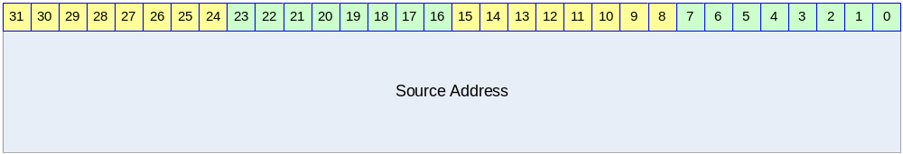

Table 8-18 Source Address Register Description
Bits | Name | R/W | Description | Init. value
[31:0] | Source Address | RW | 32bit Source Address  Control 레지스터의 SrcIncr bit가 ‘1’이면 매 전송된 byte수 만큼 증가한다. | 0000 0000h

    - Destination Address Register

Destination Address 레지스터는 말 그대로 복사가 일어날 Destination Address를 지칭하기 위한 레지스터이다.

Figure 8-21 Destination Address Register
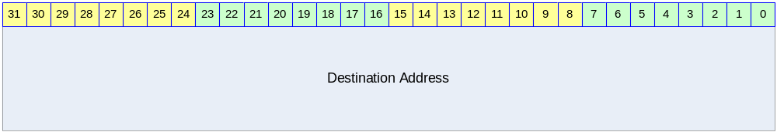

Table 8-6 Destination Address Register Description
Bits | Name | R/W | Description | Init. value
[31:0] | Destination Address | RW | 32bit Destination Address  Control 레지스터의 DstIncr bit가 ‘1’이면 매 전송된 byte수 만큼 증가한다. | 0000 0000h

    - Control Register

Control 레지스터는 현재 전송하고 있는 Descriptor의 data transfer의 동작을 규정하는 레지스터이다.

Figure 8-22 Control Register
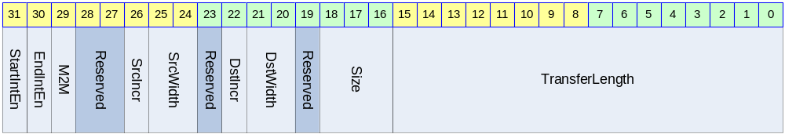

Table 8-19 Control Register Description
Bits | Name | R/W | Description | Init. Value
[31] | StartInEn | RW | Start Interrupt Enable Flag  0 : Start Interrupt를 masking함  1 : Start Interrupt를 발생시킴 | 0b
[30] | EndIntEn | RW | End Interrupt Enable Flag  0 : End Interrupt를 masking함  1 : End Interrupt를 발생시킴 1 | 0b
[29] | M2M | RW | Memory-to-Memory Transfer Flag  0 : DMA Request 신호로 DMA 동작  1 : DMA Request 신호 없이 DMA 동작  Memory에서 memory로 data를 전송하는 경우 외부의 DMA Request 신호와 관계 없이 전송이 계속된다. M2M bit가 ‘1’인 경우 외부 DMA Request 신호를 무시하고 DMA Request가 항상 assert되어 있는 것과 동일하게 DMA Controller가 동작하게 된다. | 0b
[26] | SrcIncr | RW | Source Address Increment Flag  0 : 매 transfer마다 Source Address 증가시킴  1 : 매 transfer마다 Source Address 증가안함 | 0b
[25:24] | SrcWidth | RW | Source Device의 BUS Width  00 : BYTE(8bit)  01 : HWORD(16bit)  10 : WORD(32bit)  11 : reserved  Source Device가 memory라면 반드시 WORD로 세팅해야 한다. | 00b
[22] | DstIncr | RW | Destination Address Increment Flag  0 : 매 transfer마다 Destination Address 증가시킴  1 : 매 transfer마다 Destination Address 증가안함 | 0b
[21:20] | DstWidth | RW | Destination Device의 BUS Width  00 : BYTE(8bit)  01 : HWORD(16bit)  10 : WORD(32bit)  11 : reserved  Destination Device가 memory라면 반드시 WORD로 세팅해야 한다. | 00b
[18:16] | Size | RW | Transfer Size  매 DMA Request마다 한번에 전송할 byte수  000 : 1 byte  001 : 2 byte  010 : 4 byte  011 : 8 byte  100 : 16 byte  101 : 32 byte  Other : reserved | 000b
[15:0] | TransferLength | RW | 전체 전송할 byte 수/현재 남아 있는 byte 수  16 bit이므로 하나의 Descriptor에서 65535 byte(64KB -1)까지 전송할 수 있다.  매 data transfer마다 감소하게 되어 “현재 남아있는 전송할 byte 수”를 지칭하게 된다. | 0000h

    - Descriptor Register

Descriptor 레지스터는 새로 Loading될 Descriptor의 address를 담고 있는 레지스터이다.

Figure 8-23 Descriptor Register
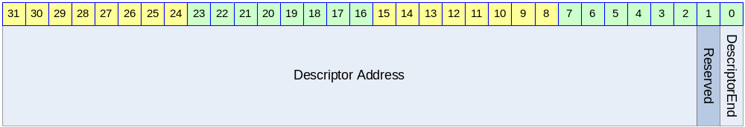

Table 8-20 Descriptor Register Description
Bits | Name | R/W | Description | Init. Value
[31:2] | Descriptor Address | RW | Load할 Descriptor Address의 상위 32bit  Descriptor Address는 32bit align 되어야 함.  DescriptorEnd bit가 ‘1’이면 어떠한 값이라도 관계 없다. | 0
[0] | DescriptorEnd | RW | Descriptor End Flag  0 : Descriptor Address가 VALID함  1 : Descriptor Address가 VALID하지 않음.  ‘1’로 세팅된 경우 현재 처리중인 Descriptor가 마지막 Descriptor임을 의미한다. | 0b

    - Status Register

Status 레지스터는 현재 DMA Channel의 동작 상황을 알려준다.

Figure 8-24 Status Register
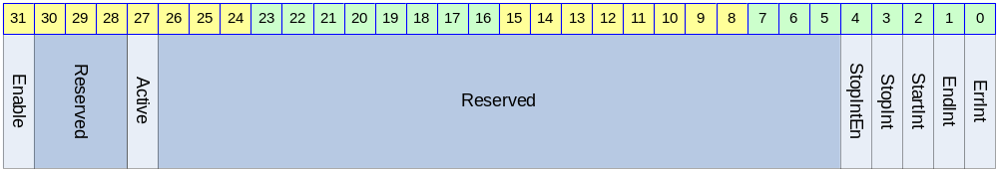

Table 8-21 Status Register Description
Bits | Name | R/W | Description | Init. Value
[31] | Enable | RW | Enable Flag  0 : DMA Channel Disabled  1 : DMA Channel Enabled  Channel이 Stop Interrupt나 Error Interrupt에 의해 disable되더라도 ‘0’으로 clear되지 않는다. | 0b
[27] | Active | R | Active Flag  0 : 현재 data transfer를 진행중이지 않음  1 : 현재 data transfer를 진행중임 | N/A
[4] | StopIntEn | RW | Stop Interrupt Enable Flag  0 : Stop Interrupt 발생을 disable함  1 : Stop Interrupt 발생을 enable함 | 0b
[3] | StopInt | RW | Stop Interrupt Status  0 : Stop Interrupt가 발생하지 않았음  1 : Stop Interrupt가 발생하였음  StopIntEn과 생관 없이 Stop interrupt 상황에서 ‘1’로 set된다. StopIntEn이 ‘0’이면 이 bit의 값과 관계 없이 interrupt가 발생하지 않는다. 이 bit가 ‘1’일 때는 Channel의 동작이 멈추게 되므로 Channel을 enable 시키기 위해서는 이 bit를 ‘0’으로 clear해 주어야 한다.  ‘1’을 write하면 clear되고 ‘0’을 write하는 것은 아무런 영향을 미치지 않는다. | 0b
[2] | StartInt | RW | Start Interrupt Status  0 : Start Interrupt가 발생하지 않았음  1 : Start Interrupt가 발생하였음  Control 레지스터의 StartIntEn이 ‘0’이면 이 bit는 ‘1’로 변하지 않는다.  ‘1’을 write하면 clear되고 ‘0’을 write하는 것은 아무런 영향을 미치지 않는다. | 0b
[1] | EndInt | RW | End Interrupt Status  0 : End Interrupt가 발생하지 않았음  1 : End Interrupt가 발생하였음  Control 레지스터의 EndIntEn이 ‘0’이면 이 bit는 ‘1’로 변하지 않는다.  ‘1’을 write하면 clear되고 ‘0’을 write하는 것은 아무런 영향을 미치지 않는다. | 0b
[0] | ErrInt | RW | Error Interrupt Status  0 : Error Interrupt가 발생하지 않았음  1 : Error Interrupt가 발생하였음  이 bit가 ‘1’일 때는 Channel의 동작이 멈추게 되므로 Channel을 enable 시키기 위해서는 이 bit를 ‘0’으로 clear해 주어야 한다.  ‘1’을 write하면 clear되고 ‘0’을 write하는 것은 아무런 영향을 미치지 않는다. | 0b

TIMER

Overview

총 4개의 16bit Timer를 제공한다.

Features

- Maximum period : PCLK duration * 2048 * 65535
- Minimum period : PCLK duration * 2

Block diagram

하나의 Timer의 하드웨어 구성은 다음과 같다.

Figure 9-25 Block Diagram
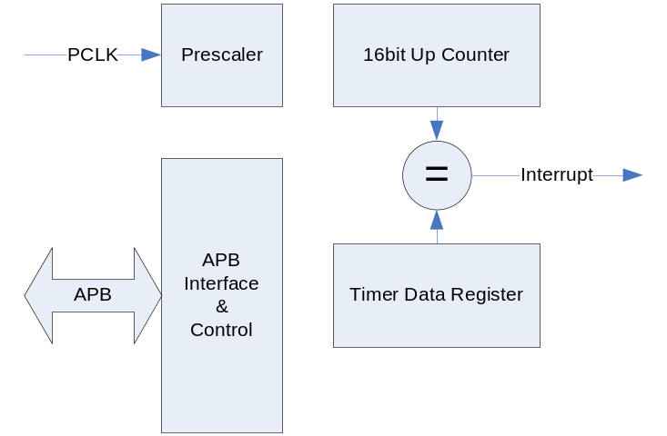

기본적으로 timer는 레지스터를 읽고 쓰기 위해서 APB Bus interface를 가지고 있다. APB BUS의 clock인 PCLK을 Prescaler를 이용하여 분주하게 되고 그 분주된 clock으로 16bit up counter가 동작하게 된다. 16 bit up counter의 값이 Timer Data 레지스터의 같은 값이 되면 positive edge 형식의 interrupt가 발생하게 되고 그 interrupt는 interrupt controller에 연결된다.

위와 같은 구조를 가지는 독립된 timer 4개가 병렬로 연결되어 있다.

Operation

다음과 같은 2 가지 모드로 동작이 가능하다.

Interval Mode

Interval Mode에서는 counter가 증가하여 timer data 레지스터에 저장된 값과 같아지면 interrupt가 생성되고 counter의 값은 자동으로 0으로 clear된다. 일정한 시간마다 interrupt의 발생을 원하면 이 mode를 사용하면 된다.

Match&Overflow Mode

Match&Overflow Mode에서는 counter가 증가하여 timer data 레지스터에 저장된 값과 같아지면 interval mode에서와 마찬가지로 interrupt가 생성된다. 하지만 counter값은 0으로 clear되지 않고, 계속 증가하게 된다. 증가가 계속되어 0xffff가 되면 다시 0으로 바뀌게 된다. Interval mode를 사용하는 경우 interrupt의 발생 주기가 interrupt service routine의 service latency보다 작은 경우 interrupt가 여러 번 발생하였는데도 한번으로 인식할 가능성이 생기게 된다. 이런 경우에는 Match&Overflow mode를 사용하게 되면 interrupt service routine이 interrupt발생 시점에서 얼마간의 시간이 흘렀는지 detect할 수 있고, Interrupt service routine에서 timer data 레지스터 값을 새로 write함으로써 다음에 발생할 interrupt의 시점을 제어할 수 있다.

Register Description

Registers

Table 9-22 Registers
Offset | Name | R/W | Description | Init. value
0000h | T0_TDAT | RW | (Timer0) Timer Data Register | XXXX FFFFh
0004h | T0_PRES | RW | (Timer0) Prescaler Register | XXXX X3FFh
0008h | T0_CTRL | RW | (Timer0) Control Register | XXXX XXX0h
000Ch | T0_CNT | R | (Timer0) Counter Register | XXXX 0000h
0010h | T1_TDAT | RW | (Timer1) Timer Data Register | XXXX FFFFh
0014h | T1_PRES | RW | (Timer1) Prescaler Register | XXXX X3FFh
0018h | T1_CTRL | RW | (Timer1) Control Register | XXXX XXX0h
001Ch | T1_CNT | R | (Timer1) Counter Register | XXXX 0000h
0020h | T2_TDAT | RW | (Timer2) Timer Data Register | XXXX FFFFh
0024h | T2_PRES | RW | (Timer2) Prescaler Register | XXXX X3FFh
0028h | T2_CTRL | RW | (Timer2) Control Register | XXXX XXX0h
002Ch | T2_CNT | R | (Timer2) Counter Register | XXXX 0000h
0030h | T3_TDAT | RW | (Timer3) Timer Data Register | XXXX FFFFh
0034h | T3_PRES | RW | (Timer3) Prescaler Register | XXXX X3FFh
0038h | T3_CTRL | RW | (Timer3) Control Register | XXXX XXX0h
003Ch | T3_CNT | R | (Timer3) Counter Register | XXXX 0000h

Timer Data Register (T0_TDAT/T1_TDAT/T2_TDAT/T3_TDAT)

Timer Data 레지스터는 counter의 값과 비교를 하기 위한 레지스터이다.

Figure 9-26 Timer Data Register
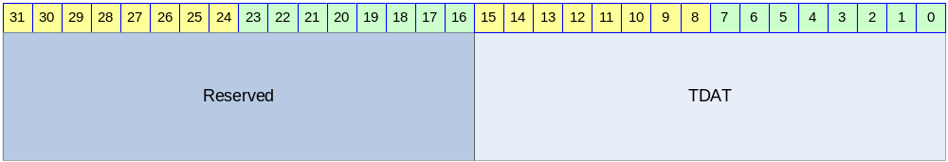

Table 9-23 Timer Data Register Description
Bits | Name | R/W | Description | Init. value
[15:0] | TDAT | RW | Timer Data 레지스터  TDAT과 16bit Counter값이 같으면 interrupt가 발생한다. | FFFFh

Timer Prescaler Register (T0_PRES/T1_PRES/T2_PRES/T3_PRES)

Timer Prescaler Register는 16bit Counter에 들어가는 clock의 속도를 조정하는 레지스터이다.

Figure 9-27 Timer Prescaler Register
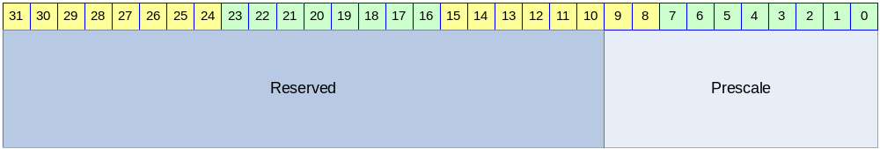

Table 9-24 Timer Prescaler Register Description
Bits | Name | R/W | Description | Init. value
[9:0] | Prescale | RW | 16bit Counter이 들어가는 clock의 속도를 결정 | 3FFh

16bit Counter에 들어가는 Clock의 속도는 다음과 같이 결정된다.
Clock = PCLK/(Prescale+1)
매 네번의 PCLK rise마다 16bit Counter가 1씩 증가하도록 만들고 싶으면 Prescale의 값을 3으로 정하면 된다.

Timer Control Register (T0_CTRL/T1_CTRL/T2_CTRL/T3_CTRL)

Timer Control 레지스터는 Timer의 동작 여부와 동작 mode를 결정하는 레지스터이다.

Figure 9-28 Timer Control Register
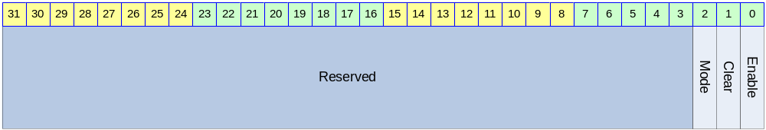

Table 9-25 Timer Control Register Description
Bits | Name | R/W | Description | Init. Value
[2] | Mode | RW | 동작 mode  0 : Interval mode  1 : Match&Overflow Mode | 0b
[1] | Clear | RW | Counter Clear  0 : 의미 없음  1 : Counter의 값을 0으로 초기화함  Clear bit가 1로 세팅되면 16 bit Counter의 값을 0으로 초기화하고 Timer Data 레지스터와 Timer Prescaler 레지스터의 값을 Reset값으로 바꾸게 된다. 1로 write되고 나면 timer가 동작하지 않으므로 0으로 반드시 다시 써 주어야 한다. | 0b
[0] | Enable | R/W | Timer Enable bit  0 : Not Enabled  1 : Enabled | 0b

Timer Counter Register (T0_CNT/T1_CNT/T2_CNT/T3_CNT)

Timer Counter 레지스터는 Read only 레지스터로 16bit Counter의 현재 값을 읽을 수 있는 레지스터이다.

Figure 9-29 Timer Counter Register
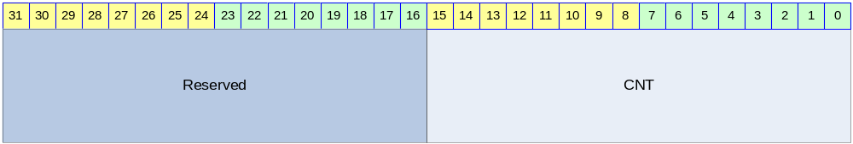

Table 9-26 Timer Counter Register Description
Bits | Name | R/W | Description | Init. Value
[15:0] | CNT | R | 16bit Counter의 현재 값 | 0000h

WDT

Overview

Feature

- Support 16 bit Programmable interval down counter.
- Support clock division factor 16,32,64, and 128.
- Support 16 bit prescale counter.
- Support Interrupt Request
- Generation of Reset Output Signal

Block Diagram

Figure 10-30 Watch Dog Block Diagram
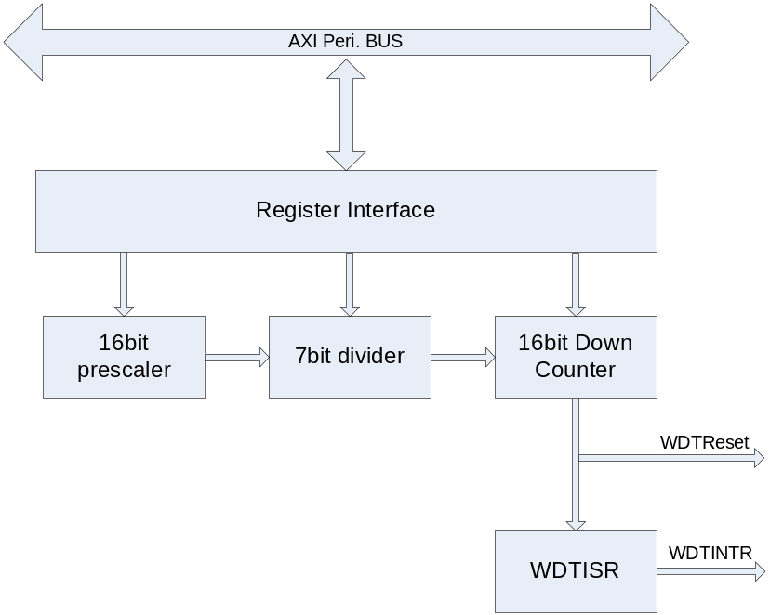

Operation

Chip이 소프트웨어나 다른 환경에 의해 오동작할 경우 전체 동작을 Reset 해주는 역할을 한다.
즉, 카운터 값이 설정된 값에 도달할 경우 Interrupt를 생성하게 되는데, 정상적인 상태에 있는 칩이라면 Interrupt 발생시 마다 카운터 값을 Reload 하여 전체 동작에 Reset를 걸지 않게 할 수 있지만, 반대의 경우라면 칩에 Reset이 걸리게 되어 있다.

Clock Prescaler Block

Interrupt Generation Block

Reset Output Generation

Register Description

WDT Registers

Table 10-27 WDT Registers(Base Address : 1FFF 0000h)
Offset | Name | R/W | Description | Init. value
0000h | WDTCON | RW | WDT Control Register | 0000 0030h
0004h | WDTPSR | RW | WDT Prescale Register | 0000 FFFFh
0008h | WDTLDR | RW | WDT Load Register | 0000 FFFFh
000Ch | WDTCNT | RW | WDT Count Register | 0000 FFFFh
0010h | WDTISR | RW | WDT Interrupt Status Register | 0000 0000h

WDT Control Register

Figure 10-31WDT Control Register Bits
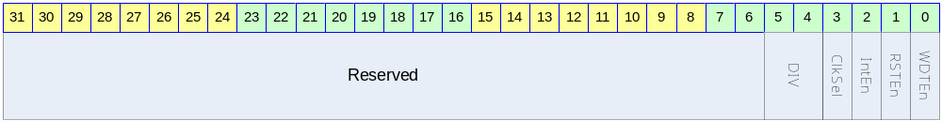

Table 10-28 WDT Control Register Description(Offset : 0000 0000h)
Bits | Name | R/W | Description | Init. value
[31:6] |  |  | Reserved | 0
[5:4] | DIV | RW | 0b00 : 16  0b01 : 32  0b10 : 64  0b11 : 128 | 11b
[3] | ClkSel | RW | 0 : Both Prescale and Divide Clock is used for Counting  1 : Only Prescal Clock is user for Counting | 0
[2] | IntEn | RW | 0 : WDT Interrupt Disable  1 : WDT Interrupt Enable | 0
[1] | RSTEn | RW | 0 : Reset Output Disabled  1 : Reset Output Enabled | 0
[0] | WDTEn | RW | WDT Enable  0 : WDT Disable  1 : WDT Enable | 0

WDT Prescale Register

Figure 10-32 WDT Prescale Register Bits
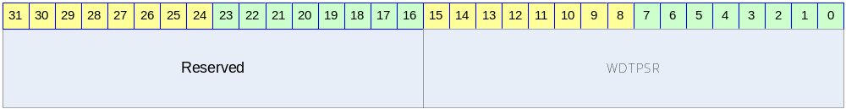

Table 10-29 WDT Prescale Register Description(Offset : 0000 0004h)
Bits | Name | R/W | Description | Init. value
[31:16] |  |  | Reserved | 0
[15:0] | WDTPSR | RW | Prescaler Value | ffffh

WDT Load Register

Figure 10-33 WDT Load Register Bits
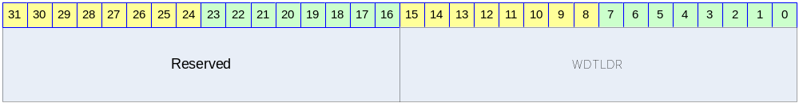

Table 10-30 WDT Load Register Description(Offset : 0000 0008h)
Bits | Name | R/W | Description | Init. value
[31:16] |  |  | Reserved | 0
[15:0] | WDTLDR | RW | Reload Value | ffffh

WDT Count Register

Figure 10-34 WDT Count Register Bits
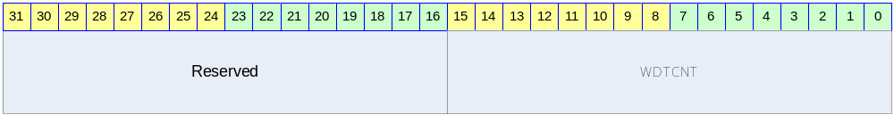

Table 10-31 WDT Count Register Description(Offset : 0000 000Ch)
Bits | Name | R/W | Description | Init. value
[31:16] |  |  | Reserved | 0
[15:0] | WDTCNT | R | Current WDT Count Value | ffffh

WDT Interrupt Status Register

Figure 10-35 WDT Interrupt Status Register Bits
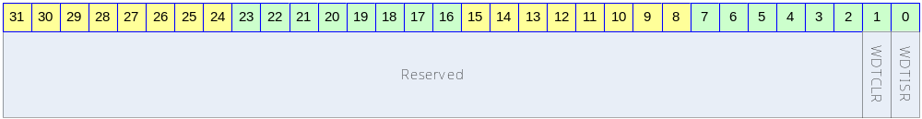

Table 10-32 WDT Interrupt Status Register Description(Offset : 0000 0010h)
Bits | Name | R/W | Description | Init. value
[31:2] |  |  | Reserved | 0
[1] | WDTCLR | W | Write 1, Cleared Interrupt
[0] | WDTISR | R | 0 : Interrupt Is asserted  0 : Interrupt Is not asserted

I2S

Overview

I2S Protocol은 Philips에서 개발한 stereo audio data를 전송하는 규약으로 많은 audio codec이 I2S protocol을 사용하고 있다. I2S protocol은 BCLK(bit clock), LRCLK(left/right channel detect signal), SD(Serial Audio Data) signal을 사용하여 audio data를 전송한다.
I2S controller는 I2S protocol을 사용하여 외부의 audio codec으로 audio data를 전송하거나 audio codec으로부터 audio data를 수신하는 기능을 한다. 즉, 사용자는 audio data를 play하거나 외부의 analog audio를 audio codec을 거쳐 record할 수 있다.

Features

- 8/16/24/32bit per sample support
- No audio PLL need
- Integrated Digital Oscillator
  - Fully programmable sampling rate(determined by SYS_CLK frequency)
  - MCLK(256*sampling rate) generation
    - Not support 384*sampling rate, 512*sampling rate
- Support normal I2S mode and MSB(=Left) justified mode
- Programmable LRCLK polarity
- Maximum 64x32bit FIFO(static configurable) for each transmission/receive
  - DMA request generation
- Master/slave configuration
  - BCLK output support only 64*sampling rate

Block diagram

전체적인 하드웨어 구성은 다음 그림과 같다.

Figure 11-36 I2S Controller Block Diagram
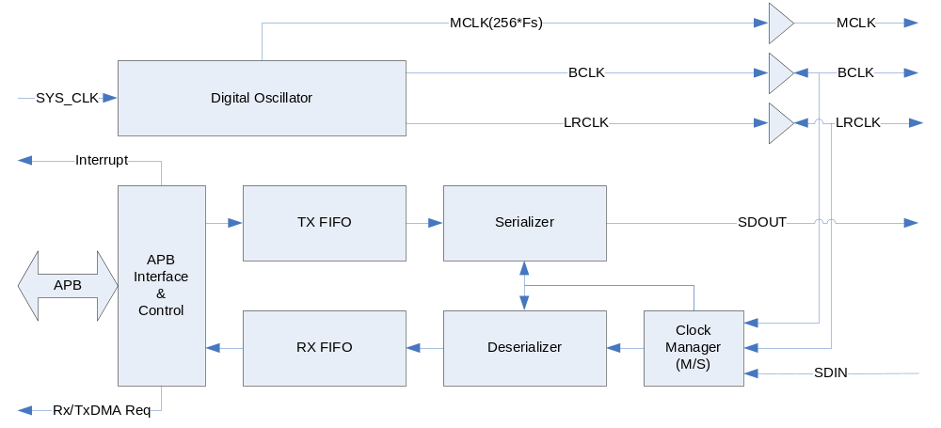칩 외부 pin으로 I2S Protocol signal인 BCLK/LRCLK/SDOUT/SDIN이 연결되어 있고, 256배의 sampling rate를 출력하는 MCLK pin도 존재한다. 칩 내부로는 기본적으로 APB BUS interface를 이용하여 연결되고, 그 외로 Digital Oscillator의 입력 clock으로 SYS_CLK을 입력 받고, DMA request와 Interrupt request를 출력한다.

Signals

칩 외부로 연결되는 신호들은 다음과 같다.

Table 11-33 External Signals
Signal Name | Direction | Description | Init. value
MCLK | Output | 256배의 sampling rate의 clock을 외부로 출력 | N/A
BCLK | InOut | Bit Clock  Master로 configuration 되면 output이 되고  Slave로 configuration 되면 input이 된다. | N/A
LRCLK | InOut | Left/Right Channel Indicator  Master로 configuration 되면 output이 되고  Slave로 configuration 되면 input이 된다. | N/A
SDOUT | Output | Serial Data output | N/A
SDIN | Input | Serial Data Input | N/A

Operation

Digital Oscillator

Digital Oscillator는 SYS_CLK 입력을 바탕으로 MCLK/BCLK/LRCLK을 생성하는 동작을 한다. MCLK은 Master Clock으로 대부분의 I2S Codec이 요구하는 sampling rate의 256배에 해당되는 clock을 말한다. 이 MCLK의 생성을 위해서 보통의 경우에는 Audio PLL을 사용하지만 설계된 I2S Controller는 Audio PLL을 사용하지 않고 SYS_CLK을 분주하여 사용하여 생성하도록 되어있다. SYS_CLK을 단순히 정수배 분주를 하게 되면 정확한 주파수의 MCLK을 생성할 수 없기 때문에 DDS(또는 DTO) 알고리즘을 사용하도록 구성하였다.
Digital Oscillator의 동작은 I2S_CLKCTRL 레지스터의 MClkOn field에 의해 On/Off할 수 있다. 생성할 MCLK의 주파수는 I2S_CLKCTRL 레지스터의 DTORATIO field에 의해서 결정된다. DTORATIO field에서는 SYS_CLK의 주파수와 생성할 MCLK의 주파수의 비율을 적어주면 되는데 다음과 같은 식을 사용하면 된다.
DTORATIO = RoundToNearInteger[2^18*(MCLK의주파수/SYS_CLK의주파수)]
예를 들어 SYS_CLK으로 100MHz의 clock을 가하고 생성하고 싶은 MCLK이 12.288MHz(256*48KHz)라면 다음과 같은 식에 의해 DTORATIO에 32212를 적어주면 된다.
DTORATIO = RoundToNearInteger[2^18*(12.288MHz/100MHz)]
= RoundToNearInteger[262144*0.12288]
= RoundToNearInteger[32212.25472]
= 32212
이렇게 생성된 MCLK은 비교적 정교한 clock이지만 Audio PLL을 사용하여 생성하는 clock에 비해 몇가지 오차가 발생한다.

주파수 오차

DTORATIO값이 정수 값이므로 finite bit-length로 인한 주파수 오차가 발생한다. 또한 clock cycle time이 매 clock 동일하게 유지되지 않는다. 우선 finite bit-length로 인한 주파수 오차는 18bit의 DTORATIO를 사용하여 0.1%보다 작도록 설계되었으므로 큰 문제가 되지 않는다. 매 clock 달라질 수 있는 clock cycle time은 다음과 같이 계산할 수 있다.

우선 FrequencyRatio라는 값은 다음과 같이 정의하자.
FrequencyRatio = 2^18/DTORATIO
FrequencyRatio의 값은 ‘SYS_CLK의주파수/MCLK의주파수’와 finite bit-length로 인한 오차를 제외하고는 동일한 값을 가지게 된다. FrequencyRatio를 rounding하여 다음 두 값을 계산한다.
FrequencyRatio_Higher = FrequencyRatio보다 작지 않은 가장 작은 integer
FrequencyRatio_Lower = FrequencyRatio보다 크지 않은 가장 큰 integer
이 값으로 다음과 같은 값을 계산할 수 있다.
Minimum Cycle Time = FrequencyRatio_Lower*SYS_CLK의주기
Maximum Cycle Time = FrequencyRatio_Higher*SYS_CLK의주기

예를 들어 SYS_CLK이 100MHz(주기는 10ns)이고 MCLK이 12.288MHz라면 위에서 계산한대로 DTORATIO는 32212가 되므로 FrequencyRatio = 8.183… 이 된다.
Minimum Cycle Time은 80ns(8*10ns)가 되고 Maximum Cycle Time은 90ns(9*10ns)가 된다. 즉 특정 cycle은 80 ns가 되고 특정 cycle은 90 ns가 된다.

duty cycle

MCLK의 duty cyle이 정확하게 50%를 가지지 않는다. Duty cycle이 정확하게 50%가 되려면 FrequencyRatio의 값이 짝수 Integer값을 가지면 되지만 일반적인 경우 그럴 가능성은 매우 낮다. 이런 경우 Worst duty cycle은 다음과 같이 계산할 수 있다.
FrequencyRatio_Odd = FrequencyRatio와 가장 가까운 홀수 integer
Worst Duty Cycle(%) = 100* RoundToNearInteger[FrequencyRatio_Odd/2] / FrequencyRatio_Odd

동일한 예로 SYS_CLK이 100 MHz이고 MCLK이 12.288MHz라면 위에서 계산한 대로 FrequencyRatio는 8.183…이 되고 FrequencRatio_Odd는 9가 된다. 따라서 Worst Duty Cycle은 다음과 같다.
Worst Duty Cycle(%) = 100*4/9 = 44.44(%)
일반적인 Audio Codec은 MCLK의 duty cycle을 40%~60%를 요구한다.(CirrusLogic CS42L51과 같은 칩은 45%~55%를 요구하기도 한다.) 40%를 만족시키기 위해서는 SYS_CLK이 MCLK에 비해 적어도 5배 이상 동작해야 한다.(45%를 만족시키기 위해서는 11배 이상으로 동작해야 한다.)

BCLK과 LRCLK도 MCLK과 마찬가지로 주파수 오차와 duty cycle 오차가 생기게 된다. 이 경우도 동일한 방법으로 계산할 수 있다. 하지만 BCLK/LRCLK은 MCLK에 비해 훨씬 느리게 동작하므로 보통의 경우 그러한 오차가 큰 의미를 지니지는 않는다.

Master/Slave Configuration

I2S protocl에서 master라고 하면 BCLK과 LRCLK을 출력하는 device를 의미하고, slave는 BCLK과 LRCLK을 생성하지 않고 받기만 하는 device를 의미한다. I2S_CLKCTRL 레지스터의 ClkMS bit를 ‘1’로 하면 I2S Controller가 master로 동작하게 되고, ‘0’으로 하면 slave로 동작하게 된다. Master로 동작하는 경우에는 반드시 I2S_CLKCTRL 레지스터의 MClkOnㅇ ‘1’로 세팅되어야 한다.
만약 I2S Controller가 MCLK을 생성하여 외부의 I2S Codec에 MCLK을 공급하면서 I2S protocol상에서는 slave로 동작하고 싶은 경우에는 MClkOn을 ‘1’, MClkOE를 ‘1’로 하고 ClkMS를 ‘0’으로 세팅하면 된다.

Transmit 동작 : Audio Play

외부의 I2S DAC으로 PCM data를 transmit하는 동작은 serializer block이 수행하게 되는데 I2S_CTRL 레지스터의 하위 16bit에 의해 control된다. Serializer block은 enable되면 TX FIFO(Transmit FIFO)에서 data를 읽어서 SDOUT pin으로 PCM data를 serial로 전송을 하게 된다.

Enabling Sequence

Transmit을 enable시키기 위해서는 단순히 I2S_CTRL 레지스터의 하위 16bit을 원하는 값으로 세팅하면 초기화는 끝나게 된다. TX FIFO에 데이터가 없는 상황에서 TxEn bit가 ‘1’로 세팅된 경우 TX FIFO UnderRun Interrupt가 발생하게 된다. 초기에 이것을 피하기 위해서는 TX FIFO에 어느 정도 PCM data를 채운 상태에서 TxEn bit을 ‘1’로 세팅할 수도 있다.

Transmit data의 공급

외부 I2S DAC으로 전송할 PCM data는 TX FIFO에 채워져야 하는데 TX FIFO에 data를 채우는 데는 두 가지 방법을 사용할 수 있다. 우선 CPU가 직접 공급하는 방법이 있다. CPU가 polling하여 data늘 공급할 수 있는데 I2S_STATUS register에서 TxFifoLevel field를 보고 TX FIFO가 full이 아니라면 계속 TX FIFO에 값을 채울 수 있다. Interrupt를 사용하고 싶을 때는 I2S_CTRL 레지스터의 TxDMAIntEn bit를 ‘1’로 세팅해 주고 TxFifoTH field의 값을 적절히 세팅하면 TX FIFO의 Level이 (TxFifoTH+1)보다 작으면 interrupt가 발생하게 된다. 그 때 마다 CPU가 TX FIFO에 data를 write하면 된다.
또 한가지 방법은 DMA Controller를 사용하는 방법이다. I2S Controller는 TX FIFO의 Level이 (TxFifoTH+1)보다 작으면 무조건 Tx DMA Request 신호를 생성하게 된다. DMA Controller가 해당 signal을 받으면 DMA가 동작하도록 configuration해 두면 DMA Controller가 Memory에서 data를 읽어 TX FIFO에 자동으로 채워주게 된다.
참고로 DMA Controller를 사용하는 방법과 CPU가 직접 data를 TX FIFO에 채워주는 방법을 동시에 사용하는 것은 권장되지 않는다. TxDMAIntEn bit가 ‘1’로 세팅된 경우 Tx DMA Request상황(즉, TX FIFO의 Level이 TxFifoTH+1보다 작은 경우)에서 Interrupt가 발생하고 I2S_STATUS 레지스터의 TxDMA bit가 set되고 DMA Controller가 동작하게 된다. DMA Controller가 Service를 마치게 되면 TX FIFO의 Level이 TxFifoTH+1보다 작아져 다시 TxDMA bit가 ‘0’으로 clear된다. 이러한 상황이 발생하면 CPU는 interrupt를 받지만 interrupt handler가 I2S_STATUS 레지스터를 확인할 때는 이미 TxDMA bit가 clear될 수 있기 때문에 interrupt를 놓칠 수 있다. 따라서 DMA Controller를 사용하는 경우에는 TxDMAIntEn bit를 ‘0’으로 하는 것을 권장한다.

SDOUT 출력

TX FIFO에서 읽은 데이터가 SDOUT으로 차례로 출력되며 각 채널의 data가 모두 전송되고 BCLK의 toggle이 계속되는 경우에는 하위 bit를 ‘0’으로 출력하게 된다.

TX FIFO UnderRun Error

Serializer block은 I2S protocol상에서 Left Channel의 전송이 시작될 때 TX FIFO에서 data를 읽어오게 되는데, 이 때 TX FIFO에 data가 없으면 TX FIFO UnderRun Error가 발생되고, TX FIFO가 다시 채워질 때까지 SDOUT pin으로는 마지막으로 전송된 sample이 전송되게 된다. 만약 I2S_CTRL 레지스터의 TxWLen field가 24bit/32bit으로 세팅된 경우에는 TX FIFO에 적어도 두 개 이상의 32bit data가 있어야 UnderRun Error가 발생하지 않으며, 16bit/8bit의 경우에는 TX FIFO에 하나 이상의 data가 있을 때 UnderRun Error가 발생하지 않는다.
참고로 Transmit을 enable할 때 TX FIFO가 empty인 상태에서 I2S_CTRL 레지스터의 TxEn bit가 ‘1’로 세팅된 경우에도 TX FIFO UnderRun Error가 발생한다. 이 때도 역시 마지막에 전송된 sample이 전송되는데, 하드웨어가 초기화된 상태에서는 마지막에 전송된 sample로 left/right channel 모두 ‘0’이 들어 있고, transmit 동작이 enable되었다가 disable된 경우에는 마지막에 전송된 sample은 말 그대로 최후에 전송되었던 sample data가 된다. 마지막에 전송된 sample의 값을 ‘0’으로 초기화하고 싶은 경우에는 I2S_CTRL 레지스터의 TxReset bit를 ‘1’로 write하면 된다.

Disabling Transmit

Transmit동작을 disable 시키고 싶으면 I2S_CTRL 레지스터의 TxEn bit를 ‘0’으로 clear해 주면 된다. TxEn bit가 ‘0’이 되면 더 이상 DMA Request는 생성되지는 않지만, TX FIFO에 남아 있는 data는 계속 출력이 되고 TX FIFO에 data가 모두 소진 될 때 동작이 끝나게 된다. 만약 I2S_CTRL 레지스터의 TxWLEN이 24bit/32bit이고 TX FIFO에 data가 1개만 남아 있는 경우에는 TX FIFO가 소진되 않고 TX FIFO UnderRun Error가 발생된다. 이 경우 Transmit을 강제로 disable 시키기 위해서는 I2S_CTRL 레지스터의 TxReset bit를 ‘1’로 write하면 된다. 이러한 경우를 피하기 위해서 DMA Controller는 항상 짝수개의 word 단위로 FIFO를 채우도록 setting하는 것을 권장한다.
Transmit이 disable되면 맨 마지막으로 출력된 sample이 계속 SDOUT pin으로 출력된다. 참고로 TxEn bit가 ‘0’이 되더라도 I2S_STATUS의 TxFifoURInt bit은 clear되지 않는다.
정리하면 다음과 같은 절차로 transmit을 disable시킬 수 있다.
(a) I2S_CTRL 레지스터의 TxEn bit를 ‘0’으로 clear
(b) I2S_STATUS 레지스터의 TxFifoLevel field를 보고 empty가 될 때까지 대기
(c) TxWLen이 24bit/32bit이고 TxFifoLevel field가 1에서 계속 변하지 않으면 TxReset bit를 ‘1’로 write하여 강제로 종료

TxReset

Transmit block의 state를 초기화하기 위해서 I2S_CTRL 레지스터의 TxReset bit를 ‘1’로 write해 주면 된다. TxReset bit를 ‘1’로 write하면 TX FIFO의 level이 0이 되고 TX FIFO에 들어있는 data는 flushing된다. 또한 맨 마지막으로 전송된 Left/Right sample은 모두 0으로 초기화된다. Transmit을 enable하기 전에 TxReset bit을 ‘1’로 write하여 state를 초기화해 주는 것을 권장한다.

Receive 동작 : Audio Record

외부의 I2S ADC를 통해서 audio data를 받는 일은 Deserializer block이 수행한다. Deserializer block은 enable되면 SDIN pin으로 들어오는 serial audio data를 RX FIFO에 채우는 동작을 수행하게 된다.

Enabling Sequence

Receive 동작을 enable시키기 위해서는 I2S_CTRL 레지스터의 상위 16bit를 세팅해주면 된다. RxEn bit가 ‘1’이 되고 Left channel data 입력이 시작되면 동작을 시작하게 된다. RxEn bit를 ‘1’로 세팅하기 전에 I2S_STATUS의 RxFifoORInt bit을 ‘0’으로 clear해 주는 것을 권장한다.

Receive data

외부 I2S ADC에서 전송한 PCM data는 Deserializer block이 받아 RX FIFO에 채워 넣게 되고, 그것을 읽어가는데는 두 가지 방법이 사용될 수 있다. 우선 CPU가 직접 읽어가는 방법이 있다. CPU가 polling을 통행 data를 읽어갈 수 있는데 I2S_STATUS 레지스터의 RxFifoLevel field의 값을 보고 RX FIFO가 empty가 아니라면 계속 RX FIFO에서 data를 읽어갈 수 있다. Interrupt를 사용할 수도 있는데 I2S_CTRL 레지스터의 RxDMAIntEn bit를 ‘1’로 세팅해 주고 RxFifoTh의 값을 적절히 세팅하면 RX FIFO의 Level이 RxFifoTH보다 커지면 interrupt가 발생하게 된다. 그 interrupt를 받을 때 마다 CPU가 RX FIFO에서 data를 read하면 된다.
또 한가지 방법은 DMA Controller를 사용하는 방법이다. I2S Controller는 RX FIFO의 Level이 RxFifoTH보다 커지면 Rx DMA Request 신호를 생성하게 된다. DMA Controller가 해상 신호를 받으면 DMA가 동작하도록 configuration하면 DMA Controller가 RX FIFO에서 data를 읽어 Memory로 전송하게 된다.
참고로 DMA Controller를 사용하는 방법과 CPU가 직접 data를 RX FIFO에서 읽어가는 방법을 동시에 사용하는 것은 권장되지 않는다. RxDMAIntEn bit가 ‘1’로 세팅된 경우 Rx DMA Request 상황(즉 RX FIFO의 Level이 RxFifoTH보다 큰 경우)에서 Interrupt가 발생하여 I2S_STATUS레지스터의 RxDMAInt bit이 ‘1’로 set 되는데, DMA Controller가 DMA service를 완료하여 RX FIFO의 Level이 RxFifoTH보다 작아지게 되면 자동으로 RxDMAInt bit이 ‘0’으로 clear된다. 따라서 Interrupt가 발생하고 CPU가 interrupt를 check하기 위해서 I2S_STATUS 레지스터를 읽었을 때 RxDMAInt bit를 올바르게 읽지 못할 가능성이 존재한다. 따라서 DMA Controller를 사용하는 경우에는 RxDMAIntEn bit를 ‘0’으로 하는 것을 권장한다.

RX FIFO OverRun Error

Deserializer block이 SDIN pin으로 serial audio data를 읽어왔는데 RX FIFO에 더 이상 저장할 공간이 남아 있지 않은 경우 RX FIFO OverRun Error Interrupt가 발생하고 I2S_STATUS 레지스터의 RxFifoORInt bit이 ‘1’로 set된다. RX FIFO OverRun이 발생하면 입력받은 sample을 저장하지 못하고 잃어버리게 되고 RX FIFO에 저장 공간이 생길 때까지 입력 받은 sample을 모두 잃어버리게 된다. I2S_CTRL 레지스터의 RxWLen이 24bit/32bit으로 configuration되어 있는 경우에는 RX FIFO에 저장할 수 있는 공간이 1 word가 남아 있더라도 left/right channel sample을 모두 저장할 수 없으므로 OverRun Error가 발생하게 된다.

Disabling Receive

Receive 동작을 disable 시키기 위해서는 I2S_CTRL 레지스터의 RxEn bit을 ‘0’으로 clear해 주면 된다. RxEn bit가 ‘0’이 되면 더 이상 Rx DMA request가 발생하지 않으며, 입력 받은 sample을 더 이상 FIFO에 채우지 않게 된다. 따라서 RX FIFO에 남아 있는 data는 CPU가 직접 읽어가야 한다. 이 때 주의할 점은 RxEn bit가 ‘0’이 되기 전에 RX DMA Request가 발생하여 DMA Controller가 동작을 시작하였을 때는 DMA Controller의 동작이 끝날 때까지 기다렸다가 FIFO에서 data를 읽어가야 한다는 점이다. 정리하면 다음과 같은 절차로 Receive 동작을 disable 시킬 수 있다.
(a) I2S_CTRL 레지스터의 RxEn bit를 ‘0’으로 clear함
(b) DMA Controller를 사용하고 있었으면 DMA Controller를 disable함
(c) RX FIFO의 내용을 CPU가 읽어서 memory에 저장함

참고로 RxWLen이 24bit/32bit으로 configuration되었을 때는 맨 마지막 Left channel sample만 FIFO에 저장되고 Right channel sample이 저장되지 안은 상황에서 receive 동작이 중지 될 수도 있으므로 유의해야 한다.

RxReset

Receive block의 state를 초기화하기 위해서는 I2S_CTRL 레지스터의 RxReset bit를 ‘1’로 write해 주면 된다. RxReset bit을 ‘1’로 write하면 RX FIFO의 level이 0이 되고 RX FIFO에 들어 있는 data는 flushing된다. Receive를 enable하기 전에 RxReset bit을 ‘1’로 write하여 state를 초기화해 주는 것을 권장한다.

Interrupt

I2S Controller는 Active high level sensitive interrupt signal을 다음과 같은 경우에 생성한다.
- TxDMAIntEn이 ‘1’이고 TX DMA Request 상황
- RxDMAIntEn이 ‘1’이고 RX DMA Request 상황
- TxFifoURIntEn이 ‘1’이고 TX FIFO UnderRun Error 발생
- RxFifoORIntEn이 ‘1’이고 RX FIFO OverRun Error 발생

단, DMA Interrupt(TxDMAInt와 RxDMAInt)의 경우 DMA Controller가 동작할 때는 자동으로 interrupt가 low로 떨어지게 되므로 그것을 피하려면 TxDMAIntEn과 RxDMAIntEn을 ‘0’으로 setting해 주어야 한다.

Left-justified Mode/I2S Mode Selection

Transmit/Receive 각각 Left(MSB)-justified mode와 I2S compatible mode를 선택할 수 있다. Left-justified mode와 I2S compatible mode는 기본적으로 동일하고 Channel Selection Signal(LRCLK)이 transition한 다음에 처음에 전송되는 data가 어떤 channel에 속하는 지만 차이가 있다. (아래 그림 참조)

Figure 11-37 Left(MSB)-justified Mode and I2S compatible Mode
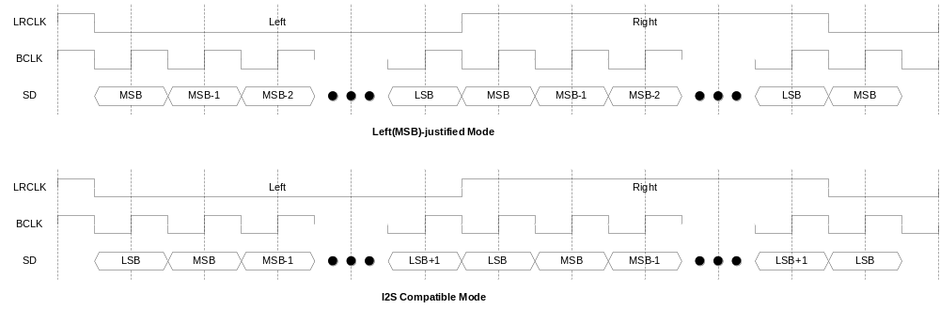

I2S_CTRL레지스터의 TxLJust bit, RxLJust bit에 의해 Transmit/Receive 동작이 configuration된다. 또한 I2S_CLKCTRL 레지스터의 LRClkInv bit를 변경하여 LRCLK의 polarity를 변경할 수 있다.

WordLength와 FIFO data

Transmit/Receive 각각 I2S_CTRL 레지스터의 TxWLen, RxWLen field에 의해 sample 하나의 sample의 bit width를 8bit/16bit/24bit/32bit으로 변경할 수 있다. FIFO는 32bit word 단위를 사용하므로 각 sample이 어떤 방식으로 FIFO에 저장되는지를 알아보면 다음과 같다.

8 bit/sample

8 bit/sample의 경우 다음과 같이 packing되어 32bit FIFO에 저장된다.
Figure 11-38 8 bit/sample data format
LeftSample/RigthSample은 각각 Left Channel Sample, Right Channel Sample을 의미하며, LeftSample0/RightSample0가 LeftSample1/RigthSample1에 비해 먼저 전송되고 Receive의 경우에는 먼저 받은 sample이 LeftSample0/RightSample0가 된다. 당연히 TX FIFO에 먼저 저장된 data부터 전송이 되고, Receive의 경우 먼저 받은 data들이 RX FIFO에 먼저 채워지게 된다.

16 bit/sample

16 bit/sample의 경우 다음과 같이 packing되어 32bit FIFO에 저장된다.
Figure 11-39 16 bit/sample data format
하위 16bit가 Left channel sample이며 상위 16bit가 Right channel sample이다.

24 bit/sample

24 bit/sample의 경우 다음과 같이 32bit FIFO에 저장된다.
Figure 11-40 24 bit/sample data format
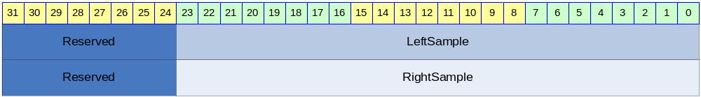

FIFO에는 Left Channel sample이 먼저 저장되고 Right Channel sample이 나중에 저장된다. Transmit의 경우 상위 8bit reserved 영역은 의미가 없고, Receive의 경우 Reserved 영역이 자동으로 sign extension되어 저장된다. 즉 Reserved 영역 8bit가 23번 bit와 같은 값으로 저장된다.

32 bit/sample

32 bit/sample의 경우 다음과 같이 32bit FIFO에 저장된다.
Figure 11-41 32 bit/sample data format
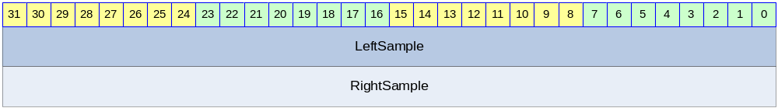

FIFO에는 32bit Left Channel sample이 먼저 저장되고 Right Channel sample이 나중에 저장된다.

Register Description

Registers

Table 11-34 Registers
Offset | Name | R/W | Description | Init. value
0000h | I2S_CLKCTRL | RW | Clock Control Register | 0000 0000h
0004h | I2S_CTRL | RW | Control Register | 0201 0201h
0008h | I2S_STATUS | RW | Status Register | 0000 0000h
000Ch | I2S_DATA | RW | FIFO | N/A

I2S_CLKCTRL Register

I2S_CLKCTRL 레지스터는 Digital Oscillator의 동작과 Master/Slave configuration을 control하는 레지스터이다.
Figure 11-42 I2S_CLKCTRL Register
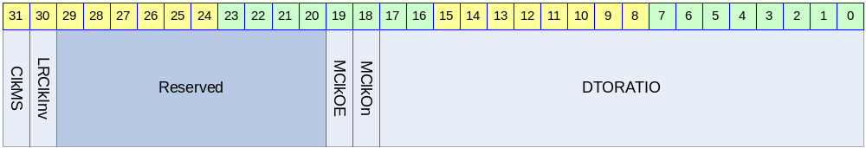

Table 11-35 I2S_CLKCTRL Register Description(Offset : 0000h)
Bits | Name | R/W | Description | Init. value
[31] | ClkMS | RW | LRCLK/BCLK의 master/slave mode 결정  0 : LRCLK/BCLK의 slave 모드로 동작  1 : LRCLK/BCLK의 master 모드로 동작 | 0b
[30] | LRClkInv | RW | LRCLK의 polarity  0 : LRCLK 정상(Left 0, Right 1)  1 : LRCLK Inverting(Left 1, Right 0) | 0b
[19] | MClkOE | RW | MCLK의 Output Enable 신호  0 : MCLK을 output pin으로 출력하지 않음  1 : MCLK을 output pin으로 출력함  MCLK output pin이 chip 전체의 GPIO와 mux될 수 있으므로 이 field는 변경될 가능성이 크다. | 0b
[18] | MClkOn | RW | Digital Oscillator의 동작을 On/Off 시킴  0 : Digital Oscillator가 동작하지 않음  1 : Digital Oscillator가 동작함 | 0b
[17:0] | DTORATIO | RW | 18bit DTO 비율  ‘2^18*MCLK의주파수/SYS_CLK의주파수’를 계산한 후 정수로 반올림한 값을 적어준다. MCLK을 생성하고 싶지 않으면 0을 write한다. | 0

ClkMS bid이 ‘1’이면 MClkOn bit은 반드시 ‘1’이어야 하고, DTORATIO field가 올바르게 setting되어야 한다. 참고로 MClkOn이 ‘1’이고 MClkOE가 ‘0’이면 MCLK을 출력하지는 않고, BCLK과 LRCLK을 생성하기 위해서만 사용하게 된다.

I2S_CTRL Register

I2S_CTRL 레지스터는 Serializer/Deserializer Block의 동작을 제어한다.

Figure 11-43 I2S_CTRL Register
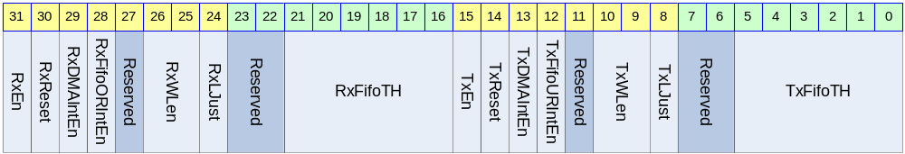

Table 11-36 I2S_CTRL Register Description(Offset : 0004h)
Bits | Name | R/W | Description | Init. value
[31] | RxEn | RW | Receive 동작의 Enable/Disable  0 : disable  1 : enable | 0b
[30] | RxReset | W | Receive hardware reset  1을 write하면 Receive 동작 관련 hardware를 초기화함  0을 write하는 것은 의미 없음 | 0b
[29] | RxDMAIntEn | RW | RX DMA request에 Interrupt발생을 enable함  0 : DMA Request Interrupt disable  1 : DMA Request Interrupt enable | 0b
[28] | RxFifoORIntEn | RW | RX FIFO OverRun Interrupt 발생을 enable함  0 : RX FIFO OverRun Interrupt disable  1 : RX FIFO OverRun Interrupt enable | 0b
[26:25] | RxWLen | RW | Receive 동작시 Word Length  00 : 8 bit/sample  01 : 16bit/sample  10 : 24bit/sample  11 : 32bit/sample | 01b
[24] | RxLJust | RW | Receive동작의 Left-justified mode와 I2S Mode 선택  0 : I2S compatible mode  1 : Left(MSB)-justified mode | 0b
[21:16] | RxFifoTH | RW | RX FIFO의 DMA request threshold  RX FIFO의 level이 RxFifoTH보다 크면 DMA Request가 생성된다. | 1
[15] | TxEn | RW | Transmit 동작의 Enable/Disable  0 : disable  1 : enable | 0b
[14] | TxReset | W | Transmit hardware reset  1을 write하면 Receive 동작 관련 hardware를 초기화함  0을 write하는 것은 의미 없음 | 0b
[13] | TxDMAIntEn | RW | TX DMA request에 Interrupt발생을 enable함  0 : DMA Request Interrupt disable  1 : DMA Request Interrupt enable | 0b
[12] | TxFifoURIntEn | RW | TX FIFO UnderRun Interrupt 발생을 enable함  0 : TX FIFO UnderRun Interrupt disable  1 : TX FIFO UnderRun Interrupt enable | 0b
[10:9] | TxWLen | RW | Transmit 동작시 Word Length  00 : 8 bit/sample  01 : 16bit/sample  10 : 24bit/sample  11 : 32bit/sample | 01b
[8] | TxLJust | RW | Transmit동작의 Left-justified mode와 I2S Mode 선택  0 : I2S compatible mode  1 : Left(MSB)-justified mode | 0b
[5:0] | TxFifoTH | RW | TX FIFO의 DMA request threshold  TX FIFO의 level이 TxFifoTH보다 작거나 같으면 DMA Request가 생성된다. | 1

I2S_STATUS Register

I2S_STATUS 레지스터는 I2S Controller의 동작 상황을 알려주기 위한 레지스터이다.

Figure 11-44 I2S_STATUS Register
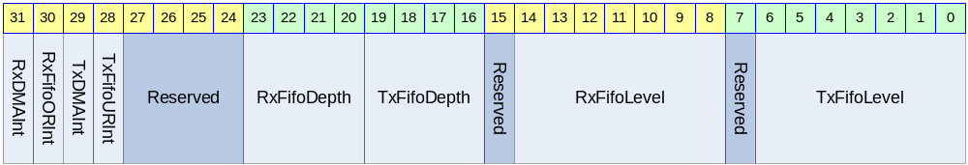

Table 11-37 I2S_STATUS Register Description(Offset : 0008h)
Bits | Name | R/W | Description | Init. Value
[31] | RxDMAInt | R | Receive DMA Request Interrupt  0 : DMA Request를 하고 있지 않음  1 : DMA Request를 하고 있음  Receive DMA Request를 하고 있으면 ‘1’이 되고 DMA Controller나 CPU가 RX FIFO를 읽어가면 자동으로 ‘0’으로 clear된다. I2S_CTRL의 RxDMAIntEn의 값과 관계 없이 변하고, RxDMAIntEn이 ‘1’이면 CPU로 interrupt를 보내게 된다. | N/A
[30] | RxFifoORInt | RW | Receive FIFO OverRun Interrupt 발생  0 : OverRun 상황 없었음  1 : OverRun 상황 있었음  CPU가 ‘1’을 write하여 clear할 수 있고, clear하기 전까지는 ‘0’으로 reset되지 않는다. I2S_CTRL 레지스터의 RxFifoORIntEn이 ‘1’이면 CPU로 interrupt를 보내게 된다. | N/A
[29] | TxDMAInt | R | Transmit DMA Request Interrupt  0 : DMA Request를 하고 있지 않음  1 : DMA Request를 하고 있음  Transmit DMA Request를 하고 있으면 ‘1’이 되고 DMA Controller나 CPU가 TX FIFO에 data를 채우면 자동으로 ‘0’으로 clear된다. I2S_CTRL의 TxDMAIntEn의 값과 관계 없이 변하고, TxDMAIntEn이 ‘1’이면 CPU로 interrupt를 보내게 된다. | N/A
[28] | TxFifoURInt | RW | Transmit FIFO UnderRun Interrupt 발생  0 : UnderRun 상황 없었음  1 : UnderRun 상황 있었음  CPU가 ‘1’을 write하여 clear할 수 있고, clear하기 전까지는 ‘0’으로 reset되지 않는다. I2S_CTRL 레지스터의 TxFifoURIntEn이 ‘1’이면 CPU로 interrupt를 보내게 된다. | N/A
[23:20] | RxFifoDepth | R | Receive FIFO의 Depth  Maximum 6까지의 값을 가진다.  Receive FIFO는 2^RxFifoDepth개의 Entry를 가지게 된다.
[19:16] | TxFifoDepth | R | Transmit FIFO의 Depth  Maximum 6까지의 값을 가진다.  Transmit FIFO는 2^TxFifoDepth개의 Entry를 가지게 된다.
[14:8] | RxFifoLevel | R | 현재 RX FIFO의 level로 0에서 2^RxFifoDepth의 값을 가진다. I2S_CTRL 레지스터의 RxReset에 ‘1’을 write하여 강제로 0으로 초기화할 수 있다. | 0
[6:0] | TxFifoLevel | R | 현재 TX FIFO의 level로 0에서 2^TxFifoDepth의 값을 가진다. I2S_CTRL 레지스터의 TxReset에 ‘1’을 write하여 강제로 0으로 초기화할 수 있다. | 0
RxDMAInt와 TxDMAInt는 DMA Controller를 사용하는 경우 CPU의 동작과는 무관하게 toggle되므로 RxDMAIntEn, TxDMAIntEn을 모두 ‘0’으로 setting하여 CPU로 interrupt가 전달되지 않도록 하여야 한다.
RxFifoLevel의 maximum 값은 2^RxFifoDepth이고, 이 때 Receive FIFO가 full인 상태가 된다. TxFifoLevel의 maximum 값은 2^TxFifoDepth이고, 이 때 Transmit FIFO가 full인 상태가 된다. RxFifoLevel과 TxFifoLevel이 0인 경우 각 FIFO가 empty 상황임을 나타낸다.

I2S_DATA Register

I2S_DATA 레지스터는 TX FIFO와 RX FIFO를 access할 수 있는 레지스터로 Word(32bit) 단위로 access해야 한다.

Figure 11-45 I2S_DATA Register
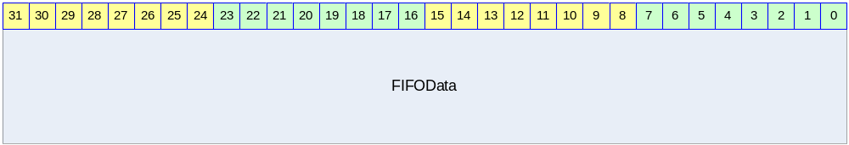

Table 11-38 I2S_DATA Register Description(Offset : 000Ch)
Bits | Name | R/W | Description | Init. Value
[31:0] | FIFOData | RW | Read의 경우 RX FIFO에서 data를 읽어서 return하고 Write의 경우 TX FIFO에 data를 write하게 된다. | N/A

TX FIFO가 full일 때 I2S_DATA에 data를 write하게 되면 write한 data는 FIFO에 write되지 않는다. RX FIFO가 empty일 때 I2S_DATA를 read하게 되면 0을 리턴한다.

I2C Master

Overview

Feature

- APB Interface
- 7/10bit Addressing
- HS-Mode Support
- Multi-Master Support
- Interrupt Signal Support

Block Diagram

Figure 12-46 I2C Block Diagram
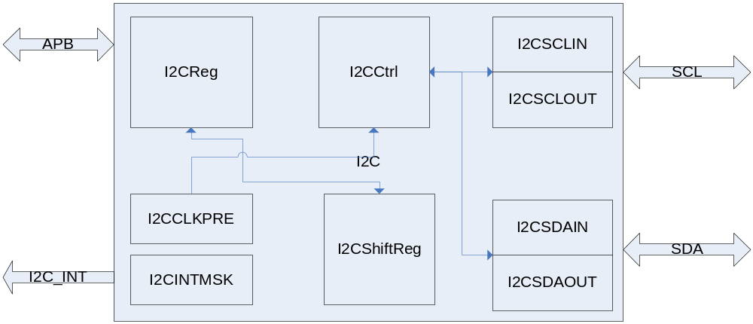

Operation

Overview

- 7/10bit addressing
- Clock Synchronization
- Arbitration
- HS-Mode

Signal Description

APB Signal (생략)

I2C Module Signal

Table 12-39 I2C Module Signal
Signal Name | Direction | Description | Init. Value
SDAo | Output | SDA line Output
SDAi | Input | SDA line Input
SCLo | Output | SCL line Output
SCLi | Iutput | SCL line Input
n_SDAEn | Output | SDA 3-State Buffer Enable
n_SCLEn | Output | SCL 3-State Buffer Enable
I2CInt | Output | I2C Interrupt Signal

Register Description

Registers

Table 12-40 Registers (Base Address : ???? ????h)
Offset | Name | R/W | Description | Init. Value
0000h | I2CCON | RW | I2C Control Register | 0000 0000h
0004h | I2CSTA | RW | I2C Status Register | 0000 0000h
0010h | I2CDAT | RW | I2C Data Register | 0000 0000h

I2CCON (I2C Control) Register

Figure 12-47 I2CCON Register Bits
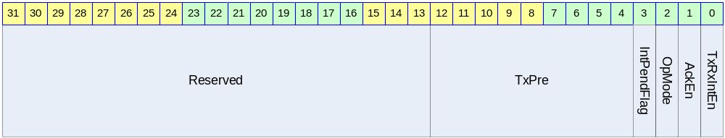

Table 12-41 I2CCON Register Description (Offset : 0000 0000h)
Bits | Name | R/W | Description | Init. Value
[12:4] | TxPre | R/W | I2C Clock Prescaler Value  Bus Clock Divide | 111111111
[3] | IntPendFlag | R/C | 1: Pending Status (READ)  Pending Clear (Write)  0: Not Pending (READ) | 0
[2] | OpMode | R/W | Operation Mode  1: Master Tx  0: Master Rx | 1
[1] | AckEn | R/W | Acknowledge Enable  1: Send ACK  0: Send NACK | 0
[0] | TxRxIntEn | R/W | Interrupt Enable  1: Interrupt Enable  0: Interrupt Disable | 0

I2CSTA (I2C Status) Register

Figure 12-48 I2CSTA Register Bits
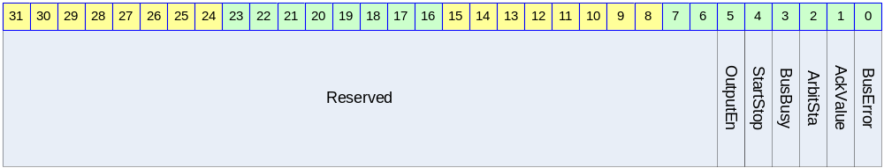

Table 12-42 I2CSTA Register Description (Offset : 0000 0004h)
Bits | Name | R/W | Description | Init. Value
[5] | OutputEn | R/W | //Reserved  1: Output Enable 0: Output Disable | 0
[4] | StartStop | W | Start/ Stop  1: Start 0: Stop  세팅되고 실행되면 자동으로 clear되는 구조 | ?
[3] | BusBusy | R | 1: Bus Busy  0: Bus not Busy  전송을 개시할 경우 이 bit를 보고 다른 mater가 사용을 하고 있는지 알 수 있다. | 0
[2] | ArbitSta | R | Arbitration Status  1: Arbitration Lost  0: Arbitration OK | 0
[1] | AckValue | R | Received Ack Value (Tx Mode일 경우에 유효)  1: Receive NACK  0: Receive ACK | 0
[0] | BusError | R | // Reserved  1: Bus Error (다른 사용 중에 start 시켰을 경우)  0: Bus no Error | 0

I2CDAT (I2C Data) Register

Figure 12-49 I2CDAT Register Bits
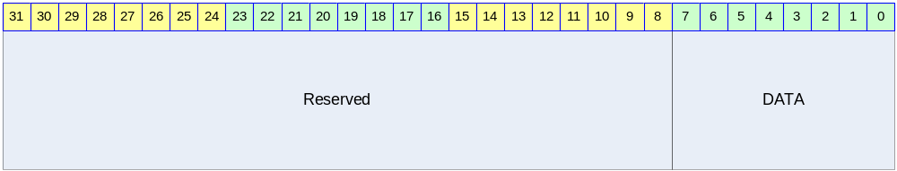

Table 12-43 I2CDAT Register Description (Offset : 0000 0008h)
Bits | Name | R/W | Description | Init. Value
[7:0] | I2C_DATA | RW | Send or Received Data  Tx로 사용될 때는 보낼 데이터를 쓰고  Rx로 사용할 때는 받은 데이터를 읽는 용도로 사용된다.  Rx모드가 아닐 때의 값은 유효하지 않음 | 0

Operation Sequence

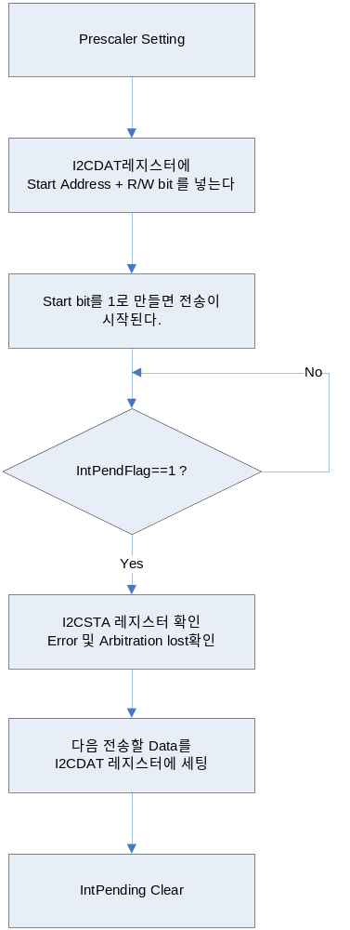

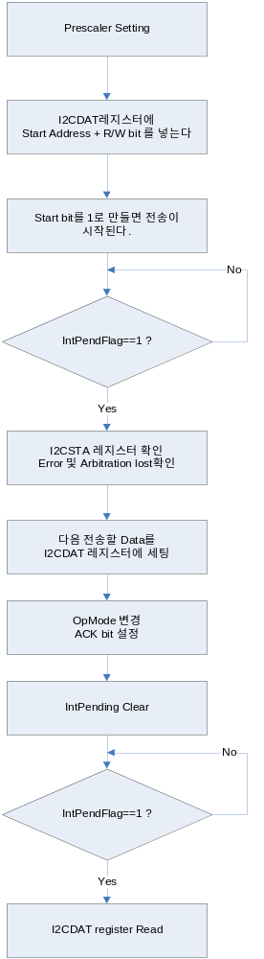

UART

  - Overview

Support 4 Ch UART
Baudrate : 115200 bps / MAX
31.25K baudrate support for MIDI
Tx 32 bytes , Rx 32 Bytes FIFOs per Ch
Digital Frequency Synthesize 기능을 내장하여 다양한 bps 지원
Self Timer기능
Included Low pass filter at RxD Signal

Figure 13-50 Block diagram

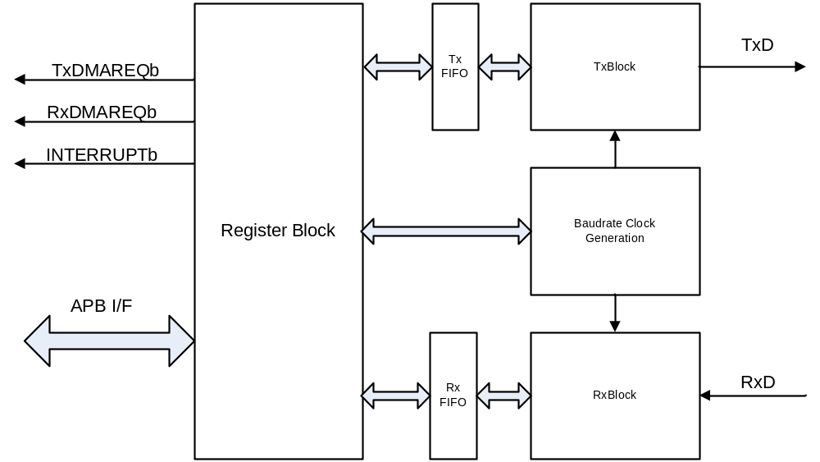

  - Register

Address | Description
0x8000 4000 | UART 0 Master command register
0x8000 4004 | UART 0 Status register
0x8000 4008 | UART 0 Buadrate Gen Register
0x8000 400C | UART 0 TxFIFO Write register
0x8000 4010 | UART 0 RxFIFO Read register
0x8000 4014 | UART 0 Receive time out register
0x8000 4018 ~  0x8000 7FFF | Reserved
0x8000 8000 | UART 1 Master command register
0x8000 8004 | UART 1 Status register
0x8000 8008 | UART 1 Buadrate Gen Register
0x8000 800C | UART 1 TxFIFO Write register
0x8000 8010 | UART 1 RxFIFO Read register
0x8000 8014 | UART 1 Receive time out register
0x8000 8018 ~  0x8000 BFFF | Reserved
0x8000 C000 | UART 2 Master command register
0x8000 C004 | UART 2 Status register
0x8000 C008 | UART 2 Buadrate Gen Register
0x8000 C00C | UART 2 TxFIFO Write register
0x8000 C010 | UART 2 RxFIFO Read register
0x8000 C014 | UART 2 Receive time out register
0x8000 C018 ~  0x8000 FFFF | Reserved
0x8001 0000 | UART 3 Master command register
0x8001 0004 | UART 3 Status register
0x8001 0008 | UART 3 Buadrate Gen Register
0x8001 000C | UART 3 TxFIFO Write register
0x8001 0010 | UART 3 RxFIFO Read register
0x8001 0014 | UART 3 Receive time out register
0x8001 0018 ~  0x8001 3FFF | Reserved

전체 UART 는 완전히 동일한 UART이다. 따라서 레지스터 세트와 설명은 하나의 UART만을 대상으로 한다.

    - Master Command Register

Address 0x0000 : Master Command Register

Figure 13-51 master command register

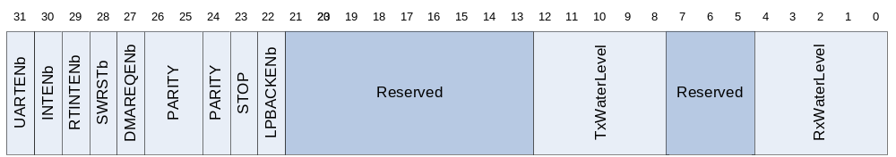

UART 의 Master Control Register이다. UART의 Enable 및 각종 제어 부분을 설정한다.
bits | Name | R/W | Description
31 | Enable UART | R/W | UART 동작의 enable/disable  0 : disable  1 : enable
30 | Enable interrupt generation | R/W | UART의 인터럽트 발생을 Enable 혹은 Disable한다.  0 : Disable  1 : Enable
29 | Enable RT Out  Interrupt | R/W | UART의 Receive timeout interrupt를 Enable 혹은 Disable 한다.  0 : Disable  1 : Enable
28 | Software Reset | WO | UART의 모든 상태를 Clear한다.  0 : no effect  1 : Software reset
27 | Enable DMA Request | R/W | DMA Request를 Enable 혹은 Disable한다.  0 : Disable  1 : Enable
26:25 | Parity | R/W | UART의 Parity mode를 설정한다.  0x : None  10 : Even parity  11 : Odd parity
24 | Data bit | R/W | UART의 Databit를 설정한다.  0 : 7 bit  1 : 8 bit
23 | Stop bit | R/W | UART의 Stop bit를 설정한다.  0 : 1 Stop bit  1 : 2 Stop bit
22 | Enable Loopback | R/W | UART의 Loopback mode를 설정한다.  0 : disable  1 : Enable
21:13 | Reserved
12:8 | Tx Water Level | R/W | TX FIFO의 Water Level을 설정한다.  해당 Water level보다 적은 데이터가 FIFO에 있으면 인터럽트 혹은 DMA 요청이 설정에 따라서 발생한다.
7:5 | Reserved
4:0 | Rx Water Level | R/W | Rx FIFO의 Water Level을 설정한다.  해당 Water level보다 적은 데이터가 FIFO에 있으면 인터럽트 혹은 DMA 요청이 설정에 따라서 발생한다.

    - Status Register

Address 0x0004 : Status Register

Figure 13-52 Status register bit filed

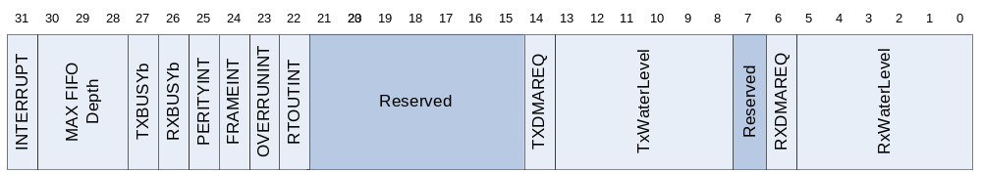

bits | Name | R/W | Description
31 | INTERRUPT | R | UART에서 인터럽트가 발생하였는지 여부를 알려주는 레지스터  0 : None  1 : Interrupt Asserted
30:28 | MAX FIFO Depth | R | UART의 FIFO의 최대 Depth를 알려준다.  버전별로 틀리므로 이 레지스터를 읽어서 크기를 확인할 수 있다.  000 : FIFO None  001 : 8 depth  010 : 16 depth  011 : 32 depth  Others : Reserved
27 | TxBUSY | R | TxModule의 동작이 현재 전송 동작 중이라는 것을 알려준다.  0 : IDLE or wait tx fifo fill  1 : Transmit busy
26 | RxBUSY | R | Rx Module의 동작이 현재 수신 동작 중이라는 것을 알려준다.  0 : IDLE or wait state  1 : Receive Busy
25 | Parity Error interrupt | R | Rx Buffer에 수신된 데이터에  Parity Error가 발생하였음을 알려준다.  0 : none parity error  1 : parity error
24 | Frame error interrupt | R | RxBuffer에 수신된 데이터에 Frame Error가 있음을 알려준다.  0 : none frame error  1 : frame error
23 | Overrun error | R | Rx FIFO가 Overrun되었음을 알려준다.  0 : None overrun error  1 : Overrun error
22 | Receive time out | R | Receive time out이 발생하였음을 알려준다.  0 : none time out  1 : Time out
21:15 | Reserved
14 | TxFIFO DMA Request | R | TxFIFO water level DMA request  0 : None request  1 : DMA Request
13:8 | TxFIFO count | R | Tx Buffer의 FIFO에 남아 있는 데이터의 개수를 확인할 수 있다.
7 | Reserved
6 | RxFIFO Count | R | RxFIFO water level DMA request  0 : None request  1 : DMA Request
5:0 | RxFIFO Count |  | Rx Buffer의 FIFO에 수신된 데이터의 Count의 개수를 확인 할 수 있다.

    - Buadrate Gen Register

Address 0x0008 : Baudrate Gen (Clock Divide) Register

Figure 13-53 Status register bit filed
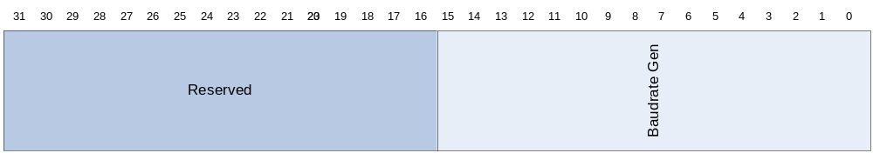

bits | Name | R/W | Description
31:16 | Reserved
15:0 | Baudrate gen | R/W | Baudrate generation clock value

    - TxFIFO Write Register

Address 0x000C : WFIFO Write Register ( Byte )

Figure 13-54 Status register bit filed
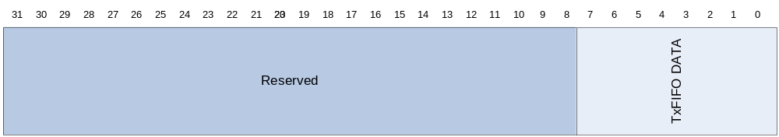

bits | Name | R/W | Description
31:08 | Reserved
7:0 | TxFIFO Data | W | Tx FIFO Data

    - RxFIFO Read Register

Address 0x0010 : RFIFO Read Register ( Byte )

Figure 13-55 Status register bit filed

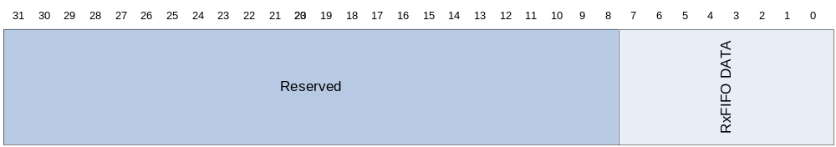

bits | Name | R/W | Description
31:08 | Reserved
7:0 | RxFIFO Data | R | Rx FIFO Data

    - Receive time out count register

Address 0x0014 : Receive Time out count
Count /w 1 MHz clock

Figure 13-56 Status register bit filed

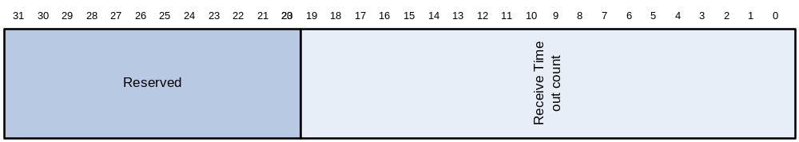

bits | Name | R/W | Description
31:20 | Reserved
19:0 | RTIMEOUT | R/W | Receive Time Out

  - Description

    - Baudrate clock generation

입력 주파수는 50MHz이며 이를 분주하여 Rx혹은 Tx의 속도를 결정한다.

Transmit/Receive baudrate = 50MHz/(Baudrate + 16)

Baudrate = DDS(Accumulator Count, Increment Value,50MHz)
= DDS(Accumulator Count,Increment Value ,50MHz)

EQ Register Value = Round(Baudrate * 16 * 65536 / 10^8)
= Round(Baudrate * 0.02097152)

예를들어서 115200bps를 만들고자 한다면

Register Value = Round(115200 *0.02097152)
= Round(2415.9191)
= 2416

Baudrate generation register에 2416을 설정하면 Baudrate는 115200 bps가 된다.

예를들어서 38400 bps를 만들려고 하면
Register Value = Round(38400 * 0.02097152)
= Round(805.30637)
= 805

이 경우 출력 주파수는
Output Freq = 5*10^7 * RegValue / (65536 * 16)
= 47.683716 * RegValue
= 381 * 805= 38385.391 = 38385 bps

ErrorRate = 15/38400 = 0.00039063 ~= 0.04
그러므로 오차율은 ~0.04%가 된다.

    - Low Pass Filter

내부에 Low pass filter를 내장하여 외부 신호의 Noise에 강한 특성을 가지고 있다.

Figure 13-57 Low pass filter in Rx Data

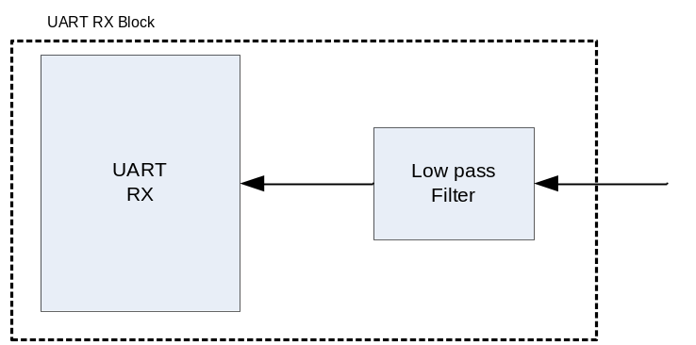

Start bit에서 noise가 발생하여도 1 bps의 시간의 23.5%까지는 noise로 인식을 한다.
이 이상의 비율로 검출이 되면 이것은 Signal로 인식이 된다.

내부에 Start signal 판별 회로에 의해서 한번 더 Filtering 됨 으로서 전체적으로 안정한 동작을 수행 할 수 있다.

    - Water Level

UART Channel 0,1 은 각각 Rx 및 Tx 방향으로 각각 32 depth의 FIFO를 가지고 있다.
UART Channel 2,3 은 각각 Rx 및 Tx 방향으로 각각 8 depth의 FIFO를 가지고 있다

이 FIFO는 Waterlevel을 설정할수 있으며 이에 의해서 DMA Request 혹은 Interrupt를 발생 시킬 수 있다.

Figure 13-58 Status Water Level

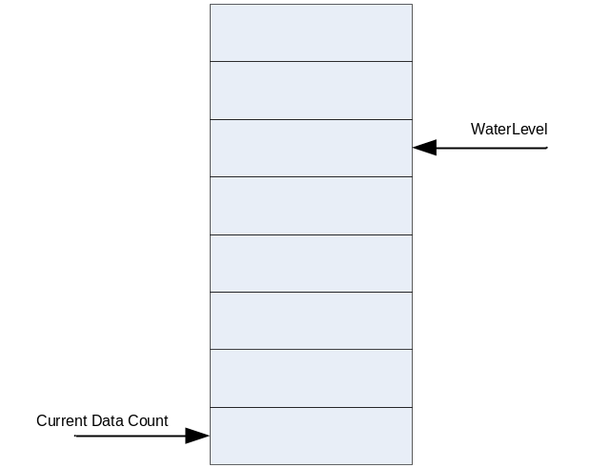

Figure 13-59 Water Level Control logic

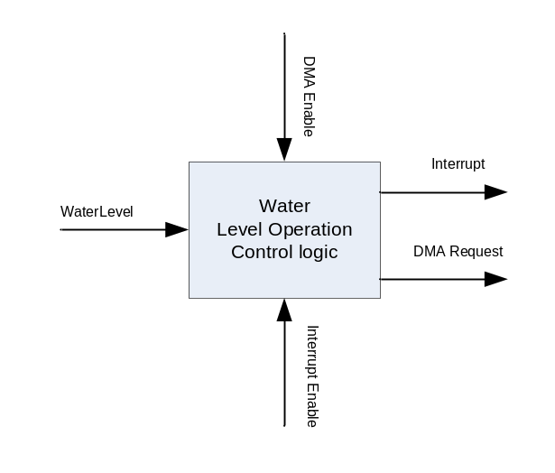

Tx의 경우 Waterlevel 보다 FIFO의 데이터의 개수가 적어지면 DMA Request가 활성화 되어 있을 경우 DMA Request를 발생 시키며 DMA Request가 활성화 되어 있지 않은 상태에서 인터럽트가 활성화 되어 있으면 인터럽트가 발생한다.

수신의 경우 Water level 보다 FIFO의 데이터 개수가 많아지면 DMA Request가 활성화 되어 있으면 DMA Request가 발생이 되며 DMA Request가 활성화 되어 있지 않은 상태에서 인터럽트가 활성화 되어 있으면 인터럽트가 발생한다.

DMA Request가 활성화 되어 있는 상태에서 송신 FIFO가 모두 비워지고 인터럽트가 활성화 되어 있으면 인터럽트가 발생한다.

DMA Request가 활성화 되어 있는 상태에서 수신 FIFO가 모두 채워지고 인터럽트가 활성화 되어 있으면 인터럽트가 발생한다.

    - Receive Time out interrupt

데이터가 일정 시간 수신되지 않으면 인터럽트를 발생시키는 기능이다. 이 기능은 Master command register의 bit 29번 receive time out register를 1로 설정함으로서 활성화 된다.

Receive timeout count register 에 값을 설정하면 설정하는 즉시 카운트를 시작하고 설정한 값만큼의 시간이 지나가도 데이터가 수신되지 않으면 인터럽트가 발생한다.

Baudrate 의16분주 Clock을 가지고 분주하여서 만든다.

만약 9600 bps 일 경우에는

9600 * 16 = 153600 Hz ➔ 153.6KHz

최대 20 Bit까지 카운트 하므로

2^20 ➔ 1048576
1048576 / 153600 ➔ 6.82 Sec

즉 최대 6.82초까지 카운트를 할 수 있다.

    - Loop back mode

UART의 기능을 테스트 하기 위해서 송신 데이터가 그대로 수신 데이터로 수신되는 모드이다. 이 기능은 Master command register의 22번 비트를 ‘1’로 설정함으로서 활성화 된다.

송수신 데이터 모드의 설정 및 패리티, Stop bit 등의 설정은 Master command register의 설정에 그대로 따른다.

Figure 13-60 UART Loopback logic

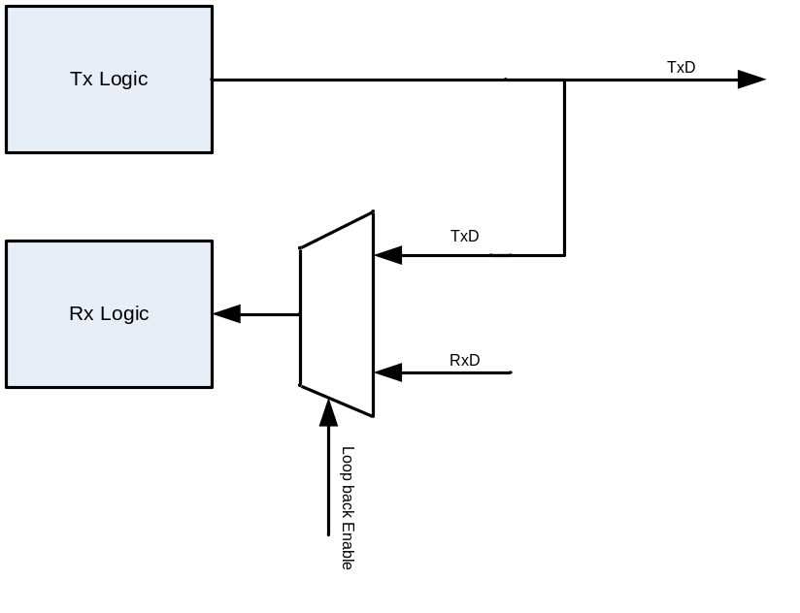

GPIO

Overview

32bit GPIO port를 가지는 GPIO Controller를 두 개 제공한다.

Features

- 32bit GPIO x 2
- Interrupt Generation
  - Active high/low level interrupt
  - Positive/Negative edge interrupt
  - Both edge interrupt

Operation

GPIO Operation

GPIO 동작은 다음과 같은 block diagram으로 이해할 수 있다. 사용자는 출력하고 싶은 data가 있으면 GPIO_OUT 레지스터에 값을 쓰고, GPIO_OE 레지스터에 출력 pin에 해당 하는 bit를 ‘1’로 write해 주면 tri-state buffer가 enable되어 외부 PAD로 출력이 이루어지게 된다. GPIO port로 입력 받은 signal은 GPIO_IN 레지스터를 읽음으로써 detect할 수있다.

Figure 14-61 GPIO Operation Block Diagram
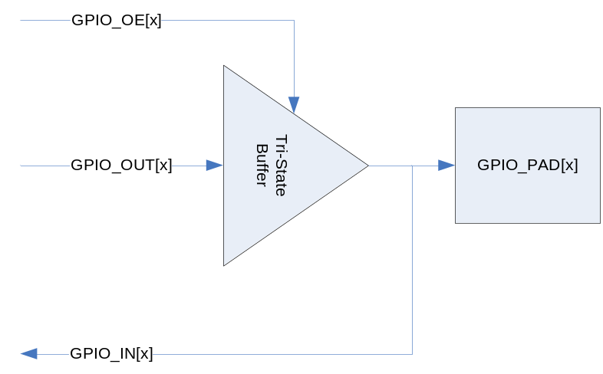

Interrupt Operation

외부에서 PAD에서 입력되는 신호를 detect하여 Interrupt Controller로 interrupt를 발생시킬 수 있다.

Figure 14-62 Interrupt Operation Block Diagram
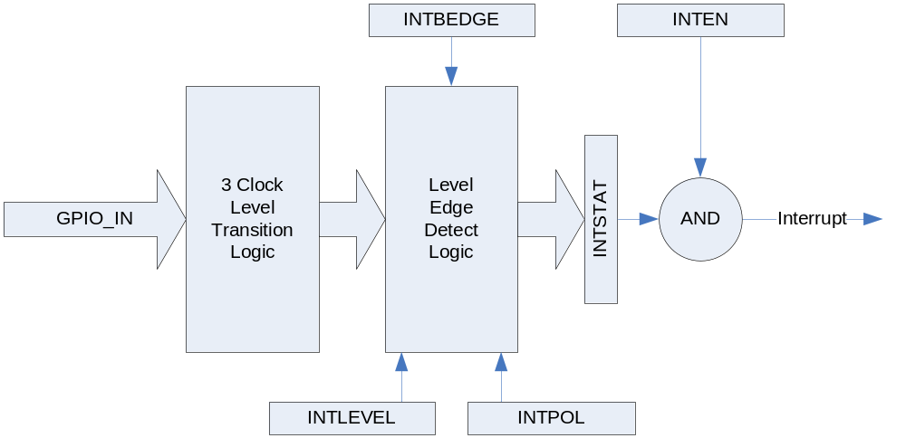

위의 그림과 같이 GPIO PAD에서 오는 GPIO_IN 신호는 3 Clock Level Transition Logic을 지나게 된다. 3 Clock Level Transition Logic은 PAD에서 들어오는 노이즈를 걸러내는 일을 하는데, 총 3 APB Clock Cycle 동안 GPIO_IN이 stable한 경우에 그것을 올바른 신호로 인식하고, GPIO_IN이 3 cycle보다 작은 시간 동안 변하는 경우에는 노이즈로 인식하여 입력 신호가 바뀌었다고 판단하지 않게 된다. 처리가 끝난 신호는 Level/Edge Detect Logic에 인가 되어 Level/Edge의 detect 결과가 INTSTAT 레지스터로 출력 된다. 그 후에 INTSTAT 레지스터와 INTEN 레지스터를 bitwise AND하고 그 결과값이 0이 아니면 active high level interrupt가 생성되게 된다. Level/Edge Detect Logic은 INTLEVEL/INTPOL/INTBEDGE 레지스터에 의해서 control되는데 우선 INTLEVEL은 Level interrupt인지 edge interrupt인지를 결정하게 된다. INTLEVEL[x]가 1이면 GPIO[x]에 입력되는 signal은 level interrupt로 처리되고 0이면 edge interrupt로 처리된다. INTBEDGE는 interrupt가 both edge에서 동작하도록 하는 레지스터이다. INTBEDGE[x]가 1이면 GPIO[x]에 입력되는 signal의 rising edge와 polling edge 양쪽에서 interrupt가 생성된다. 단 이때는 INTLEVEL[x]가 0이어야 하고 INTLEVEL[x]가 1이면 INTBEDGE[x] 값은 무시된다. INTPOL는 GPIO에 인가되는 interrupt signal의 polarity를 정하게 된다. INTPOL[x]가 1이면 active high(edge의 경우 rising edge)가 되고 0이면 active low(edge의 경우 polling edge)가 된다. INTLEVEL[x]가 0이고 INTBEDGE[x]가 1이면 both edge를 detect하는 것이므로 INTPOL[x]는 무시된다.

Interrupt Operation Example

- GPIO PAD[x]에서 받는 신호가 high level에서 interrupt 생성을 워하는 경우
INTLEVEL[x] : 1로 세팅
INTPOL[x] : 1로 세팅
INTEN[x] : 1로 세팅

- GPIO PAD[x]에서 받는 신호의 falling edge에서 interrupt 생성을 원하는 경우
INTLEVEL[x] : 0로 세팅
INTPOL[x] : 0로 세팅
INTBEDGE[x] : 0로 세팅
INTSTAT[x] : 0으로 clear함
INTEN[x] : 1로 세팅

- GPIO PAD[x]에서 받는 신호의 rising/falling edge 모두에서 interrupt생성을 원하는 경우
INTLEVEL[x] : 0로 세팅
INTBEDGE[x] : 1로 세팅
INTSTAT[x] : 0으로 clear함
INTEN[x] : 1로 세팅

Register Description

Registers

Table 14-44 Registers
Offset | Name | R/W | Description | Init. value
0000h | GPIO0_OE | RW | (GPIO0) Output Enable Register | 0000 0000h
0004h | GPIO0_IN | R | (GPIO0) Input Register | N/A
0008h | GPIO0_OUT | RW | (GPIO0) Output Register | 1234 5678h
000Ch | GPIO0_INTSTAT | RW | (GPIO0) Interrupt Status Register | N/A
0010h | GPIO0_INTEN | RW | (GPIO0) Interrupt Enable Register | 0000 0000h
0014h | GPIO0_INTLEVEL | RW | (GPIO0) Interrupt Level/Edge Selection Register | 0000 0000h
0018h | GPIO0_INTPOL | RW | (GPIO0) Interrupt Polarity Register | 0000 0000h
001Ch | GPIO0_INTBEDGE | RW | (GPIO0) Interrupt Both Edge Register | 0000 0000h
0020h | GPIO1_OE | RW | (GPIO1) Output Enable Register | 0000 0000h
0024h | GPIO1_IN | R | (GPIO1) Input Register | N/A
0028h | GPIO1_OUT | RW | (GPIO1) Output Register | 1234 5678h
002Ch | GPIO1_INTSTAT | RW | (GPIO1) Interrupt Status Register | N/A
0030h | GPIO1_INTEN | RW | (GPIO1) Interrupt Enable Register | 0000 0000h
0034h | GPIO1_INTLEVEL | RW | (GPIO1) Interrupt Level/Edge Selection Register | 0000 0000h
0038h | GPIO1_INTPOL | RW | (GPIO1) Interrupt Polarity Register | 0000 0000h
003Ch | GPIO1_INTBEDGE | RW | (GPIO1) Interrupt Both Edge Register | 0000 0000h

GPIO Output Enable Register (GPIO0_OE /GPIO1_OE)

GPIO Output Enable 레지스터는 GPIO PAD의 tristate buffer를 enable하기 위한 레지스터이다.

Figure 14-63 GPIO Output Enable Register
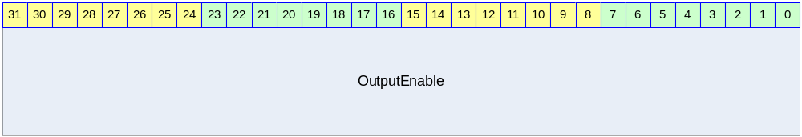

Table 14-45 GPIO Output Enable Register Description
Bits | Name | R/W | Description | Init. value
[31:0] | OutputEnable | RW | GPIO Output Enable  각 bit가 1이면 해당 GPIO PAD에 GPIO_OUT 레지스터의 해당 bit가 출력된다.  0이면 해당 GPIO PAD가 tristate 상태가 된다. | 0000 0000h

GPIO Input Register (GPIO0_IN/GPIO1_IN)

GPIO Input 레지스터는 GPIO PAD에 인가된 signal을 읽을 수 있는 레지스터이다.

Figure 14-64 GPIO Input Register
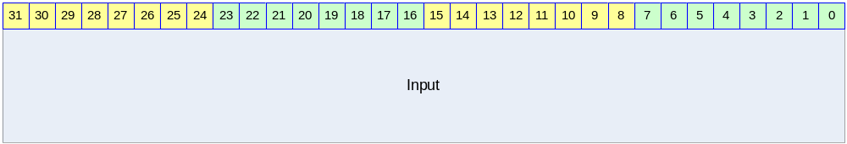

Table 14-46 GPIO Input Register Description
Bits | Name | R/W | Description | Init. value
[31:0] | Input | R | GPIO Input  GPIO PAD에 인가된 값을 읽을 수 있다.  Input[x]가 1이면 해당 GPIO PAD에 high level의 voltage가 인가되었음을 나타낸다. | N/A

GPIO Output Register (GPIO0_OUT/GPIO1_OUT)

GPIO Output 레지스터는 GPIO PAD에 출력될 값을 저장하고 있는 레지스터이다.

Figure 14-65 GPIO Output Register
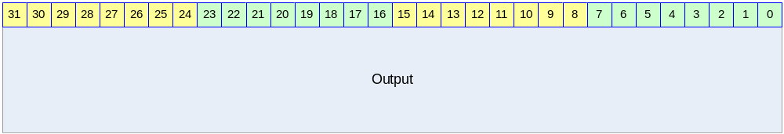

Table 14-47 GPIO Output Register Description
Bits | Name | R/W | Description | Init. Value
[31:0] | Output | RW | GPIO Output  OuputEnable[x]가 1이고 Output[x]가 1이면 해당 GPIO PAD에 high level에 해당하는 전압이 인가된다. OutputEnable[x]가 1이고 Output[x]가 0이면 해당 GPIO PAD에 low level에 해당하는 전압이 인가된다.  OutputEnable[x]가 0이면 Output[x]는 아무런 의미가 없다. | 0b

GPIO Interrupt Status Register (GPIO0_INTSTAT/GPIO1_INTSTAT)

GPIO PAD로 입력 받은 interrupt status를 의미하는 레지스터이다.

Figure 14-66 GPIO Interrupt Status Register
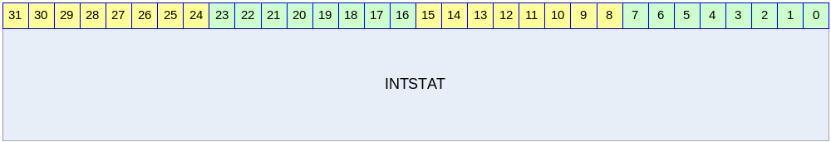

Table 14-48 GPIO Interrupt Status Register Description
Bits | Name | R/W | Description | Init. Value
[31:0] | INTSTAT | RW | GPIO Interrupt Status  1 : Level or Edge detected  0 : Level or Edge not detected  Level/Edge detect 상황이 반영되는 register이다. 1을 write하면 해당 bit가 0으로 clear되고 0을 write하는 것은 의미가 없다. | 0000 0000h

위의 동작설명에서 보았듯이 INTSTAT의 bit는 INTEN와는 아무런 상관 없이 변하게 된다. 즉 GPIO PAD에 인가되고 있는 signal에 변화가 생기게 되면 해당 bit의 INTSTAT이 변하게 된다. Interrupt는 INTSTAT과 INTEN의 bitwise AND의 결과 32bit 값이 0이 아니면 발생하게 된다. 어떤 bit 때문에 interrupt가 생성되었는지 알고 싶으면 사용자는 INTEN와 INTSTAT을 bitwise AND한 32bit data에 대해서 0이 아닌 bit를 찾아야 한다. Edge interrupt의 경우 interrupt service routine에서 해당 bit를 0으로 clear하는 것으로 Interrupt Acknowledge를 하며 된다. Level interrupt는 별도의 interrupt acknowledge를 할 필요는 없고 interrupt를 assert한 외부 device에서 해당 interrupt를 clear하는 것으로 모든 처리가 끝나게 된다.

GPIO Interrupt Enable Register (GPIO0_INTEN/GPIO1_INTEN)

GPIO PAD로 입력 받은 interrupt status를 의미하는 레지스터이다.

Figure 14-67 GPIO Interrupt Enable Register
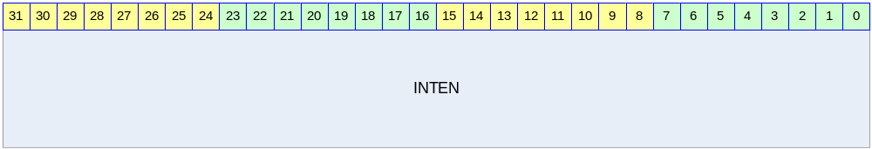

Table 14-49 GPIO Interrupt Enable Register Description
Bits | Name | R/W | Description | Init. Value
[31:0] | INTEN | RW | GPIO Interrupt Enable  1 : Interrupt Enable  0 : Interrupt Disable  어떤 bit를 1이면 INTSTAT의 해당 bit가 1로 바뀔 때 interrupt가 생성된다. | 0000 0000h

GPIO Interrupt Level/Edge Selection Register (GPIO0_INTLEVEL/GPIO1_INTLEVEL)

GPIO PAD로 입력 받을 interrupt 신호의 형태가 level trigger 인지 edge trigger인지 선택하는 레지스터이다.

Figure 14-68 GPIO Interrupt Level/Edge Selection Register
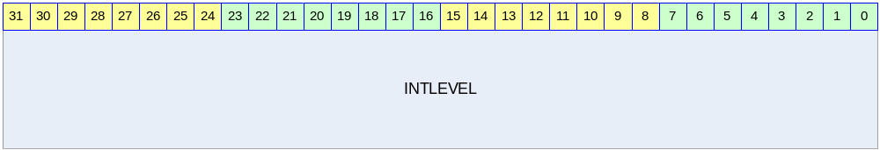

Table 14-50 GPIO Interrupt Level/Edge Selection Register
Bits | Name | R/W | Description | Init. Value
[31:0] | INTLEVEL | RW | GPIO Interrupt Level/Edge Selection  1 : Level trigger mode  0 : Edge trigger mode | 0000 0000h

GPIO Interrupt Polarity Register (GPIO0_INTPOL/GPIO1_INTPOL)

GPIO PAD에 가해지는 signal로 interrupt를 detect하는 경우 그 interrupt 신호가 active high인지 active low인지 결정하는 레지스터이다.

Figure 14-69 GPIO Interrupt Polarity Register
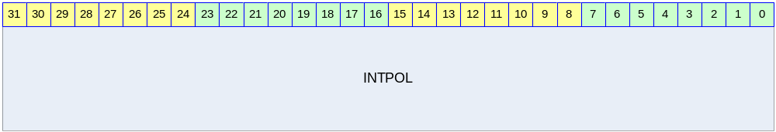

Table 14-51 GPIO Interrupt Polarity Register Description
Bits | Name | R/W | Description | Init. Value
[31:0] | INTPOL | RW | GPIO Interrupt Polarity Selection  1 : active high(rising edge)  0 : active low(falling edge) | 0000 0000h

GPIO Interrupt Both Edge Register (GPIO0_INTBEDGE/GPIO1_INTBEDGE)

GPIO PAD에 인가되는 signal의 양쪽 edge(즉 rising edge, falling edge 모두)에서 interrupt를 생성할 것인지 결정하는 레지스터이다.

Table 14-52 GPIO Interrupt Both Edge Register
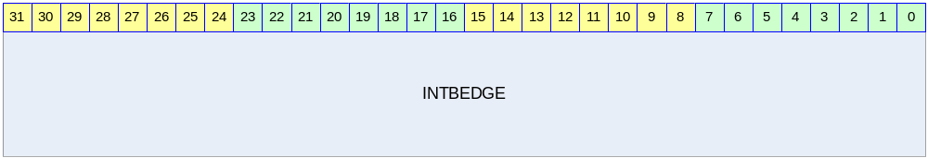

Table 14-53 GPIO Interrupt Both Edge Register Description
Bits | Name | R/W | Description | Init. Value
[31:0] | INTBEDGE | RW | GPIO Interrupt Both Edge  1 : interrupt when both edge  0 : interrupt when single edge  INTLEVEL의 특정 bit 위치의 값이 1인경우 해당 위치의 INTBEDGE bit는 아무런 의미가 없다. | 0000 0000h

NAND Flash Memory Controller

Overview

Feature
- APB Interface.
- NAND Boot support(up to 8KB)
- 8bit NAND Flash Interface.
- 512 byte/2048byte Page support
- 256 byte ECC support
- Read/Erase/Program support
- 128Mbit~2Gbit Flash memory support
- DMA support
- Using Command FIFO,DATA FIFO

Block Diagram

Figure 15-70 NAND Flash Controller Block Diagram
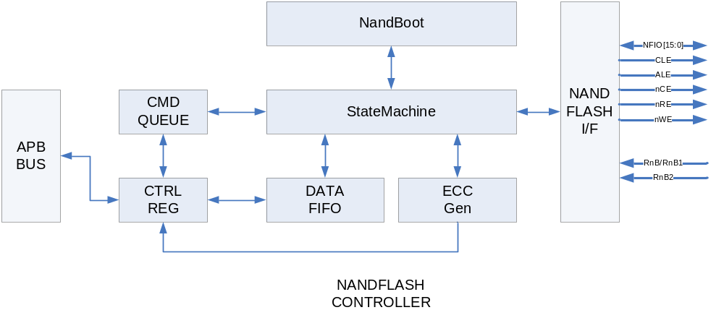

Signal Description
Table 15-54 NAND Flash Signal
Signal Name | Direction | Description | Init. value
NFIO0 ~ NFIO15 | InOut | Inout pin  Address, data, command 입출력 핀
CLE | Output | Command latch enable  CLE가 High이고 nWE이 rising edge일 때 command가 래치됨 | 1
ALE | Output | Address latch enable  ALE가 High이고 nWE이 rising edge일 때 address가 래치됨 | 1
nNFCE | Output | Chip enable | 1
nNFRE | Output | Read enable | 1
nNFWE | Output | Write enable | 1
RnB | Input | Ready & Busy | 1

Timing
Figure 15-71 Address to data load time/WE high to busy Timing
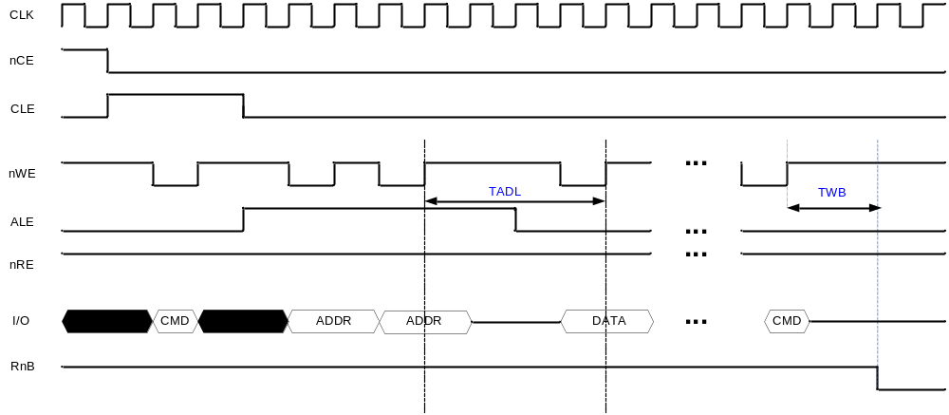
- NFCONF Register에 TADLTWB값으로 TADL, TWB 타이밍 조정이 가능함.
Figure 15-72 ALE,CLE Timing
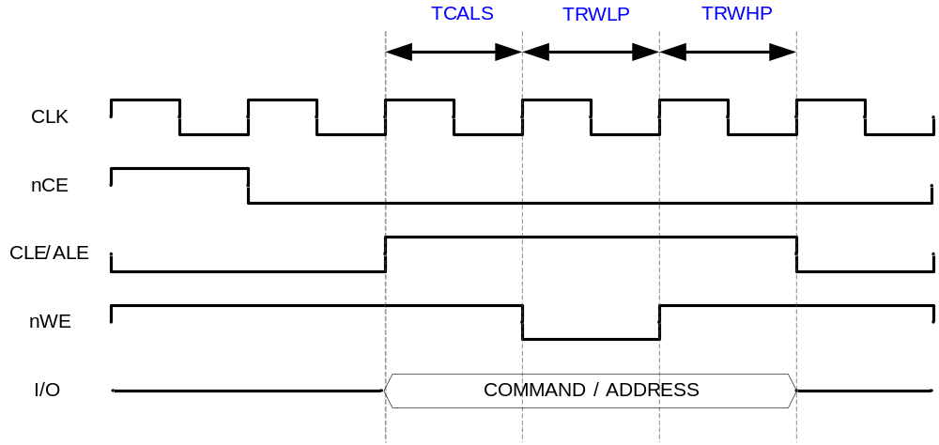
- NFCONF Register에 TCALS, TRWLP, TRWHP값으로 ALE,CLE 타이밍 조정이 가능함.

Figure 15-73 RE,WE Timing
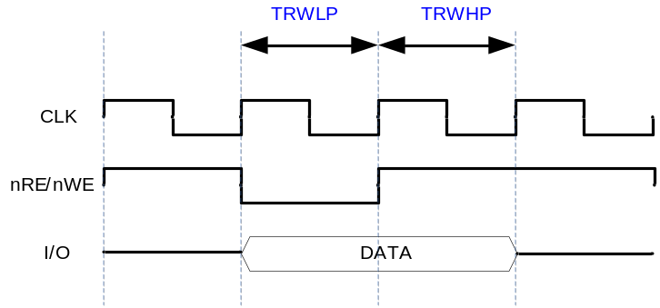
- NFCONF Register에 TRWLP, TRWHP 값으로 RE, WE의 타이밍 조정이 가능함.

Interface

Figure 15-74 Interface exampe

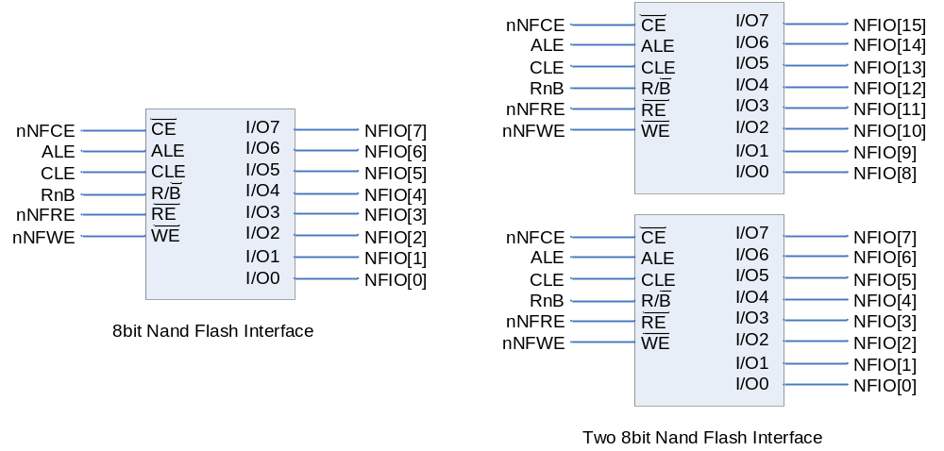

Register Description

Registers

Table 15-55 Registers
Offset | Name | R/W | Description | Init. value
0000h | NFOPER | R | Nand Flash Operation register | 0000 0000h
0004h | NFDATA | RW | Nand Flash Data register | 0000 0000h
0008h | NFCONF | RW | Nand Flash Configuration register | 0000 1e92h
000Ch | NFCTRL | RW | Nand Flash Control register | 0000 0000h
0010h | NFSTAT | RW | Nand Flash Status register | 0000 0003h
0014h | ECCSECTOR0 | R | Nand Flash Ecc sector0 register | 0000 0000h
0018h | ECCSECTOR1 | R | Nand Flash Ecc sector1 register | 0000 0000h
001Ch | ECCSECTOR2 | R | Nand Flash Ecc sector2 register | 0000 0000h
0020h | ECCSECTOR3 | R | Nand Flash Ecc sector3 register | 0000 0000h
0024h | ECCSECTOR4 | R | Nand Flash Ecc sector4 register | 0000 0000h
0028h | ECCSECTOR5 | R | Nand Flash Ecc sector5 register | 0000 0000h
002ch | ECCSECTOR6 | R | Nand Flash Ecc sector6 register | 0000 0000h
0030h | ECCSECTOR7 | R | Nand Flash Ecc sector7 register | 0000 0000h
0034h | ECCSECTOR8 | R | Nand Flash Ecc sector8 register | 0000 0000h
0038h | ECCSECTOR9 | R | Nand Flash Ecc sector9 register | 0000 0000h
003ch | ECCSECTOR10 | R | Nand Flash Ecc sector10 register | 0000 0000h
0040h | ECCSECTOR11 | R | Nand Flash Ecc sector11 register | 0000 0000h
0044h | ECCSECTOR12 | R | Nand Flash Ecc sector12 register | 0000 0000h
0048h | ECCSECTOR13 | R | Nand Flash Ecc sector13 register | 0000 0000h
004ch | ECCSECTOR14 | R | Nand Flash Ecc sector14 register | 0000 0000h
0050h | ECCSECTOR15 | R | Nand Flash Ecc sector15 register | 0000 0000h
0054h | SECCSECTOR0 | R | Nand Flash spare Ecc sector0 register | 0000 0000h
0058h | SECCSECTOR1 | R | Nand Flash spare Ecc sector1 register | 0000 0000h
005ch | SECCSECTOR2 | R | Nand Flash spare Ecc sector2 register | 0000 0000h
0060h | SECCSECTOR3 | R | Nand Flash spare Ecc sector3 register | 0000 0000h
0064h | SECCSECTOR4 | R | Nand Flash spare Ecc sector4 register | 0000 0000h
0068h | SECCSECTOR5 | R | Nand Flash spare Ecc sector5 register | 0000 0000h
006ch | SECCSECTOR6 | R | Nand Flash spare Ecc sector6 register | 0000 0000h
0070h | SECCSECTOR7 | R | Nand Flash spare Ecc sector7 register | 0000 0000h
0074h | MECCERR | R | Nand Flash Main Ecc Error register | 0000 0000h
0078h | SECCERR | R | Nand Flash Spare Ecc Error register | 0000 0000h

Operation Register(NFOER)
Operation Register는 Nand flash에 전송할 command 또는 address 각 command가 어떤 동작을 하게 할것인지를 설정해주는 Register로 하나의 command(ex. Page read, Page wirte, Block Erase)를 수행하는데 최대 3Word로 구성 할 수 있다 1st word는 Operation의 Information을 가지는 Word이고 2nd ,3th Word는 command 와 address의 조합이다. 레지스터 구성은 아래 그림과 같다.

Figure 15-75 1st Operation Register bit
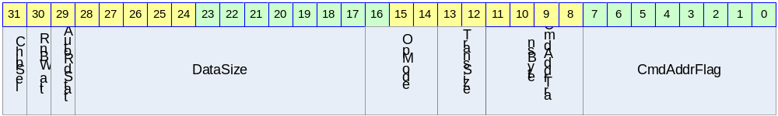

Table 15-56 1st Operation Register Description(Offset : 0000 0000h)
Bits | Name | R/W | Description | Init. value
[31] | Reserved |  |  | 0
[30:29] | Option | WO | 00: no Option 01: RnBWait  10: AutoRdStat 11: Continue  RnBWait:command Queue의 다음 command set이 RnB의 Rising edge에서 시작된다  AutoRdStat:RnB가 High가 된 후 read status Command를 날리고 status를 읽어온다.  Continue : command Queue의 다음  command set을 load하기 전까지 CE을 유지한다. | 00
[28:17] | DataSize | WO | 한 page에서 R/W할 Data Size 지정한다. IOWidth(8bit)이면byte단위,IOWidth(16bit) 이면 halfword 단위가 기본 전송단위가 된다. | 0
[16:14] | OpMode | WO | 000: read data(page read시 선택)  001: read status  010: read ID  011: write data  100,101,110 : reserved  111: NOP  Read data => page read시 사용됨  Write data => nand flash에 data를 write할 때  Read status => status read 시 사용  (Read status TransSize는 Byte단위만 가능)  Read ID => ID read 시 사용  (Read ID TransSize는 Byte단위만 가능)  Nand flash와 Nand flash controller간에 data전송이 없으면 NOP | 0
[13:12] | TransSize | WO | NFDATA를 읽거나 쓸 때 TransferSize  IOWidth 16bit이면 Half word이거나 Word만 가능  00: Byte transfer 10: Half Word transfer  10: Word transfer 11: Reserved | 0
[11:8] | CmdAddrTransByte | WO | 전송할 command byte와 address byte의 수  최대값은 8(1000b) | 0
[7:0] | CmdAddrFlag | WO | Command 인지 Address 인지를 나타내는 Flag  CmdAddrFlag[0]~CmdAddrFlag[7]의 순서로 전송된다.  0: address flag  1: command flag | 0
Figure 15-76 2nd Operation Register bit
Table 15-57 2nd Operation Register Description(Offset : 0000 0000h)
Bits | Name | R/W | Description | Init. value
[31:24] | CMDADDR4 | WO | Command or address 4th byte를 써준다. | 0
[23:16] | CMDADDR3 | WO | Command or address 3rd byte를 써준다. | 0
[15:8] | CMDADDR2 | WO | Command or address 2nd byte를 써준다. | 0
[7:0] | CMDADDR1 | WO | Command or address 1st byte를 써준다. | 0

Figure 15-77 3rd Operation Register bit
Table 15-58 3rd Operation Register Description(Offset : 0000 0000h)
Bits | Name | R/W | Description | Init. value
[31:24] | CMDADDR8 | WO | Command or address 8th byte를 써준다. | 0
[23:16] | CMDADDR7 | WO | Command or address 7th byte를 써준다. | 0
[15:8] | CMDADDR6 | WO | Command or address 6th byte를 써준다. | 0
[7:0] | CMDADDR5 | WO | Command or address 5th byte를 써준다. | 0

Data Register (NFDATA)

Nand Flash에 data를 read/write할 때 access하는 32bit 레지스터이다.
Operation 레지스터에서 설정한 TransSize에 따른 NFDATA레지스터의 Access는 아래 그림과 같다.
(ex. operation레지스터에서 word transfer로 셋팅을 하게 되면 4byte가 유효한 값을 가지고
halfword transfer 로셋팅하면 하위2byte만 유효한 값을 가지며 byte transfer로 셋팅하면 최하위 byte만 유효한 값을 가진다.)

Figure 15-78 Data Register bit(Word Access)

Figure 15-79 Data Register bit(Half Word Access)

Figure 15-80 Data Register bit(Byte Access)

Configuration Register(NFCONF)

Nand 부팅시 설정과 Timing을 설정하는 레지스터이다.
NandBootEn = nand 부팅을 enable할지 disable할지 선택함
IOWidth = NFIO를 8bit으로 할지 16bit으로 할지 선택함
BootCfg = Nand 부팅시 Nand Flash의 address cycle과 page size를 설정함
타이밍 설정에 대해서는 1-3 Timing을 참조

Figure 15-81 Configuration Register bit
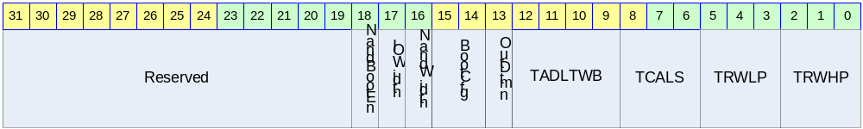

Table 15-59 Configuration Register Description(Offset : 0000 0008h)
Bits | Name | R/W | Description | Init. value
[31:19] | Reserved
[18] | NandBootEn | RO | 0: normal mode 1: nand boot enable | NFBootPin
[17] | IOWidth | RO | Nand flash controller의 I/O select  0: 8bit I/O 1: 16bit I/O | IOWidthPin
[16] | Reserved | RO | Reserved | 0
[15:14] | BootCfg | RO | 00:  3 addrcycle = 1column+2row(512page)  01:  4 addrcycle = 1column+3row(512page)  10:  4 addrcycle = 2column+2row(2048page)  11:  5 addrcycle = 2column+3row(2048page) | BootCfgPin
[13] | Reserved | RO | Reserved | 0
[12:9] | TADLTWB | RW | Duration = CLK x (TADLTWB+1) | 1111b
[8:6] | TCALS | RW | Duration = CLK x (TACLH+1) | 10b
[5:3] | TRWLP | RW | Duration = CLK x (TWEW+1) | 10b
[2:0] | TRWHP | RW | Duration = CLK x (TREW+1) | 10b

Control Register(NFCTRL)

Figure 15-82 Control Register bit
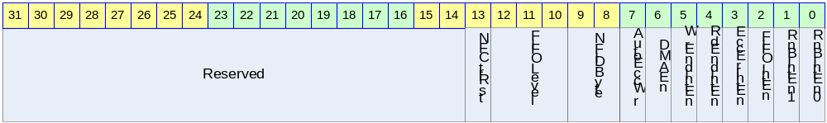
Table 15-60 Control Register Description(Offset : 0000 000ch)
Bits | Name | R/W | Description | Init. value
[31:14] | Reserved | RW | Reserved | 0
[13] | NFCtrlRst | RW | Nand flash controller reset  1을 쓰면 reset되며 auto clear된다. | 0
[12:10] | FIFOLevel | RW | FIFOLevel 셋팅  Value = FIFOLevel +1 | 111
[9] | Reserved |  | reserved | 0
[8] | Ecc512byteEn |  | 0: 256byte Ecc  1: 512byte Ecc | 0
[7] | AutoEccWr | RW | 한 페이지 모두 write하면 spare area의 Ecc영역에 계산된 ECC를 write한다.  0: Disable 1: Enable | 0
[6] | DMAEn | RW | DMA request enable  총 전송사이즈가 FIFOLevel의 배수여야 한다.  Read : Enable시 FIFO가 FIFOLevel에서 정해준 크기 만큼 데이터가 차면 DMAReq신호 발생  Write : FIFO가 empty이면 DMAReq신호 발생  0: Disable 1:Enable | 1
[5] | WrEndIntEn | RW | Write end interrupt enable  Trans size까지 모두 write 되었을때 INT발생 만약 AutoEccWr을 enable하면 status를 NFStatus에 로드한후 인터럽트가 발생한다.  0: Disable 1: Enable | 0
[4] | RdEndIntEn | RW | Read end interrupt enable  Trans size까지 모두 read 되었을때 INT발생  : Disable 1: Enable | 0
[3] | EccErrIntEn | RW | Ecc Error interrupt enable  전체 페이지를 read하였을때 Ecc Error가 생기면 인터럽트가 발생한다  0: Disable 1: Enable | 0
[2] | FIFOIntEn | RW | FIFO level interrupt enable  Read : FIFO가 지정된 레벨까지 차게 되면 인터럽트 발생  Write : FIFO가 empty면 인터럽트 발생  0: Disable 1:Enable | 0
[1] | Reserved |  | Reserved | 0
[0] | RnbIntEn0 | RW | Rnb0 interrupt enable  enable되면 Rnb rising edge에서 인터럽트 발생  0: Disable 1:Enable | 0
NFCtrlRst 을 셋팅하게 되면 내부 컨트롤 StatMachine, FIFO및 ECC레지스터를 초기화 함

Status Register(NFSTAT)

Figure 15-83 Status Register bit

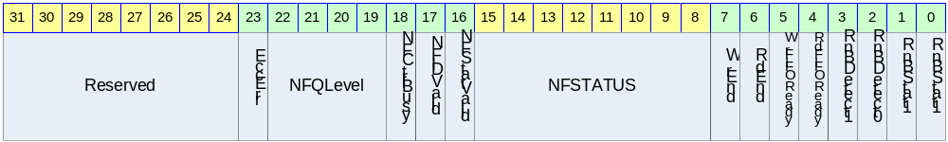

Table 15-61 Status Register Description(Offset : 0000 0010h)
Bits | Name | R/W | Description | Init. value
[31:23] | Reserved | RW | Reserved | 0
[24] | MEccErr | RW | 0: MEccErr발생 하지 않았음  1: MEccErr발생 하였음  EccErrIntEn을 1로 셋팅 하는 것과 상관없이 Main Ecc에러가 발생하면 1로 변경 된다.  만약 EccErrIntEn을 Enable하면 인터럽트가 발생하며 clear 해줘야만 다음 Ecc Error 인터럽트를 받을수 있다 반드시 clear해야 함 1을 write하면 clear | 0
[23] | SEccErr | RW | 0: SEccErr발생 하지 않았음  1: SEccErr발생 하였음  EccErrIntEn을 1로 셋팅 하는 것과 상관없이 Spare Ecc에러가 발생하면 1로 변경 된다.  만약 EccErrIntEn을 Enable하면 인터럽트가 발생하며 clear 해줘야만 다음 Ecc Error 인터럽트를 받을수 있다 반드시 clear해야 함 1을 write하면 clear
[22:19] | NFQueLevel | RW | 내부 command queue에 레벨값  Max 1000(8) | 0
[18] | NFCtrlBusy | RW | 0 : Controller Idle  1 : Controller busy | 0
[17] | NFIDValid | RW | Nand flash의 read ID를 수행하여 내부 fifo에 채운후 high가됨.  NFSTAT를 읽어가면 auto clear됨.  0:not valid 1: valid | 0
[16] | NFStatVaild | RW | Nand flash의 read status를 수행한후 High가됨  NFSTAT를 읽어가면 auto clear됨.  0:not valid 1: valid | 0
[15:8] | NFStatus | RW | Nand flash의 status를 나타내며 NFSTAT를 읽어가면 clear된다 | 00000000
[7] | WrEnd | RW | Trans size까지 모두 write 되면 HIGH가 되며 AutoRdStatus를 enable하게 되면 Status를 NFStatus로 로드한후에 HIGH가 된다.  WrEndIntEn의 enable여부에 상관없이 HIGH가 된다. 만약 인터럽트가 enable되어 있으면 WrEnd 가High일 때 인터럽트 발생  0: write not end  1: write end  1을 Write하면 clear됨 | 0
[6] | RdEnd | RW | Trans size까지 모두 read 되면(FIFO에서 모두 읽어 가게 되면) HIGH가 된다.  RdEndIntEn의 enable여부에 상관없이 HIGH가 된다 만약 인터럽트가 enable되어 있으면 RdEnd 가High일 때 인터럽트 발생  0: read not end  1: read end  1을 Write하면 clear됨 | 0
[5] | WrFIFOReady | RW | Data Write시 FIFO가 empty일 때 HIGH가됨.  인터럽트 enable여부에 상관없이 HIGH가 된다  만약 인터럽트가 enable되어 있으면  WrFIFOReadyr가 High일 때 인터럽트 발생함  반드시 clear해야만 다음 인터럽트가 발생한다.  0: FIFO not empty  1: FIFO empty  1을 Write하면 clear됨 | 0
[4] | RdFIFOReady | RW | Data Read시 FIFO가 FIFOLevel에서 정해준 크기 만큼 차거나 OpRlen에서 지정한 데이터의 마지막이 되면 HIGH가 된다.  인터럽트 enable여부에 상관없이 HIGH가 된다  만약 인터럽트가 enable되어 있으면  RdFIFOReadyr가 High일 때 인터럽트 발생함  반드시 clear해야만 다음 인터럽트가 발생한다 0: FIFO not Ready  1: FIFO Ready(interrupt enable시 인터럽트 발생했음)  1을 Write하면 clear됨 | 0
[3] | Reserved |  |  | 0
[2] | RnBDetect0 | RW | RnB의 Rising edge에서 HIGH가 됨.  RnbIntEn0가 enable되어 있으면 RnBDetec0  가 High일 때 interrupt발생함. 만약 auto  read status를 enable하면 read status를 수행  하여 Nstatus에 nand flash status를 load한  후 interrupt가 발생한다.  1을 Write하면 clear됨 | 0
[1] | Reserved
[0] | RnBSTAT0 | RO | Nand Flash의 RnB0 pin의 상태를 나타냄. | 1

Ecc Register
총16개의 256Byte ECC register(ECCSECT0~ECCSECT15) 와 8개의 spare area ECC register를 가진다(SECCSECT0 ~ SECCSECT15) 각 레지스터의 구성은 아래와 같다.

Ecc 구성

Table 15-62 Main Ecc(0000 0014h~0000 0050h)
 | D7 | D6 | D5 | D4 | D3 | D2 | D1 | D0
ECC2 | P4 | P4’ | P2 | P2’ | P1 | P1’ | 1 | 1
ECC1 | P1024 | P1024’ | P512 | P512’ | P256 | P256’ | P128 | P128’
ECC0 | P64 | P64’ | P32 | P32’ | P16 | P16’ | P8 | P8’

Table 15-63 Spare Ecc(0000 0054h~0000 00070h)
 | D7 | D6 | D5 | D4 | D3 | D2 | D1 | D0
SECC1 | 1 | 1 | 1 | 1 | 1 | 1 | P4 | P4’
SECC0 | P2 | P2’ | P1 | P1’ | P16 | P16’ | P8 | P8’

Ecc Sector Register

EccSector Register는 EccSector0에서 EccSector15까지 총 16개로 구성된다
각 interface별 EccSector의 구성은 그림 과 같다.

Figure 15-84 Interface별 Ecc Sector
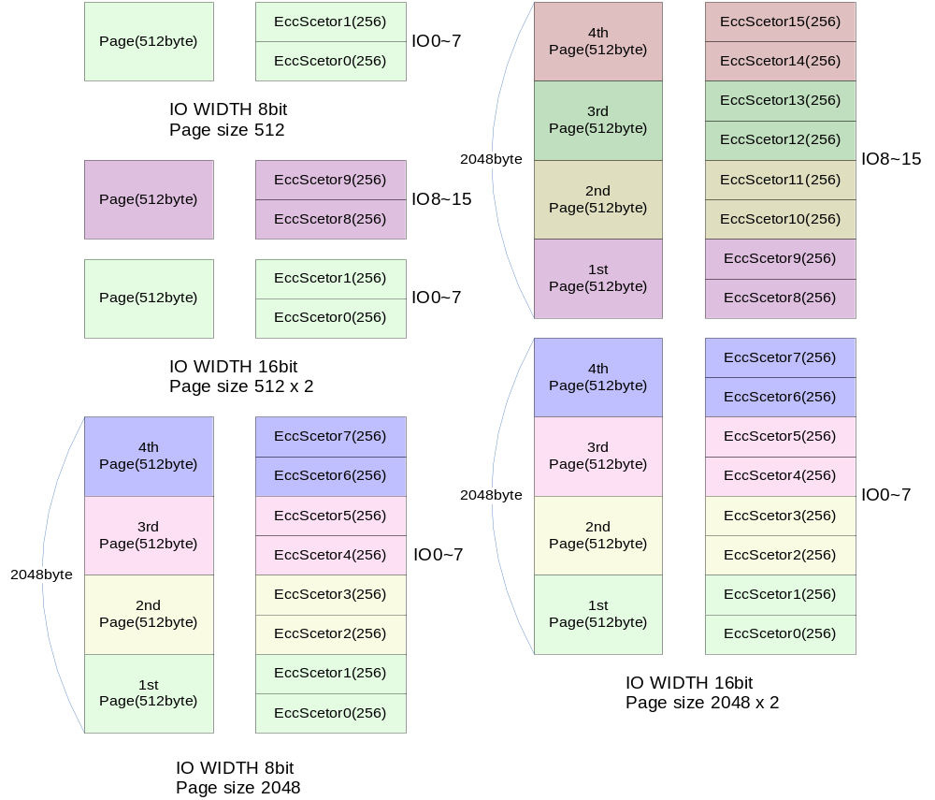
Figure 15-85 ECC Sector Register bit

Spare Ecc Sector Register
Spare EccSector Register는 SEccSector0에서 SEccSector7까지 총 8개로 구성된다
SEcc는 spare area의 LSN0,LSN1,LSN2의 값으로 생성된다. Spare Area는 아래 그림과 같은 구조로 되어있다.
Figure 15-86 Spare area
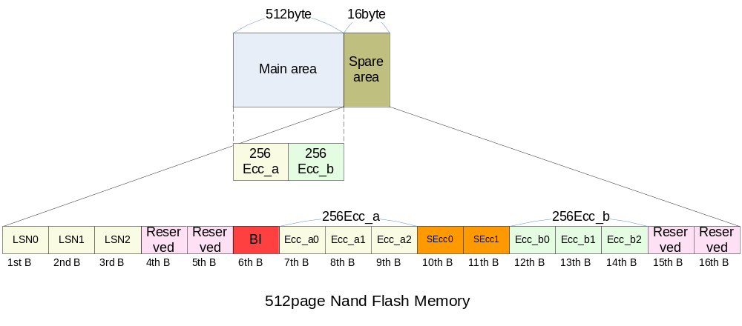
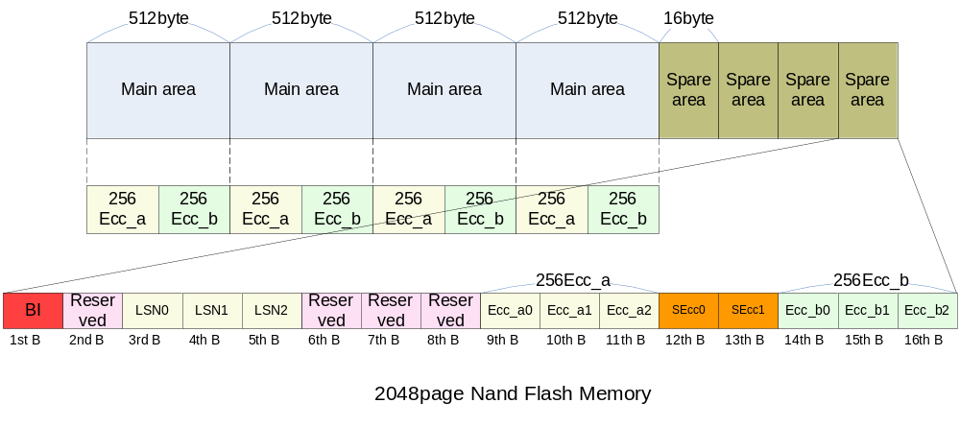

Figure 15-87 Spare ECC Sector Register bit

Ecc Error Register
ECC ERROR를 hardware에서 체크한다. 에러의 발생 유무만 판단하게 되며 정정 가능한 에러일 때 에러의 위치는 소프트웨어로 계산해야 한다. 단 페이지 전체를 read해야만 유효한 값을 가진다.

Figure 15-88 MECC Error Register bit
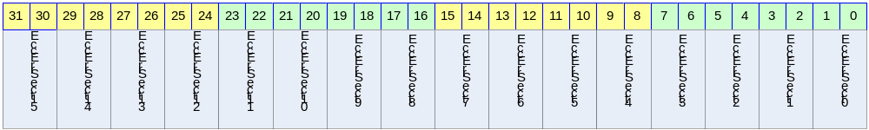

Table 15-64 MECC Error Register Description(Offset : 0000 0074h)
Bits | Name | R/W | Description | Init. value
[31:30] | EccErrSect15 | RO | 00: no Error  01: correctable error  10: uncorrectable error  11: not used | 00b
[29:28] | EccErrSect14 | RO | 00: no Error  01: correctable error  10: uncorrectable error  11: not used | 00b
[27:26] | EccErrSect13 | RO | 00: no Error  01: correctable error  10: uncorrectable error  11: not used | 00b
[25:24] | EccErrSect12 | RO | 00: no Error  01: correctable error  10: uncorrectable error  11: not used | 00b
[23:22] | EccErrSect11 | RO | 00: no Error  01: correctable error  10: uncorrectable error  11: not used | 00b
[21:20] | EccErrSect10 | RO | 00: no Error  01: correctable error  10: uncorrectable error  11: not used | 00b
[19:18] | EccErrSect9 | RO | 00: no Error  01: correctable error  10: uncorrectable error  11: not used | 00b
[17:16] | EccErrSect8 | RO | 00: no Error  01: correctable error  10: uncorrectable error  11: not used | 00b
[15:14] | EccErrSect7 | RO | 00: no Error  01: correctable error  10: uncorrectable error | 00b
[13:12] | EccErrSect6 | RO | 00: no Error  01: correctable error  10: uncorrectable error  11: not used | 00b
[11:10] | EccErrSect5 | RO | 00: no Error  01: correctable error  10: uncorrectable error  11: not used | 00b
[9:8] | EccErrSect4 | RO | 00: no Error  01: correctable error  10: uncorrectable error  11: not used | 00b
[7:6] | EccErrSect3 | RO | 00: no Error  01: correctable error  10: uncorrectable error  11: not used | 00b
[5:4] | EccErrSect2 | RO | 00: no Error  01: correctable error  10: uncorrectable error  11: not used | 00b
[3:2] | EccErrSect1 | RO | 00: no Error  01: correctable error  10: uncorrectable error  11: not used | 00b
[1:0] | EccErrSect0 | RO | 00: no Error  01: correctable error  10: uncorrectable error  11: not used | 00b

Figure 15-89 SECCERR Register bit
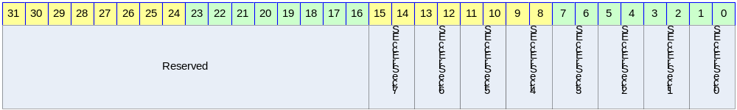
Table 15-65 SECCERR Register Description(Offset : 0000 0078h)
Bits | Name | R/W | Description | Init. value
[31:16 | Reserved |  | reserved
[15:14] | SeccErrSect7 | RO | 00: no Error  01: correctable error  10: uncorrectable error  11: not used | 00b
[13:12] | SeccErrSect6 | RO | 00: no Error  01: correctable error  10: uncorrectable error  11: not used | 00b
[11:10] | SeccErrSect5 | RO | 00: no Error  01: correctable error  10: uncorrectable error  11: not used | 00b
[9:8] | SeccErrSect4 | RO | 00: no Error  01: correctable error  10: uncorrectable error  11: not used | 00b
[7:6] | SeccErrSect3 | RO | 00: no Error  01: correctable error  10: uncorrectable error  11: not used | 00b
[5:4] | SeccErrSect2 | RO | 00: no Error  01: correctable error  10: uncorrectable error  11: not used | 00b
[3:2] | SeccErrSect1 | RO | 00: no Error  01: correctable error  10: uncorrectable error  11: not used | 00b
[1:0] | SeccErrSect0 | RO | 00: no Error  01: correctable error  10: uncorrectable error  11: not used | 00b

Programming Guide

NFOPER레지스터의 1st word

NFOER의 Option[30:29]

- RnBWait :
현재 Command를 수행하고 RnB가 Low에서 High로 변한 후 Next Command가 수행되기 원할 때 사용된
다. (Current Commnad -> RnB Low -> RnB High -> next Commnad )

- AutoRdStat :
Option으로 AutoRdStat를 선택하게 되면 Ready/Busy가 Low에서 High로 변한 뒤에 read Status
Commad 전송하여 read status를 읽을 수 있다.(page program ,Erase에서 사용)
Ex. Page program시 address 5cycle, page program command (80h,10h), Read Status Command(70h)일 때
2nd NFOPER = addr3 | addr 2 | addr1 | cmd(80h)
3rd NFOPER = cmd70h | cmd10h | addr5 | addr4
위와 같이 구성하면 Command(80h),Address(5cycle) 전송 -> Data 전송 -> Command전송(10h) -> RnB Low -> RnB High -> Command(70h) -> read status 순으로 진행된다.

- Continue :
현재 Command를 수행을 완료하고 Next Command를 Load하기 전까지 CE이 Low인 상태로 유지된다. 하나의 Command가 수행이 완료되면 CE은 High가 되지만 이 option을 써주게 되면 CE이 Low로 유지된다.

NFOPER의 OpMode
-read data : Nand Flash의 Data를 read할 때 사용된다.(Page read시)
Command를 전송하지 않고 data만 read 하고 싶다면 CmdAddrTransByte를 0으로 셋팅하고 OpMode는 read data로 설정하고 DataSize를 정해주면 지정된 사이즈만큼 RE신호가 전송된다.

-read status :Nand Flash의 status를 read할 때 사용됨
-read ID : Nand Flash의 ID를 read할 때 사용됨
-write data : Nand Flash에 Data를 Write할 때 사용된다.(page program)
Command를 전송하지 않고 data만 write 하고 싶다면 CmdAddrTransByte를 0으로 셋팅하고 OpMode는 write data로 설정하고 DataSize를 정해주면 지정된 사이즈만큼 WE신호가 전송된다.

-NOP : Nand Flash로 Data의 이동 없이 Command,Address만 전송 할 때 사용됨

Command 전송
Command전송을 위한 레지스터 셋팅은 다음과 같다.
1st Operation register에 Option, DataSize, OpMode, CmdAddrTransbyte, CmdAddrFlag를 셋팅 해준다
2nd ,3rd Operation register에 전송하고자 하는 Command나 Address를 써주면 원하는 Command가 전송된다. 아래 Page program Commad전송의 예를 보였다

Ex. Page program
Nand Flash page size 2048
address cycle 5
write할 사이즈 2048
전송 단위 word
Page write command 는 80h,10h

WriteSize = 2048<<17
WRITEDATA = 0x3<<14
CmdAddrTransByte=0x7<8(7byte 전송=command 2byte,address 5byte)
CmdAddrFlag=0x41
addr1=00h ,addr2=00h, addr3=00h, addr4=00h, addr5=00h

1st NFOPER = WriteSize|WRITEDATA|CmdAddrTransByte|CmdAddrFlag
2nd NFOPER = (addr3<<24) | (addr 2 <<16) | (addr1<<8) | (cmd(80h)
3rd NFOPER = (cmd(10h) <<16) | (addr5<<8) | (addr4)

위와 같이 NFOPER을 써주게되면 Command Queue에 순서대로 쓰여지고 Controller에서 State에 따라 Command Queue를 read하여 Nand Flash로 Command/Address를 전송하게 된다.

DATA read/write

Data write

위에서 살펴본 것처럼 command전송을 후 NFSTAT의 WrFIFOReady flag를 참조하여 NFDATA레지스터에 전송 사이즈 만큼data(위의 예에서는 2048byte)를 써주게 되면 Data write가 완료된다.(DATA FIFO Level을 8로 셋팅 했다면 WrFIFOReady Flag가 High일 때 8번 wirte한다.)

주의 WrFIFOReady Flag는 반드시 clear해줘야 한다.

Data read

Page read의 경우 역시 command전송 방법은 page Program과 동일하며 NFSTAT의 RdFIFOReady flag를 참조하여 NFDATA레지스터를 read하면 Nand Flash의 data를 읽어오게 된다.(DATA FIFO Level을 8로 셋팅했다면 RdFIFOReady Flag가 High가 됐을 때 8번 read한다. )

주의 RdFIFOReady Flag는 반드시 clear해줘야 한다.)

DMA를 이용한 Data read/write

DMA로 Data를 전송하기 위해서는 NFCTRL register의 DMAEn을 1로 셋팅하고 Read/Write Command를 전송하면 Read시에는 DATAFIFO가 설정된 FIFO size만큼 차게 되면 DMA request가 발생하여 DMA Controller에 설정된 값에 의해 data read가 수행되고 Write시에는 DATAFIFO가 empty일 때 DMA request가 발생하여 DMA Controller에 설정된 값에 의해 data write가 수행된다.
DMA를 이용한 데이터 Read/Write역시 위에서 살펴본 바와 같이 Command전송방법은 동일하며 단지 Data를read/write 하는 것만 DMA에서 해주게 된다.

